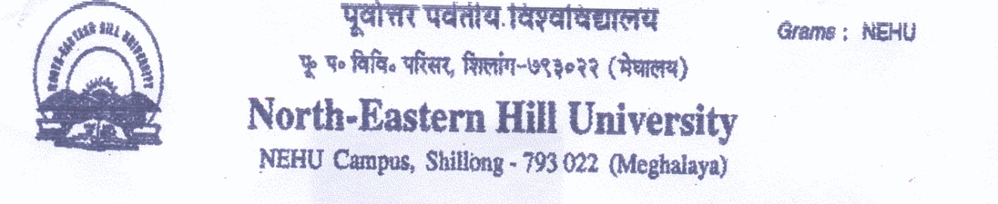 Sports Department
Contact number- 0364-2721381/1383.
Email- nehusports@gmail.com
---------------------------------------------------------------------------------------------------------
RULES AND REGULATIONS FOR INTER COLLEGE FOOTBALL (MEN) TOURNAMENT 2017.
1. The tournament shall be conducted on knock-out basis as per A.I.F.F rules.
2. Duration of the match will be 35+10+35 minutes, for the final 45+10+45 minutes.
3. 3 (Three) substitution shall be allowed in a match.
4. List of players to be submitted 30 minutes before the kick off.
Walk-over shall be awarded to the opponent college if any college does not report on time.
5. Date and timing of the game are subject to alternation according to the decision of the Tournament Committee.
6. In case of draw in the normal time, no extra time shall be given tie-breaker rule will be applied directly.
7. PROTEST will not be entertained.
8. Teacher-in-Charge of each college is to ensure that the team maintains discipline during the tournament and team report for play at the venue, time and date as per fixture.
9. Under no circumstances protest against officials/referees/judges will be entertained.
10. No postponement shall be entertained.
11. Referee’s decision during the match is final.
12. Colleges will be fully responsible for any indiscipline that may occur before, during and after the match. Tournament Committee reserves the right to suspend erring colleges for up to 1 to 3 years depending on the seriousness of the incident that may have occurred.
13. FIXTURE IS SUBJECT TO ALTERATION.
14. Once group matches are over for group-A, B & C, outstation team has to leave accommodation place provided by the University till their next round of match.
Sd/-
(N. Das)
Asst. Director
Sports Dept., NEHU,Shillong.

