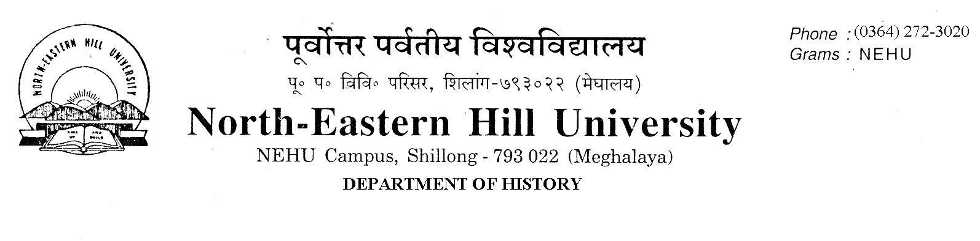
Prof. A. K. Thakur
Head
No. DH/63/Ph.D./2017/ Date: 30-8-2017

Admission Notice

The following candidates have been selected for admission to the Ph.D. and M. Phil. Programmes of study 2017 in the Department of History. They are required to take admission by paying requisite fees and deposit the receipt of fees paid to the Department of History office latest by 4th September 2017 up to 4 PM failing which they will forfeit their seats. NO
FURTHER CLAIMS WILL BE ENTERTAINED THEREAFTER.
Classes will begin on the 4th of September 2017 at 1:00 PM
If employed, the candidates are required to produce the ‘No Objection Certificate’ from their employers.

Sd/-
A.K.Thakur
Head.

Copy to The Technical Officer, NDVN Facility (VSAT) NEHU, Shillong for display on the NEHU Website.

Selected Candidate For Ph.D
Sl. No. | Name | Category | Sl. No. in Register | 40% of Marks obtained in M. A. | Weightage  if any | Marks in Written Test out of 25 | Marks in Interview out of 25 | Total
 | Ms. Tiewdahun Khongwir | S.T. | 18 | 22.4 | M. Phil. 10 | 18 | 16 | 66.4=66
 | Mr. David Arnold Kharchandy | S.T. | 20 | 22.87 | NET 10 | 15 | 17.25 | 65.12= 65
 | Mr. Kamruzzaman Chowdhary | General | 16 | 31.5 | Nil | 15 | 18.5 | 65
 | Ms. Tania Begum | General | 3 | 26.4 | Nil | 20 | 17.62 | 64.02= 64
 | Ms. Iwasankini Rymbai | S.T. | 27 | 22.4 | M. Phil. 10 | 20 | 10.25 | 62.65= 63
 | Ms. Swaswati Borkataki | General | 21 | 23.73 | Nil | 22 | 15.12 | 60.85= 61
 | Ms. Bishnu Kumari Gurung | General | 22 | 24.73 | Nil | 20 | 15.62 | 60.35 =60
 | Ms. Ankita Borgohain | General | 15 | 26.8 | Nil | 15 | 17.87 | 59.67= 60
 | Ms. R. Merika Nongtdu | S.T. | 28 | 22.37 | Nil | 20 | 16 | 58.37=58

Selected Candidate For M. phil
Sl. No. | Name | Category | Sl. No. in Register | 40% of Marks obtained in M. A. | Weightage  if any | Marks in Written Test out of 25 | Marks in Interview out of 25 | Total
 | Ms. Roja Ahmed | General | 4 | 30.4 | Nil | 19 | 18 | 67.4  =67
 | Ms. Rima Sarkar | General | 13 | 26.1 | Nil | 20 | 17.62 | 63.72  =64
 | Ms. Rima Kalita | General | 8 | 24.64 | Nil | 17 | 19.75 | 61.39  =61
 | Mr. Khangamlung Goimei | S. T. | 14 | 21.63 | Nil | 17 | 17.25 | 55.88  =56

Sd/- Sd/-
Prof. A. K. Thakur Prof. A. N. Passah
Head Convener Admission Committee

