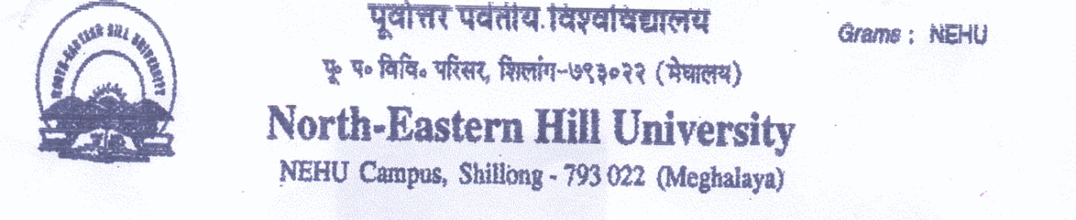 Sports Department
Contact number- 0364-2721381/1383.
Email -nehusports@gmail.com.
-----------------------------------------------------------------------------------------------------------------------------
Notice

Sealed Quotations for Sports Materials for Sports Department, NEHU, Shillong will be opened on 19th June 2019 at 11.00 am instead of 11th June 2019 in front of the tender participants if they wish to attend. Last date for receiving of sealed quotations will be the same i.e. 10th June 2019.

Sd/-
(Prof. S. Umdor)
Teacher In-charge

