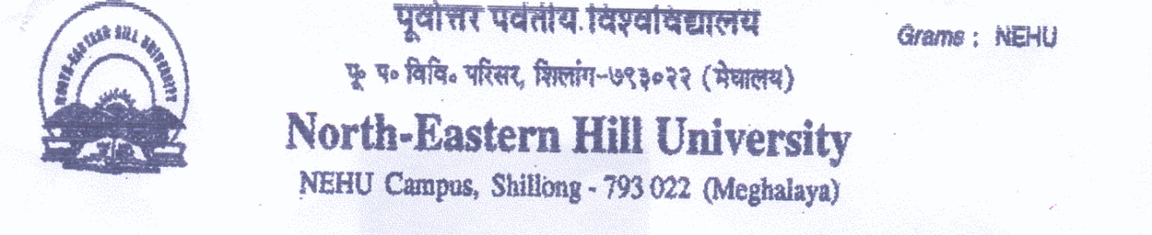
Quotations for Sports Materials for the Sports Department, NEHU, Shillong Session 2018-19
Items | Specification | Rate | Remarks
- Movable Badminton Pole | Brand name ,model number etc | Per Pair | Catalogue Required
- Moveable Volleyball Post | Brand name ,model number etc | Per Pair | Catalogue Required
- Camera | Brand name ,model number etc | Per No | Catalogue Required
- Sound system | Brand name ,model number etc | Per Set | Catalogue Required
- Medals | Weight:- 100 grams per piece with writing and NEHU Logo | Per set of 2  (Gold & Silver) | (Sample Required)

Terms and Conditions:
- Envelope containing the quotations should be sealed with wax or cello tapes and duly super scribed “QUOTATION FOR SPORTS MATERIALS should be addressed to “The TEACHER IN-CHARGE, SPORTS DEPARTMENT NEHU, Permanent Campus, Shillong-793022, Meghalaya and should reach on or before 10th December, 2018 latest by 11.00 am. The quotations will be opened on the same day at 11.30 am. Interested firms may send their representatives to witness the opening of the quotations. However, if the date for receiving and opening of tenders is subsequently declared as holiday(s) the tenders will be opened on the next working day following the holiday but there will be no change in the time for opening indicated above.
- The firm shall quote their rates in INR for each & every item used for supply of tendered items which include all taxes, transportation, labour charges, fixing and nothing extra shall be paid on any account. GST, if any should be mentioned clearly in rupees.
- Sample/ catalogue as mentioned above items to be produced at the time of opening tender is mandatory and the selected sample items / catalogue of the particular firm will be retain by the sports department for verification till the materials are supplied.
- Interested firm should submit their Trading License, Tax Clearance Certificate, a copy of GST Registration and any other documents as and when required while participating in tender in the state of Meghalaya

Sd/-
Prof. S. Umdor
Teacher In-charge
Sports Department
North-Eastern Hill University
Shillong-793022 (Meghalaya)

