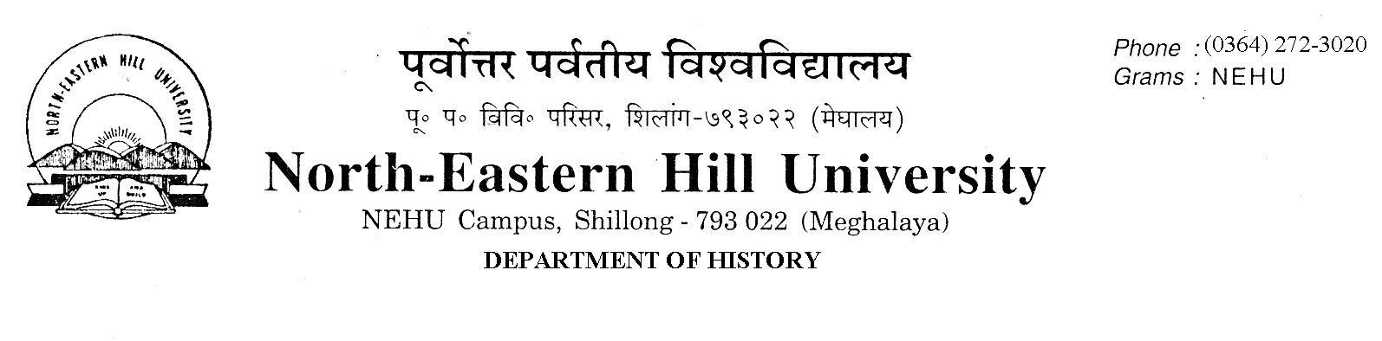
No.DH/58/DPC/2020-174 Dated 13.01.2021.

TO WHOM IT MAY CONCERN

Sealed quotations of prices are invited from suppliers/vendors for External Hard Disk (Drive) mentioning the brand and the cost for 1 TB and 2 TB.
The sealed quotations are to reach the office of the undersigned, latest by 22.01.2021 at 11.00 A.M. and will be opened on the same day at 11.30 A.M. The suppliers/vendors are instructed to clearly quote the specifications of the items and terms and conditions after sales services. They can also send their representatives to witness in opening the quotations, if they wish.

Sd/-
C.A. Mawlong
Head
Department of History.

- .

