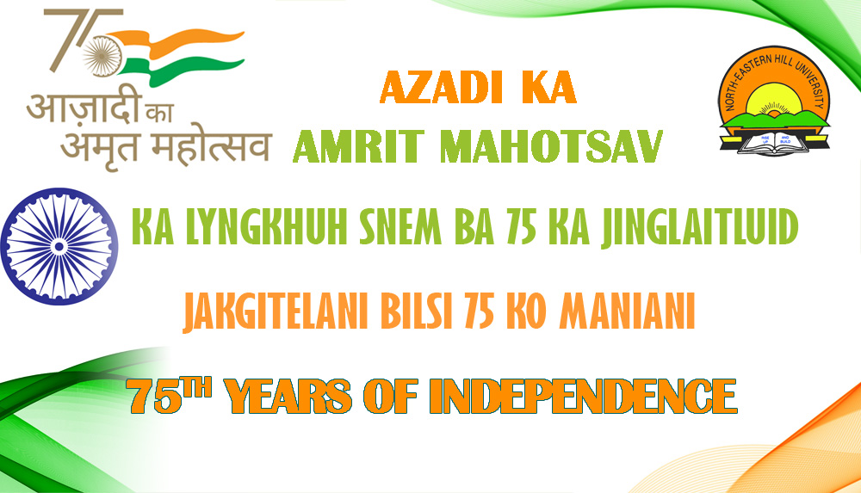
File No.1-09/Admn/Yoga Day/2019(Vol-III) 3rd March 2023

Circular
The Yoga Committee of the North-Eastern Hill University, Shillong is organising a lecture on Yoga & Health on the 9th of March 2023 at the VC’s Conference Hall at 3.00 pm to 4.30 pm.
Above lecture will be delivered by Dr. Vijay Kumar, Principal In-charge, Professor & Head, Department of Swasthavritta & Yoga, North-Eastern Institute of Ayurveda & Homoeopathy (NEIAH), Shillong
All are cordially invited to participate.
This is issued as per decision and direction of the University Level Yoga Committee (YLYC)
Sd/-
(N. Das)
Convener
University Level Yoga Committee
NEHU, Shillong, Meghalaya

