NORTH-EASTERN HILL UNIVERSITY
DEPARTMENT OF LINGUISTICS
SHILLONG-793022
Dr. Saralin A. Lyngdoh Tel: +91-8837396270 (M)
Assistant Professor +91-3634-3315 (O)
Email:saralyngdoh@gmail.com

Dated: 09th November 2021

Re-Advertisement

A Walk-in Interview

Applications are invited on plain paper for the post of Field Investigator (purely on contract basis), for the Project entitled “‘Linguistic Mapping of Regional Dialects of Khasi’” ICSSR-NERC Shillong in the Department of Linguistics NEHU Shillong.
Apply with CV in standard format on or before 1st of December 2021 to the undersigned. A Walk-In Interview will be held on 3rd of December 2021 in the Department of Linguistics.

Details of the Post:
1. One Field Investigator for the period of two months (12,000 per month)

Mode: Walk- in- interview
Posts: Both full time posts
Qualification: MA, M.Phil, Ph.D. (Linguistics)
Area of Specialization: Knowledge of Khasi and English Languages
Venue: Department of Linguistics, North Eastern Hill University, Shillong
Date & Time: 3rd December at 11.A.M

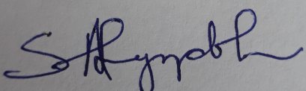
Dr. Saralin A. Lyngdoh
(Principal Investigator)

