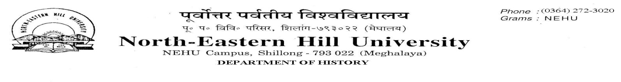
No.DH.23/ADMN/2020-21/173 Dated 12.01.2021
ADDENDUM

It may be noted that candidates whose names have appeared on the list of admitted students for the P.G. programme in History, NEHU, must produce their certificates in original (Mark sheets, SC/ST/EWS/Wards of Ex-Servicemen) at the Department Office on the 18th January, 2021 between 11A.M. and 4 P.M. for physical verification of the same, failing which they will forfeit their seats.

Sd/- Sd/-
Prof. C.A. Mawlong Prof. A.K. Thakur
HOD, History Convener, Admission Committee, History

