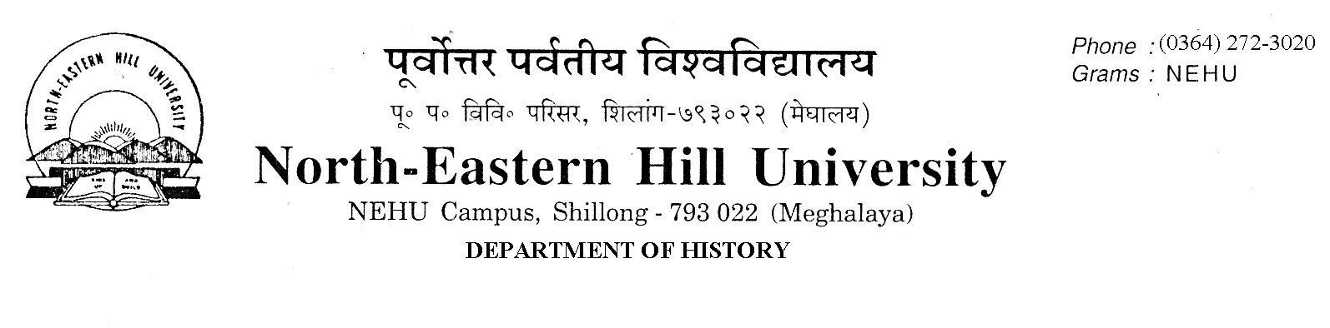
No.DH/23/ADMN/2020-21/186 Dated 20.01.2021
ADMISSION NOTICE
The following candidates whose applications have been duly verified are selected for admission to the M.A. Programme (2020-21) in the Department of History. They are required to take admission by paying requisite fees on line and send either the scanned copy of the receipt of fees paid to the Department of History Office/email of the HoD, History (hodhis@nehu.ac.in) or the printed copy by hand, latest by 1 P.M on 22nd January 2021, failing which a candidate will forfeit his/her seat.
NO FURTHER CLAIMS WILL BE ENTERTAINED THEREAFTER.
Sl. No. | Name | University | State | SC/  ST/  GEN | % | NEHU Weightage | Total | Remarks
1 | Mr. Akhim Hazarika | NEHU | Assam | Gen | 50.88 | + 20 | 70.88 | Ward of Ex-servicemen under Supernumerary Seat
2 | Mr. Kamminjoy Khongsai | NEHU | Meghalaya | ST | 46.75 | + 20 | 66.75 | Ward of Ex-servicemen under Supernumerary Seat

Second List
Sl No | Name | Category | Univ. | % | +20 NEHU Weightage
1 | Mr. Christni Haadong Debbarma | ST | NEHU | 60 | 80 MBOSE Cl.XII 70.8
2 | Ms. Christinarakme B. Marak | ST | NEHU | 60 | 80 MBOSE Cl.XII 63.4
3 | Mr. Estarlan Warbah | ST | NEHU | 60 | 80 MBOSE Cl.XII 62.2
4 | Ms. Grespina T. Sangma | ST | NEHU | 60 | 80 MBOSE Cl.XII 61.2
5 | Mr. Gevinson Syiem | ST | NEHU | 60 | 80 MBOSE Cl.XII 59

Sd/- Sd/-
C.A. Mawlong A. K. Thakur
Head Convener, Admission Committee

