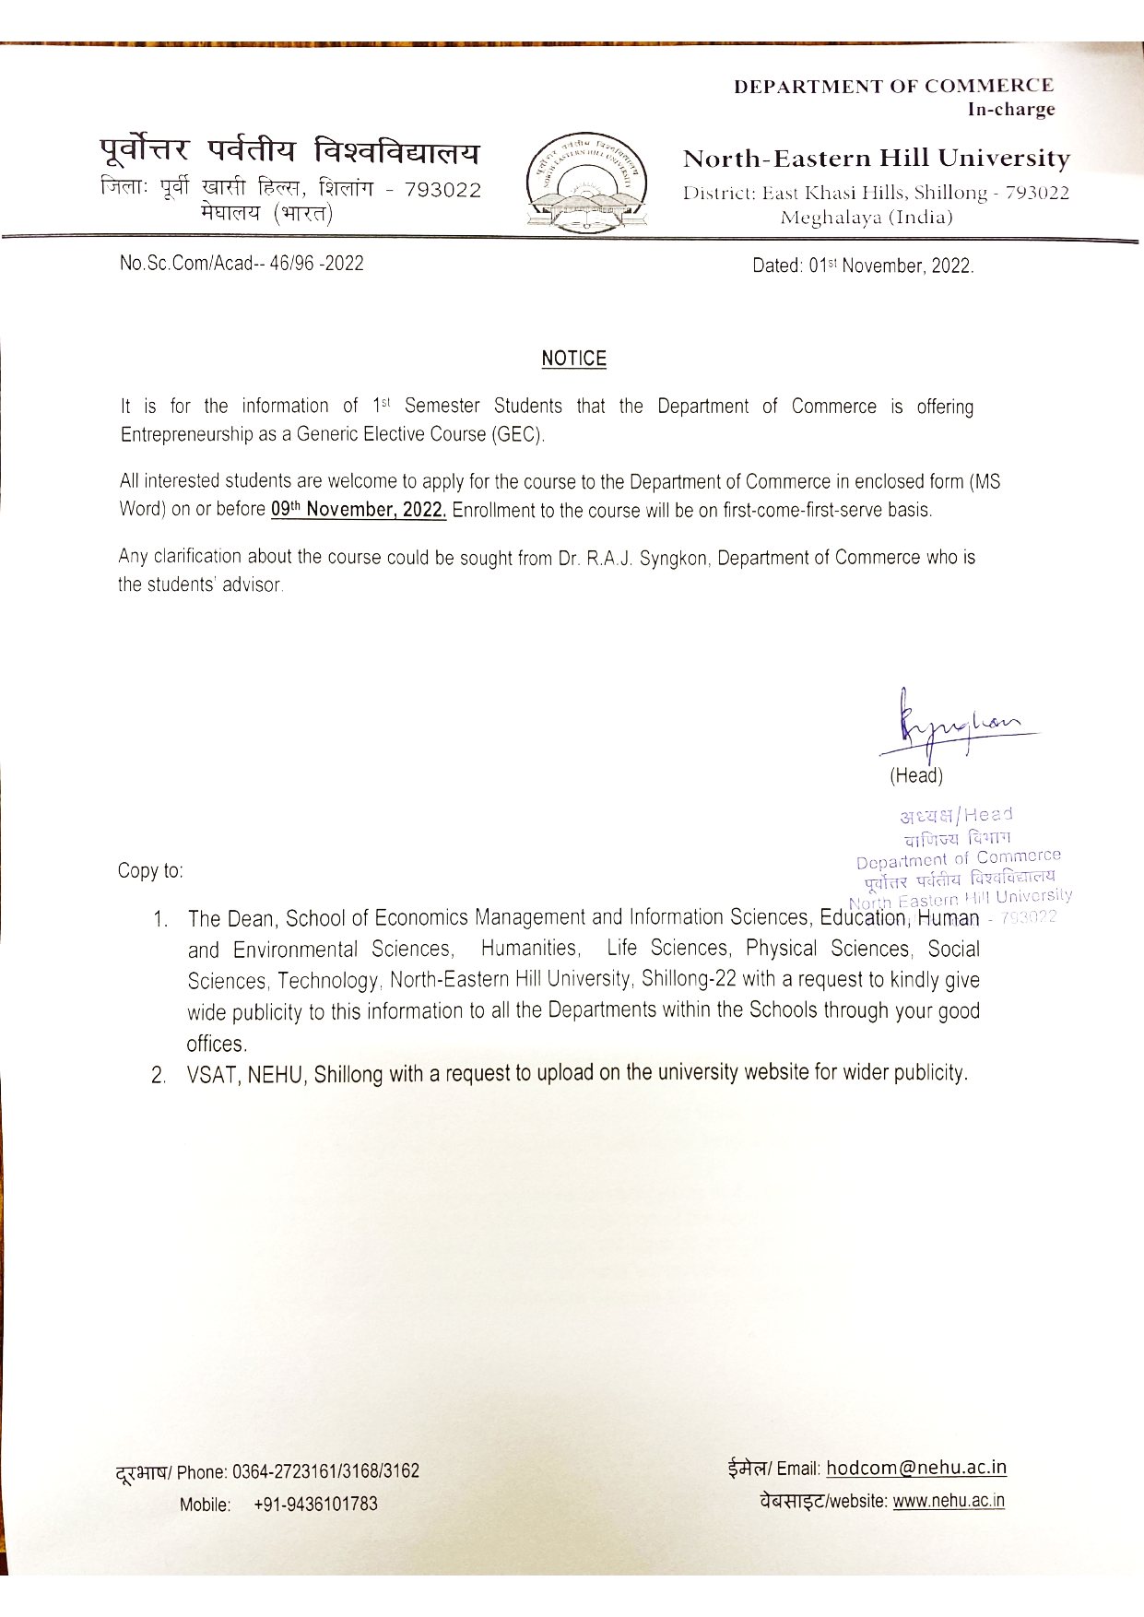

NORTH – EASTERN HILL UNIVERSITY

Permanent Campus: Shillong – 793022 (Meghalaya)

Application form for Registration of Students for Elective Course(s)
(To be submitted in triplicate)

- Name of the student in full :___________________________________

- Name of the Department/Centre :___________________________________

- Roll No :___________________________________

- NEHU Registration No :___________________________________

- Name & Number of Elective Course(s) applied:(1) ______________________________

(2) ________________________________ (3) ________________________________

- Name of Department servicing the Course(s) : (1) ________________________________

(2) ________________________________ (3) ________________________________

(4) ________________________________

_______________________
Signature of Student
_________________________
Signature of Student Counselor

___________________________________
Signature of the Head of the Department with seal

____________________
Office seal

……………………………………………………………………………………………..
Accepted / Not Accepted

Signature of HOD Servicing the Open Course

Signature & Seal of the Dean of School

