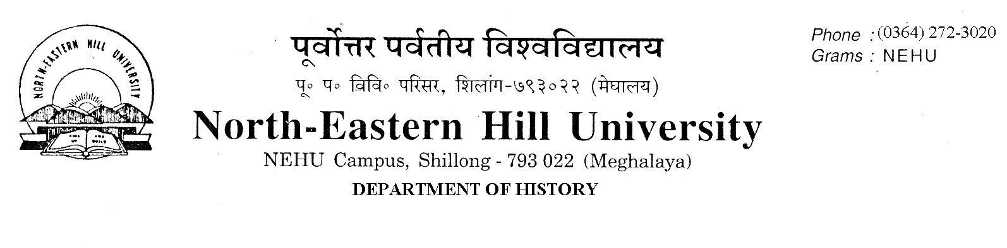

Prof. C.A. Mawlong
Head.

No.Dh/63/Ph.D/2021- Dated 15 March 2021.
Notice Ph.D. Entrance Test 2021.

This is to inform all candidates appearing for the Entrance Examination for the Ph.D. Admission in the Department of History, NEHU, Shillong, that the venue for the Examination on the 16th March 2021 (from 10.30 A.M. to 12.30 P.M) will be held in the Non-Science Cluster Class Room No. 206 and 209 (B).
The Cluster Class Room is near the Central Library, NEHU.

Sd/-
C.A. Mawlong
HOD, History

