Report on Yoga Activities organised by the North-Eastern Hill University for the Year 2022-23
University Level Yoga Committee Members-2022-23
- Prof. D. K. Choubey, Department of Hindi, NEHU--------------------------------- Chairmen
- Prof. A. K. Thakur, Department of History, NEHU--------------------------------- Member
- Prof. K. C. Kabra, Department of Commerce, NEHU------------------------------ Member
- Prof. Aparna Mathur, Department of History, NEHU-----------------------------Member
- Prof. Geetika Ranjan, Departmnent of Anthropology, NEHU-------------------Member
- Dr. Kamaljit Chirom, Department of Mass Communication, NEHU-----------Member
- Shri N. Das, Asst. Director (PE & Sports), NEHU-----------------------------------Convener

- Report on celebration of 8th International Day of Yoga 21st June 2022
The North-Eastern Hill University, Shillong, Meghalaya celebrates ‘8th International Day of Yoga’ on the 21st of June 2022 at the Multi-Use Convention Hall, NEHU Permanent Campus, Shillong. The program was conducted by the University Level Yoga Committee and National Service Scheme Cell of the University. All together 235 numbers of participants took part in the event including teachers, non-teaching staff, students and campus residents.
The celebration was started at 6.15 am with lightening of the lamps followed by welcome address by Prof. D. K. Choubey, Chairman, University Level Yoga Committee. A short speech was delivered by the Senior Most Professor of the University Prof. S. B. Prasad.
Every participant watched the live address of Hon’ble Prime Minister of India from Mysuru Palace from 6.00 to 7. 00 am. After the Prime Minister’s address, there was a Yoga Protocol participated by the every participants. Yoga protocol was lead by Dr. Anamika Upadhaya and her team from Art of Living.
The Vice-Chancellor of the North-Eastern Hill University Prof. P. S. Shukla also addresses the gathering as Chief Guest. In his address, the Vice-Chancellor of the University has emphasize on mass participation and performing yoga activities regularly to get maximum health benefits.
The program was operated by Prof. Getika Ranjan, Member, University Level Yoga Committee.
The program ended with vote of thanks by Coordinator, NSS Cell, NEHU Dr. M. Khymdeit

Glimpses of 8th International Day of Yoga 21st June 2022
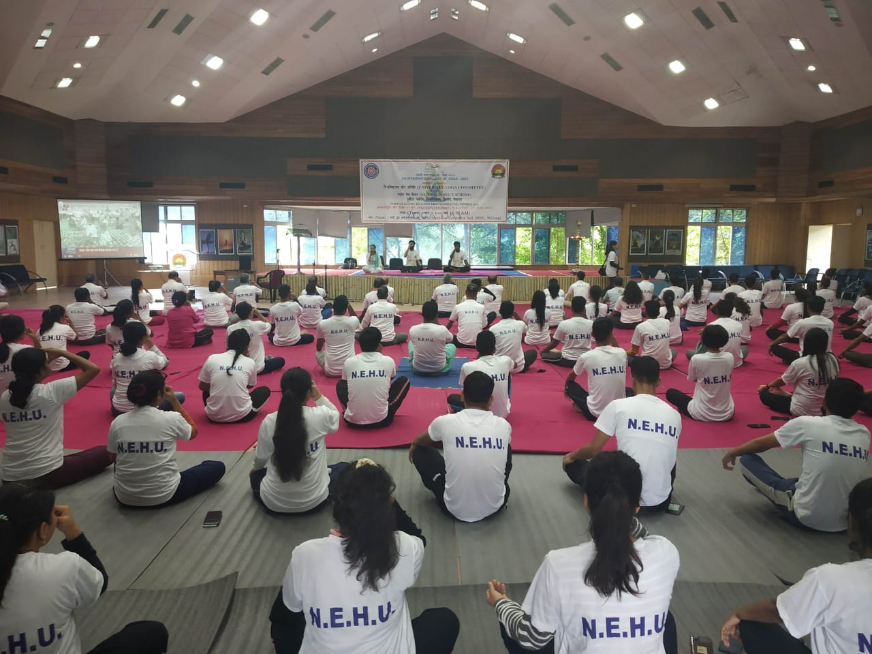
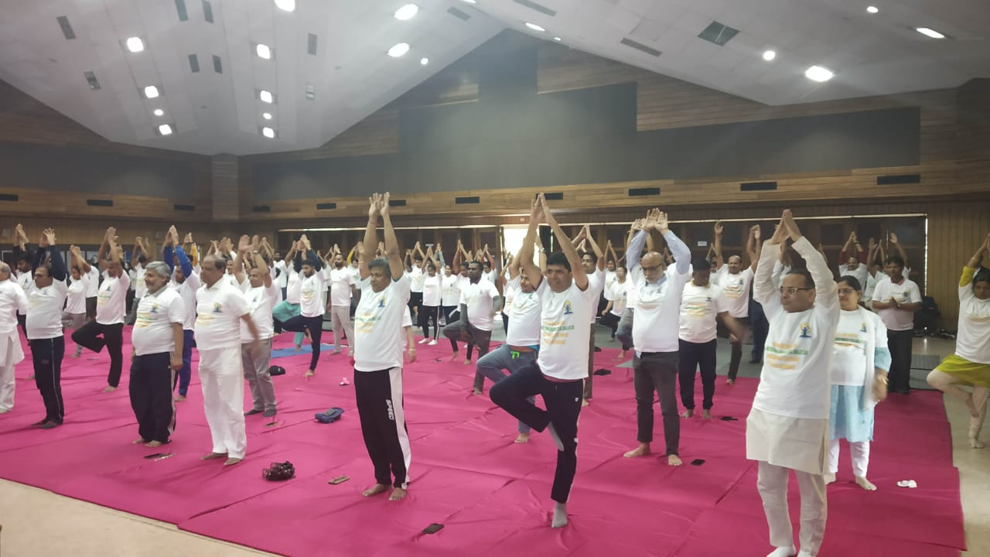
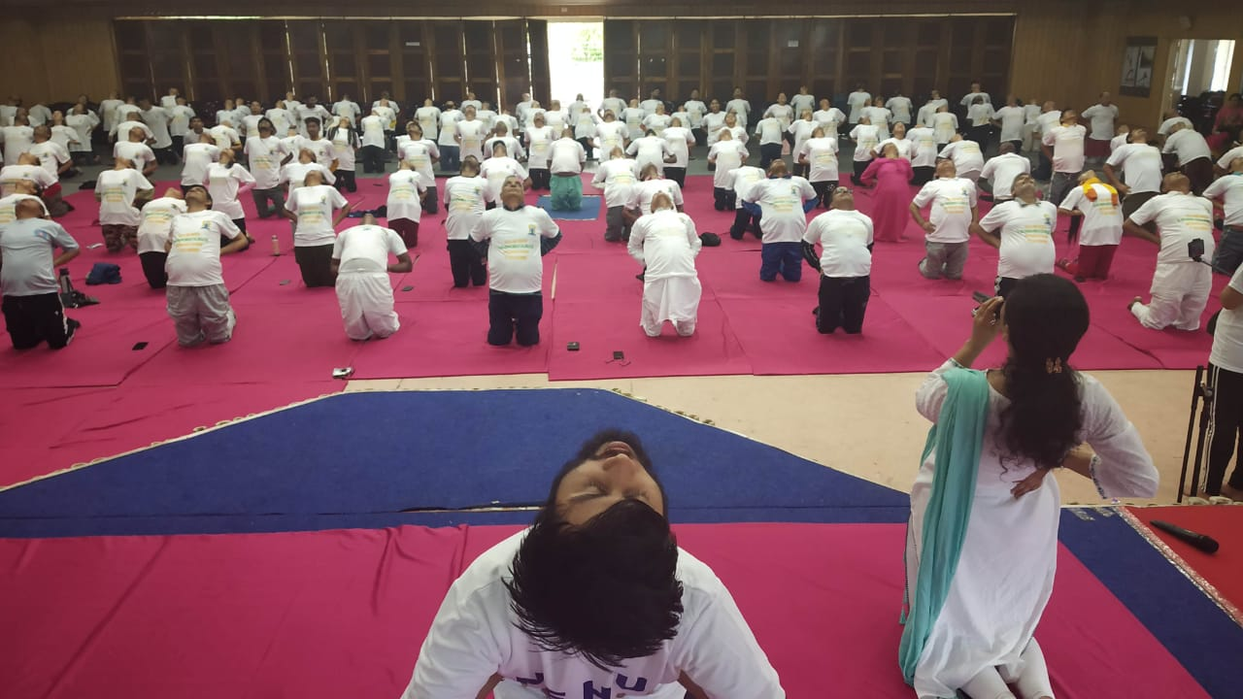

- Report of one week ‘Yoga Shivir’ from 22nd to 27th August 2022

The University Level Yoga Committee organised a one week ‘Yoga Shivir’ from the 22nd to 27th August 2022 at the Community Hall, NEHU Permanent Campus, Shillong. Before commencement of the Shivir, Shri N. Das, Convener of the committee approached officially local communities i.e. Headman of Umshing, Kyntonmassar, Mawkynroh and Mawtawar for participation in the Yoga Shivir. For the first time local communities are came forward and participated in the Yoga Shivir.
Expert personnel from the Meghalaya Yog Samiti, Patanjali, Shillong have assisted the committee to organise the Yoga Shivir. The Shivir was inaugurated with lightening of lamp by the Officiating Vice-Chancellor, NEHU Prof. S. B. Prasad, Chairman of the University Level Yoga Committee Prof. D. K. Choubey, Coordinator of the Yoga Shivir Prof. K. C. Kabra, and Convener of the Committee Shri N. Das on the 22nd August 2022 at 7.00 am. About 90 participants have participated in the yoga shivir.
The shivir was ended on the 27th August 2022, one of the participants has share his experiences about the yoga shivir and also mentioned that performing yoga activities will save us from visiting white coat i.e. doctors for any illness and also from black coat i.e. lawyer for any crime.
Light refreshments were served to every participant on the opening and closing day of the yoga shivir.
Glimpses of one week ‘Yoga Shivir’ from 22nd to 27th March 2023
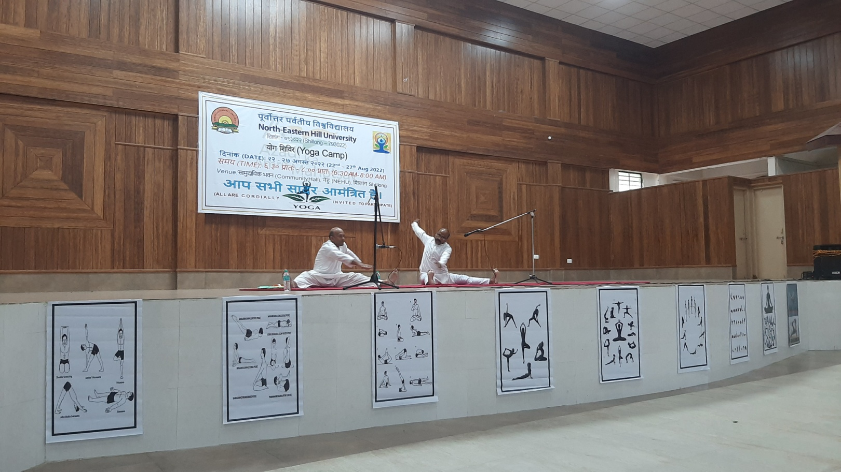

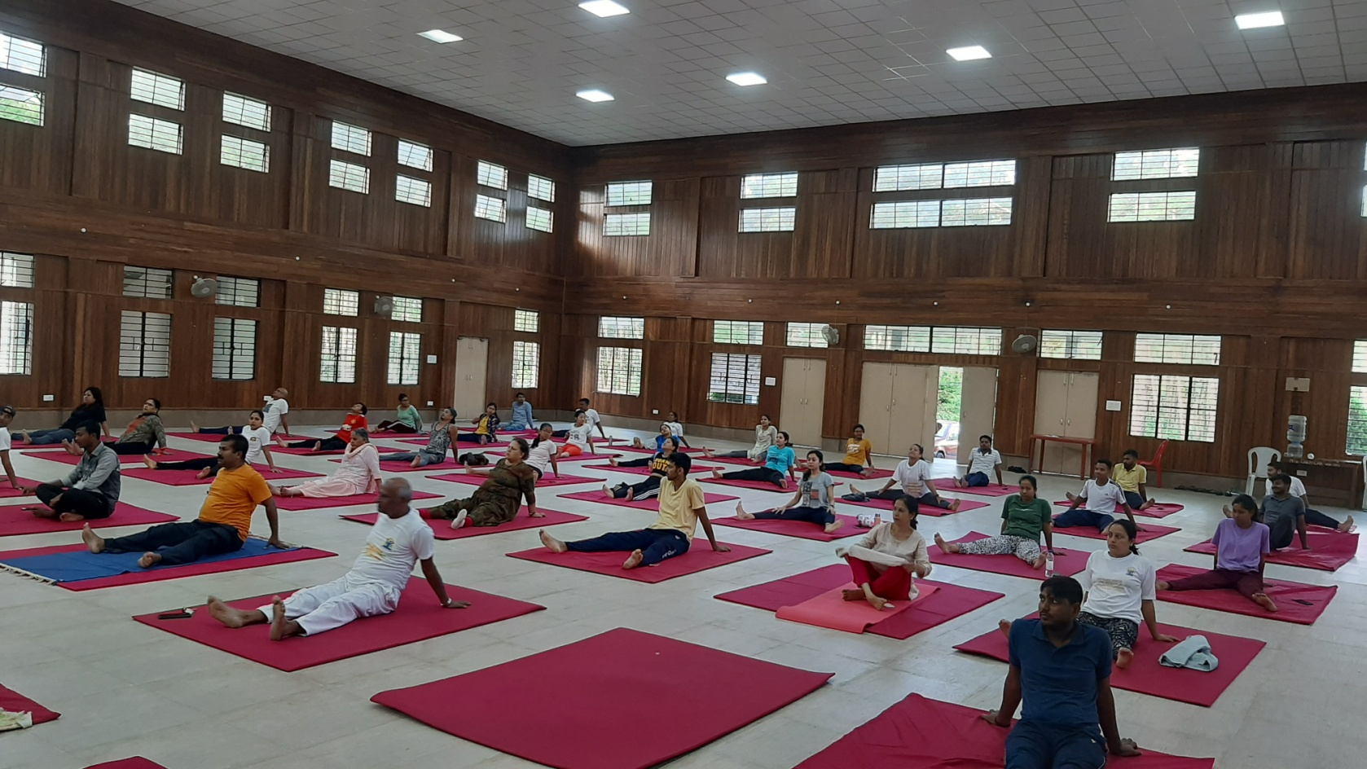

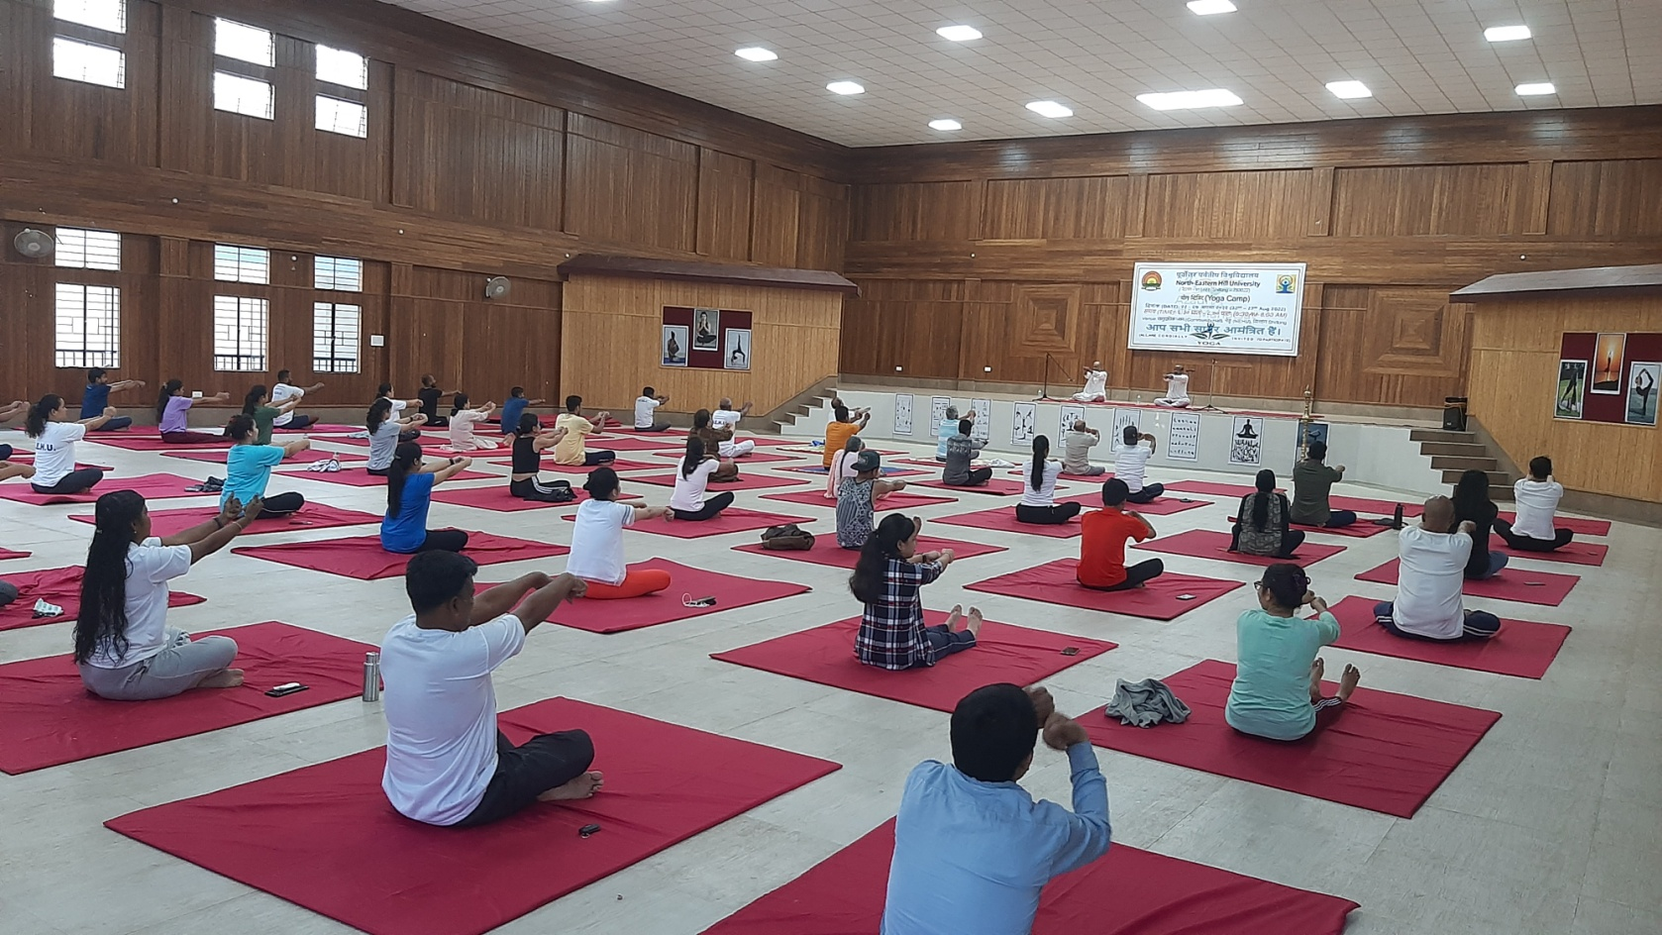

- Talk on ‘Yoga & Health’ on the 9th March 2023

The University Level Yoga Committee organised a talk on Yoga & Health on the 9th of March 2023 at the Conference Hall, Administrative Building, NEHU Permanent Campus, Shillong.

The talk was started with opening remarks from the Chairman of the University Level Yoga Committee Prof. D. K. Choubey.

The talk was delivered by Dr. Vijay Kumar, Professor & Head, Department of Swastha Vritta and Yoga, North-Eastern Institute of Ayurveda & Homoeopathy (NEIAH), Mawdiangdiang, Shillong. The Program was attended by faculty members, non-teaching staff and students of the University.

The Honorable Vice-Chancellor of the North-Eastern Hill University Prof. P. S. Shukla was present during the talk and shared his closing remark. The program was ended with both of thanks from the Convener of the University Level Yoga Committee Shri N. Das

Glimpses of Talk on Yoga & Health-9th March 2023
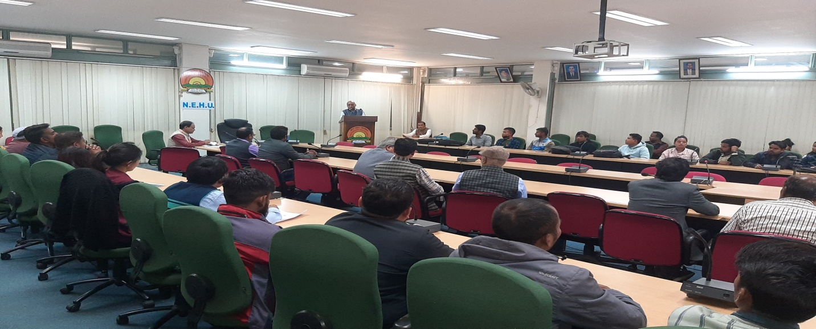
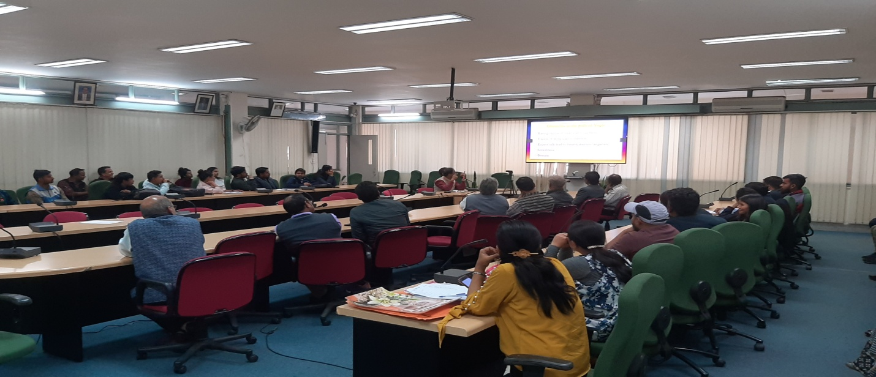

- Report of three days ‘Yoga Shivir’ from
The Yoga Committee of the North-Eastern Hill University, Shillong is also organised ‘Yoga Shivir’ (Yoga Camp) from 16th to 18th March 2023 at the Indoor Stadium, NEHU Permanent Campus, Shillong. Dr. Anamika Upadhaya, An AYUSH Certified Trainer and Member of Art of Living and her team assisted the University Yoga Committee to organise the camp. All participants were awarded with participation certificates. The ‘Yoga Shivir’ was ended with both of thanks from the Convener of the University Level Yoga Committee Shri N. Das
Glimpses of ‘Yoga Shivir’ from 16th to 18th March 2023
