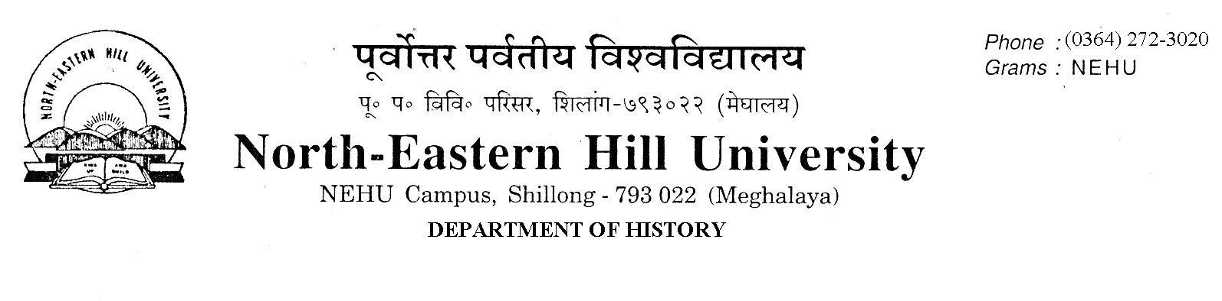
No.DH/63/Ph.D/2021-292 Dated 19.03.2021
NOTICE

The Following Candidates have been selected for admission to the Ph.D Programme for the Department of History, 2021. The selected Candidates are to complete their admission process by payment of their fees and submit the receipt (in hard copy) to the Department office by 26th March, 2021. Candidates should meet their respective supervisors after their admission. Candidates who are employed in any institution should also submit their NO OBJECTION CERIFICATE to the Department of History at the earliest.

Sl.No | Application No. | Name | Category | Supervisor
1 | 21100885 | MR. GINNA CHONGLOI | ST | Dr. M.S. N. Rahman
2 | 21101002 | MR. AKUMTONG LONGKUMER | ST | Prof. C. A. Mawlong
3 | 21101229 | MS. LINDA BESSY LYNGDOH | ST | Prof. A. N. Passah
4 | 21101318 | MR. HEMANGO AKSHAY HIWALE | Gen | Dr.B. Dutta
5 | 21101394 | MR. JAMES LALFAKZUALA | ST | Prof.A.N. Passah
6 | 21101507 | MS. V. MANCY BAITE | ST | Prof. A.K. Thakur

Sd/-
C.A. Mawlong
HOD, History

