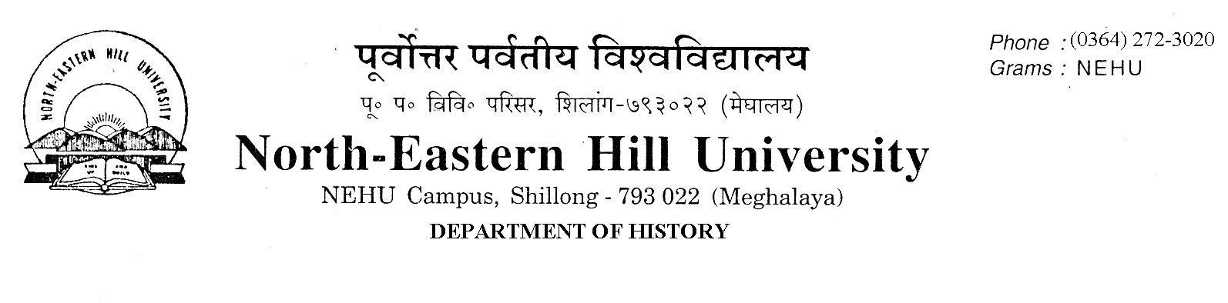NOTICE
No.DH/63/Ph.D/2021/288 Dated 18.3.2021.
Ph.D Entrance Test Result

The following candidates have qualified the written test and are shortlisted for personal Interview. The shortlisted candidates are to report to the Department of History office at 11.30 A.M. on the 18th March, 2021 with all their Marksheets, Cerificates in original (in support of their claims) with a copy of their Application Form ( in photocopy/printout). Candidates who have claimed clearance of NET/SLET exams are to produce their supporting certificate/documents in support of their claims.

Sl.No | Application No. | Name | Catagory
1 | 20100119 | WINGAMRAIBOU ABONMAI | ST
2 | 21100885 | GINNA CHONGLOI | ST
3 | 21101002 | AKUMTONG LONGKUMER | ST
4 | 21101117 | GAIPUILU KAMEI | ST
5 | 21101162 | EMERALDA KHARKONGOR | ST
6 | 21101229 | LINDA BESSY LYNGDOH | ST
7 | 21101318 | HEMANGO AKSHAY HIWALE | Gen
8 | 21101394 | JAMES LALFAKZUALA | ST
9 | 21101481 | DAFINIA LAPASAM | ST
10 | 21101507 | V. MANCY BAITE | ST

C.A. Mawlong

