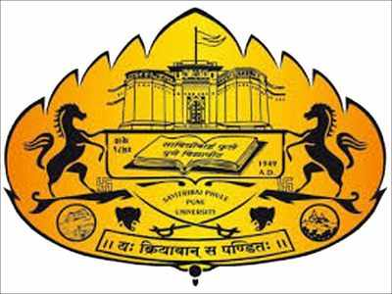 | SCHOOL OF EDUCATION  (Under PMMMNMTT)  SAVITRIBAI PHULE PUNE UNIVERSITY: PUNE | 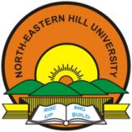

One-Day National Workshop
on
Continuing Professional Development of Teacher Educators through
Blended Learning Approach

In Collaboration with
SCHOOL OF EDUCATION
NORTH-EASTERN HILL UNIVERSITY: SHILLONG
(9th November 2019)
Introduction
Teacher is a lifelong learner. The development of any nation depends mainly on the standards of its educational institutions. The Draft Policy of National Policy of Education 2019 stressed the need and importance of professional development of teacher educators in the present digital world. At present, digital learning is playing a pivotal role in teaching, learning, research and extension. The roles and responsibilities of a teacher are changing from time to time. At international level, the UN, UNESCO, and EU are stressing the need of ICT integrated teaching and learning in Teacher Education Programme. At the same time, the Government of India, MHRD, UGC, NCERT, and NCTE are stressing the need of Online Learning and integration of ICT in Teacher Education Programme through various programmes and plans. The Continuing Professional Development (CPD) of Teacher Educators is only the key to fulfil the needs of a learner. Continuing Professional Development is important because it ensures an employee continue to be competent in his/her profession. It is an ongoing process and continues through a professional’s career. Teacher Education is a professional course. There are lot of changes are occurring in the field of Teacher Education. There is an urgent need to upgrade the teacher educators to reach their goals. Blended learning is an approach to education that combines online educational materials and opportunities for interaction online with traditional place-based classroom methods. The Blended Learning Approach is very effective, helpful and useful for teacher educators for continuing professional development.

Objectives of the Workshop
- To Sensitise the Teacher Educators towards Blended Learning Approach.
- To provide the detailed information about how to use blended learning approach for Continuing Professional Development of Teacher Educators.
- To provide OER content with special reference to Continuing Professional Development through Blended Learning.
- To provide hands-on experience to Teacher Educators on the applications of ICT in Continuing Professional Development through Blended Learning Approach.
Broad Themes of the Workshop
- Continuing Professional Development
- Blended Learning
- Massive Open Online Courses (SWAYAM & FutureLearn)
- 7 Ss Model of Learning and Teaching through Online
Participants : Teacher Educators, SPPU, Pune
Duration : One Day (9th November 2019) Time: 10:00 am – 4:00 pm
Venue : Dept of Education & Extension, SPPU, Pune.
Registration Fee: There is no registration fee.
Note:
- The Organizers will provide workshop Kit & Working lunch and refreshment (morning and evening) to all the participants.

Prof. S. A. Sonawane  Workshop Convenor  Director  School of Education  Savitribai Phule Pune University, Pune. | Prof. C. Nongbri  Advisor  Dean, School of Education  North-Eastern Hill University  Shillong, Meghalaya.
Dr. Vaibhav G. Jadav  Workshop Co-ordinator (SPPU)  Dept of Education & Extension  Savitribai Phule Pune University, Pune.  Mobile: +91-9421503397  e-mail: vaibhav.jvg@gmail.com | Dr. N. Amareswaran  Workshop Co-ordinator (NEHU)  Dept of Education  North-Eastern Hill University, Shillong.  Mobile: +91-9441910359, +91-9485125291  e-mail: amareswaran@gmail.com  blog: https://hamsareddy.blogspot.com

*****

