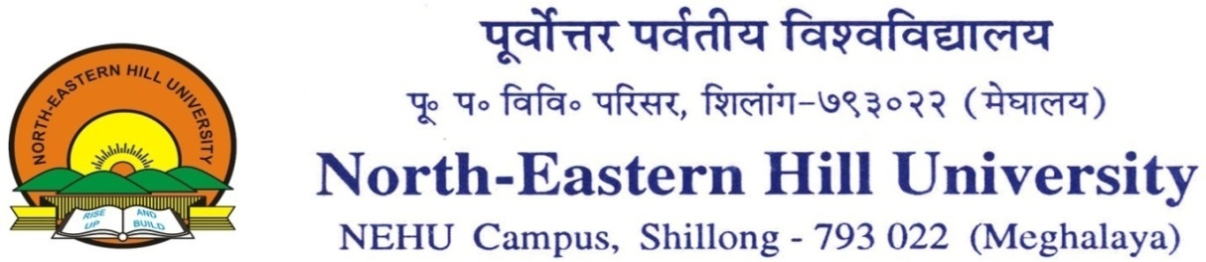
.
Head, Geology Department
Dated: 17.05.2021

NOTICE
The M. Sc. (Geology) Second Semester Programme offers two Open papers viz. GLO-204 (Geochemistry and Geophysics – 4 credits) and GLO-205 (Disaster Risk Resilience – 2 credits).
The interested students may apply for the above-mentioned courses through their respective Head’s/ Teacher In-charge at the earliest through email (hodgeology@nehu.ac.in).
The classes will start 24th (Monday) May 2021.

Head

