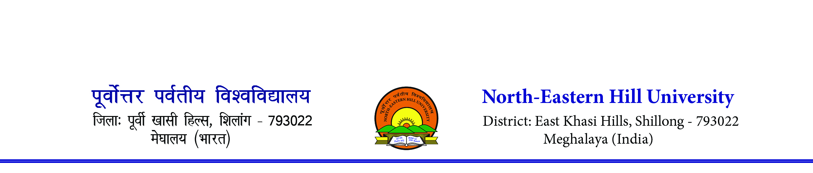
F. No.1-103/SP/FIP/2022- Dated 24th June 2022
NOTICE
The Sports Department of the University will be organising a Badminton (Men & Women) Tournament, Inter Schools of the University for NEHU students under ‘Fit India Movement’ and celebration of University Golden Jubilee on the 29th & 30th June 2022.
Rules & Regulations
- Last date of entry 28th June 2022 till 11.00 am. Team list must be forwarded by the respective Dean of Schools. Maximum boys in a team should be 6 and a minimum of 4, maximum girls in a team should be 4 and minimum of 2 members.
- Matches will be played in the evening, starting from 4 pm onwards
- Team list may be submitted to the Sports Department, NEHU or Email nehusports@nehu.ac.in.
- Each team must report at the venue of the tournament. Player of any team failing to report on the court when called will be liable to be scratched.
- Matches will be played of best of five games in respect of Men Team Events i.e. First Single. Second Single, First Double, than third singles and last the second doubles and best of three games in respect of Women Team Events i.e. First Single, than Doubles and last Second singles. If any college wins any of the three matches out of five in men team events and two out of three matches in Women team Events, they will be declared winners.
- Any dispute during the tournament should be brought to the notice of the organiser and thereafter to the notice of the Tournament Secretary within 30 minutes at the end of the game/incident in writing.
- According to new format of points the following system will be adopted:
# All matches will be played for boys to the best of five sets of 21 points game and girls to the best of 3 sets of 21 points using rally point system (similar to table tennis and volleyball where a point is scored when any one of the players make a mistake).
# at 20 all, the winner is the one gets 2 points consecutively. To ensure that the game does not drag on too long, once they are 29 all, the player who scores the next point will be the WINNER.
This is issued as per direction of the Director In-charge, Sports Department, NEHU
Copy to
- All Deans, NEHU, Shillong for favour kind information with a request to bring to the knowledge of students.
- All HOD’s, NEHU, Shillong for favour of kind information with a request to bring to the knowledge of students.
- The Dean of Students Welfare, NEHU for favour of kind information
- The President & Sports Secretary, NEHUSU for information.

N. Das
Asst. Director (PE)

