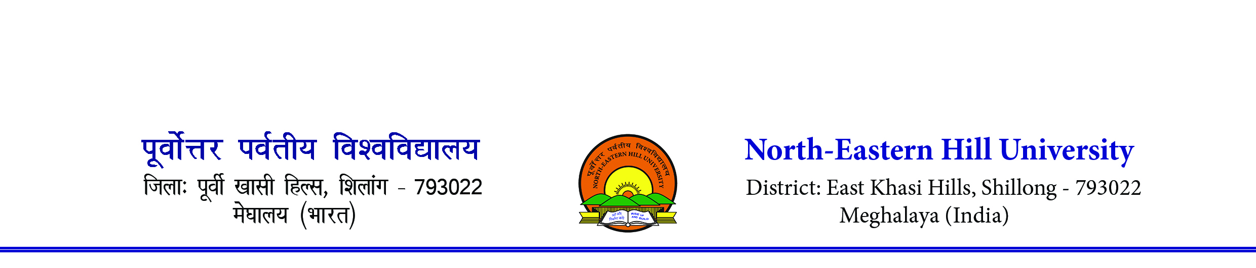Sports Department
Contact number- 0364-2721381/1383. Email -nehusports@nehu.ac.in
___________________________________________________________________

REVISED ELIGIBILITY RULES FOR PARTICIPATION IN THE INTER-COLLEGE TOURNAMENTS

A) Eligibility Rules
1. Only bonafide, full time student, who is enrolled for a degree or post-degree or diploma coursewhich is of a minimum duration of one academic year and whose examination is conducted by the university subsequent to passing the 12th class examination under the 10+2 pattern of education by a recognized Board of Higher Secondary/Senior Secondary conducted in the country or an equivalent examination shall be eligible to participate in the Inter-College Tournaments approved by the Inter-University Sports Board of India.

1.1 Students of Open Universities shall be considered to be bonafide students and shall be eligible to participate provided they fulfill other conditions. However, students enrolled in Correspondence Course, Institutes or Universities, casual students, external students and studentspursuing Bridge courses shall not be eligible to participate in Inter-College Tournaments

2. All students for participating in the Inter- College Tournaments shall fulfill the following compulsory conditions:

a) Not more than 7 years have elapsed since a student passed the exanimation qualifying his/her for first admission to a degree or diploma course of a university or college affiliated to a university.
b) Only students who are less than 25 years of age as on 1st July of the academic year in which the tournament is held, can participate as per AIU Rules.

c) Students can participate for one year more than the normal length of the academic programmewhich he/she is following/pursuing.

3. A student employed on full time and part time basis shall not be eligible to participate.

4. A student shall not be allowed to represent more than one university during a single academic year.

5 Provisional admission to a course of a university’ or college shall not make the student eligible to represent the College in Inter-College Tournaments

6. In the case of a student migrating from one College to another, his/her migration case will be considered eligible only after his/her admission in the new college is regularized and he/sheis admitted as a bonafied student by the new University

7. A bonafide and eligible university/college student shall be allowed to participate in Inter College Tournaments not more than two years in a particular class maintaining the same restriction of participation to a period of one year more than the normal length/duration of a degree/course. For example, not more than four years while pursuing Graduate degree course and not more than three years while pursuing Post graduate Course/Degree, as the case may be.

8. Interchange of faculty is allowed, provided the student passes the first year of the class/course.
If the candidate plays for two years from one class and if he/she changes course for the identical year, he/she shall not be eligible to participate in Inter- College Tournaments unless he/she clears/passes 1st year of his/her new course.

B) Explanation
1. One year means the academic year in which the tournament is held irrespective of whether thestudent's result is declared or not. It will normally extend from June/July of one year to 12calendar months to the next Year.
2. The restriction of participation in Inter-College Tournaments to a period of one year morethan the length/duration of academic course means that the students pursuing a three-year degreeprogramme (i.e. BA, B. Com, B. Sc etc.) can participate for four years, while a student .pursuingfour year programme (i.e. BE, B.Tech etc.) can participate for five years.

C. Disqualifications for violation of Eligibility Rules
1. Any disqualification of a player on grounds of ineligibility will result in the automaticscratching of the team for that academic year. The team shall also be debarred from participatingin the tournament (in that game) to be held in the following year.
2. A player disqualified on the grounds of ineligibility shall not be permitted to participate in Inter-College Tournaments in the next year also.

Mandatory Documents to Submit along with Eligibility Proforma
1) Xerox Copy of Identity Card, Class XII mark sheet/ pass certificate and birth certificate/ matriculation admit card duly attested by the DSW/Director/Principal of the concerned college is mandatory to submit along with the Eligibility Proforma in each tournament.
2) Only students who are less than 25 years of age as on 1st July of the academic year in which the tournament is held, can participate as per AIU rules.
3) No separate calling entry letter will be issued. Kindly give entry as per the calendar 2023-24.
4) Colleges may download the eligibility proforma from the NEHU web site. www.nehu.ac.in 4) Submission of undertaking by the students is mandatory in each event/ game.
5. Latest Medical Fitness Certificate from a Government Recognized Doctor only.
6. Parents & Participant Consent Form

Sd/
(N. Das)
Asst. Director (PE & Sports)

