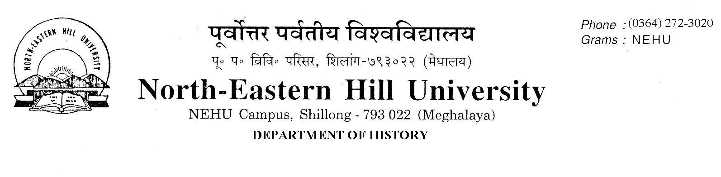Prof. V. Rengsi
Head
No.DH/23/Admn/2019-210 Dated 26.08.2019
Admission to M.A. Programme (2019-21)
The following candidates whose documents have been duly verified are selected for admission to the M.A. Programme (2019-21) in the Department of History. They are required to take admission by paying requisite fees online and deposit a photocopy of the receipt of fees paid in the Department of History office latest by 28th August 2019 up to 4 PM failing which they will forfeit their seats and their seats will be offered to the waitlisted candidates (being maintained in the Department) in order of merit.
NO FURTHER CLAIMS WILL BE ENTERTAINED THEREAFTER.
Classes will begin on the 29th of August 2019 at 10:30 A.M. All are required to attend.
Merit List
SL.NO | APPLICATION NO | NAME | CATEGORY | UNIVERSITY
 | 191111515 | MEBAAI MAYA WAHLANG | ST | NEHU
 | 191111916 | JOANA JAKRIM MARAK | ST | NEHU
 | 191111715 | IMKONGKUMZUK JAMIR | ST | NEHU
 | 191111595 | DARISHA LYNGDOH | ST | NEHU
 | 19110237 | BIJOY CHAKMA | ST | NEHU
 | 19111403 | MONDAYSTONE LYNGDOH | ST | NEHU
 | 19117619 | SUMI DAS | GEN | GU
 | 191111749 | KANGABAM MALANGBA SINGHA | GEN | NEHU
 | 191112899 | WONDERFUL SUCHIANG | ST | NEHU
 | 191110433 | TEMSURENLA KICHU | ST | NEHU
 | 191112248 | STEPHEN THANGGOULAL DOUNGEL | ST | NEHU
 | 191113575 | CHICHANBENI KHUVUNG | ST | NEHU
 | 191112498 | DUOVA DUO | ST | NEHU
 | 19115220 | EVANGEL NONGPHUD | ST | NEHU
 | 191111803 | SAKANIKA KHONGLAH | ST | NEHU
 | 191111943 | DEITINORA WARLARPIH | ST | NEHU
 | 191111982 | MINIMA D SANGMA | ST | NEHU
 | 19114932 | CHRISTINE BASUKLANG LAMARE | ST | NEHU
 | 19110512 | AJUNGLA IMTI | ST | NEHU
 | 191110439 | YAPI MAYING | ST | RGU
 | 191114058 | CHESIL ARENGH | ST | NEHU
 | 191111350 | SANSULI BASUMATARY | ST | GU
 | 191112092 | MLATOLI (Subject to production of S. T. Certificate in Original on or before 29th August 2019, failing which the seat will be forfeited) | ST | NEHU
 | 19113563 | THURSTIA ARENGH | ST | NEHU
 | 19110820 | BESLINDA MARWEIN | ST | NEHU
 | 191112009 | DEGE SORA | ST | NEHU
 | 19118657 | RUMI BARMAHALIA | ST | GU
 | 191112837 | ROZER DAVIS M SANGMA | ST | NEHU
 | 191113465 | NUWAKAMWAMUT SWER | ST | NEHU
 | 191111851 | CHONGNIU M | ST | NU
 | 19110413 | KEYIPUONA NDANG | ST | PATKAI
 | 191113359 | GRECY REANG | ST | NEHU
 | 19113956 | NGAIZASIAM | ST | NEHU
 | 19116075 | LALBIAK MAWII | ST | NEHU
 | 19116296 | LAPHIBANYLLA TRON | ST | NEHU
 | 19110565 | VESHELU SAPU | ST | NU
 | 191113108 | BIDYUT BASUMATARY | ST | GU
 | 19112154 | C LALREMTLUANGA(Subject to production of S. T. Certificate in Original on or before 29th August 2019, failing which the seat will be forfeited) | ST | NEHU
 | 19110750 | NOTANU LUHO | ST | NU
 | 19118160 | BAISHALI DEBNATH | GEN | DIB
 | 19113633 | M SANJEETA SINGHA | GEN | NEHU
 | 19117985 | HIMSHIKHA GOSWAMI | GEN | GU
 | 191113819 | SUPRIYA HADU | ST | NEHU
 | 191110789 | MADHUMITA SAHA | GEN | GU
 | 19119432 | VELLE WHISO | ST | NU
 | 191111664 | SHIMTILANG DHAR | ST | NEHU
 | 191112768 | SILKAME SANGMA | ST | NEHU
 | 19111590 | KENEIHOSALE KISO | ST | NU
 | 19110849 | AKHUMLA SANGTAM | ST | NU
 | 19114424 | REVAKORDOR MAWLONG | ST | NEHU
Differently abled
SL.NO | APPLICATION NO | NAME | CATEGORY | UNIVERSITY
1 | 191113871 | AITIMON KHARBANI | ST | NEHU

Economically Weaker Section
SL.NO | APPLICATION NO. | NAME | CATEGORY | UNIVERSITY
1 | 19113383 | SHANGLAKPAM SWEETA SHARMA | Gen | MU

Sd/-
V. Rengsi
Head

