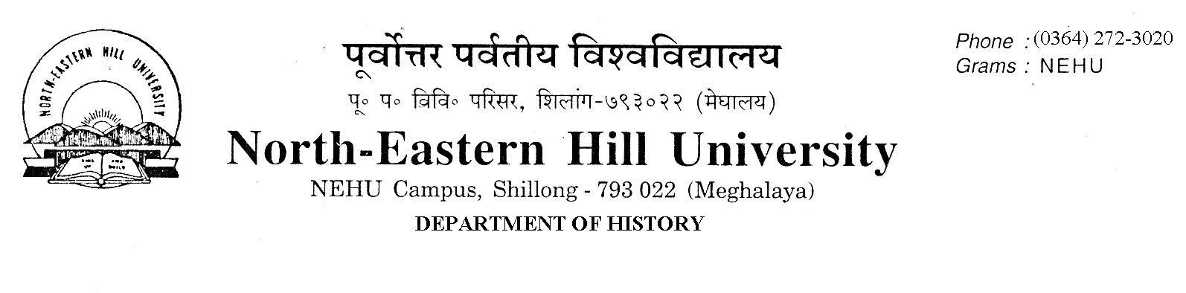
Prof. V. Rengsi
Head
No.DH/23/Admn/2019-238 Dated 05.09.2019
Admission to M.A. Programme (2019-21)
The following candidates (2nd List) whose documents have been duly verified are selected for admission to the M.A. Programme (2019-21) in the Department of History. They are required to take admission by paying requisite fees online and deposit a photocopy of the receipt of fees paid in the Department of History office latest by 11th September 2019 up to 4 PM failing which they will forfeit their seats and their seats will be offered to the waitlisted candidates (being maintained in the Department) in order of merit.
NO FURTHER CLAIMS WILL BE ENTERTAINED THEREAFTER.

 | 19118505 | SUNNIKA KHYLLAIT | ST | NEHU
 | 19114338 | TOINALI T ACHUMI | ST | NU
 | 19110629 | VATIKANI YEPTHO | ST | PATKAI

Sd/-
V. Rengsi
Head

