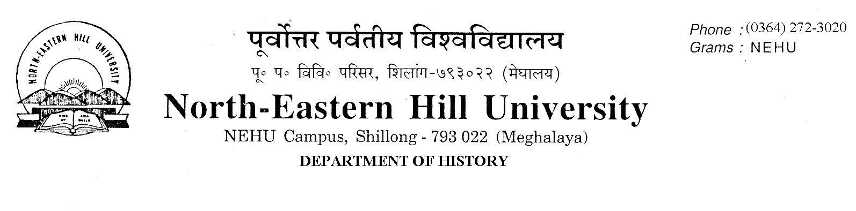
No.DH/13/NB/2019-20/ Dated 06 February, 2020

NOTICE

It is hereby notified that (1) Classes for 2nd/4th and M.Phil/Ph.D Course Work will commence from 17th February 2020.
(2) Deferred End Semester Examinations will be held on 13th and 14th February 2020 as under:-
Date & Time | Semesterr | Course No. | Name of paper
13.02.2020  10.00 A.M. to 1.00 P.M.  1.30 P.M. to 4.30 P.M. | 3rd  ^{1st} | HIS-C-302  HIS-C-303  HIS-C-304  HIS-C-108  HIS-C-109  HIS-C-112 | Religion and Society in Ancient India 1500 BC-AD 1200  Religion and Society in Medieval India  Indian Nationalism  Technology in the making of Early China  The Rise of Islam and the Early Caliphate AD.610-661  Social Movements in the United States of America
14.02.2020  10.30 A.M. to 1.30 P.M | 3rd | HIS-C-308  HIS-C-310 | Political Ideas and Institutions during the Sultanate period  History of Ideas in Modern India

Sd/-
V. Rengsi

