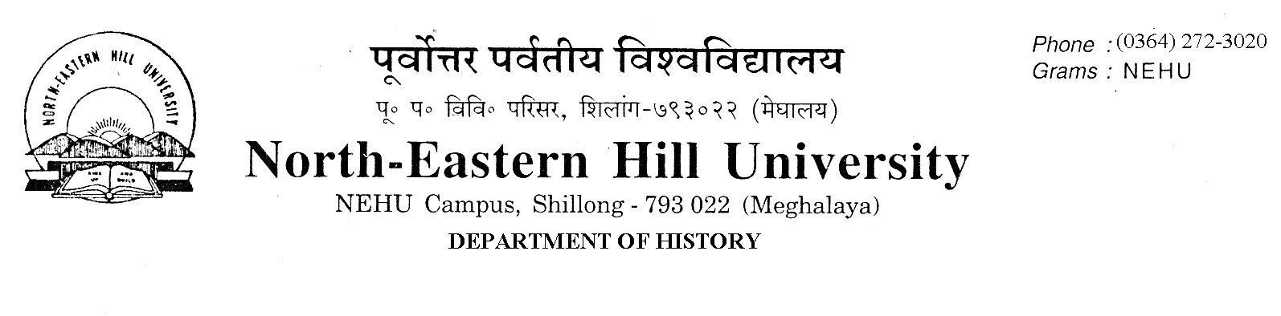Prof. V. Rengsi
Head

No.DH/23/Admn/2019-208 Dated 23.08.2019
Notice
The following candidates are hereby instructed to appear in person for verification of documents in original for admission to the M.A. Programme 2019-21 of the Department of History, NEHU, Shillong on 26th August 2019 from 11.00 A.M. to 2.30 P.M. in the Department, failing which they shall forfeit their claim to the seat. Candidates are advised to come prepared to take immediate admission if selected to the programme.
49 seats will be filled in by candidates shortlisted below on the basis of merit and verification of documents.

V. Rengsi
Head

SL.NO | APPLICATION NO | NAME | CATEGORY | UNIVERSITY
 | 191111515 | MEBAAI MAYA WAHLANG | ST | NEHU
 | 191111916 | JOANA JAKRIM MARAK | ST | NEHU
 | 191111715 | IMKONGKUMZUK JAMIR | ST | NEHU
 | 191111595 | DARISHA LYNGDOH | ST | NEHU
 | 19110237 | BIJOY CHAKMA | ST | NEHU
 | 19111403 | MONDAYSTONE LYNGDOH | ST | NEHU
 | 19117619 | SUMI DAS | GEN | GU
 | 191111742 | PERANGUMHEILE HERIE | ST | NEHU
 | 191111749 | KANGABAM MALANGBA SINGHA | GEN | NEHU
 | 191112899 | WONDERFUL SUCHIANG | ST | NEHU
 | 191110433 | TEMSURENLA KICHU | ST | NEHU
 | 19115124 | CAMILIA CHYNE | ST | NEHU
 | 191112248 | STEPHEN THANGGOULAL DOUNGEL | ST | NEHU
 | 191113575 | CHICHANBENI KHUVUNG | ST | NEHU
 | 191112498 | DUOVA DUO | ST | NEHU
 | 19115220 | EVANGEL NONGPHUD | ST | NEHU
 | 191111803 | SAKANIKA KHONGLAH | ST | NEHU
 | 191111943 | DEITINORA WARLARPIH | ST | NEHU
 | 191111982 | MINIMA D SANGMA | ST | NEHU
 | 19114932 | CHRISTINE BASUKLANG LAMARE | ST | NEHU
 | 19110512 | AJUNGLA IMTI | ST | NEHU
 | 191110439 | YAPI MAYING | ST | RGU
 | 191114058 | CHESIL ARENGH | ST | NEHU
 | 191111350 | SANSULI BASUMATARY | ST | GU
 | 191112092 | MLATOLI | ST | NEHU
 | 19113563 | THURSTIA ARENGH | ST | NEHU
 | 19110820 | BESLINDA MARWEIN | ST | NEHU
 | 191112009 | DEGE SORA | ST | NEHU
 | 19118657 | RUMI BARMAHALIA | ST | GU
 | 191112781 | NCHUMBEMO O EZUNG | ST | NEHU
 | 191110706 | PARISHMITA BHUYAN | GEN | GU
 | 191112837 | ROZER DAVIS M SANGMA | ST | NEHU
 | 191113465 | NUWAKAMWAMUT SWER | ST | NEHU
 | 191111851 | CHONGNIU M | ST | NU
 | 19110413 | KEYIPUONA NDANG | ST | PATKAI
 | 191113359 | GRECY REANG | ST | NEHU
 | 19113956 | NGAIZASIAM | ST | NEHU
 | 19118726 | GYAMAR TALANG | ST | NEHU
 | 19116075 | LALBIAK MAWII | ST | NEHU
 | 19116296 | LAPHIBANYLLA TRON | ST | NEHU
 | 19110565 | VESHELU SAPU | ST | NU
 | 191113108 | BIDYUT BASUMATARY | ST | GU
 | 191110598 | KOJ TATUNG | ST | RGU
 | 19112154 | C LALREMTLUANGA | ST | NEHU
 | 19110750 | NOTANU LUHO | ST | NU
 | 19118160 | BAISHALI DEBNATH | GEN | DIB
 | 19113633 | M SANJEETA SINGHA | GEN | NEHU
 | 19117985 | HIMSHIKHA GOSWAMI | GEN | GU
 | 191113819 | SUPRIYA HADU | ST | NEHU
 | 191110789 | MADHUMITA SAHA | GEN | GU
 | 19119432 | VELLE WHISO | ST | NU
 | 191111664 | SHIMTILANG DHAR | ST | NEHU
 | 191112768 | SILKAME SANGMA | ST | NEHU
 | 19111590 | KENEIHOSALE KISO | ST | NU
 | 19110849 | AKHUMLA SANGTAM | ST | NU
 | 19114424 | REVAKORDOR MAWLONG | ST | NEHU
 | 19118505 | SUNNIKA KHYLLAIT | ST | NEHU
 | 19114338 | TOINALI T ACHUMI | ST | NU
 | 19110629 | VATIKANI YEPTHO | ST | PATKAI
 | 191112628 | RIKORDOR KHARMUTI | ST | NEHU

Differently abled
SL.NO | APPLICATION NO | NAME | CATEGORY | UNIVERSITY
1 | 191113871 | AITIMON KHARBANI | ST | NEHU

Economically Weaker Section
SL.NO | APPLICATION NO. | NAME | CATEGORY | UNIVERSITY
1 | 19113383 | SHANGLAKPAM SWEETA SHARMA | Gen | MU
2 | 19112493 | CHANDAM ADHIKARY | Gen | GU

V. Rengsi
Head

