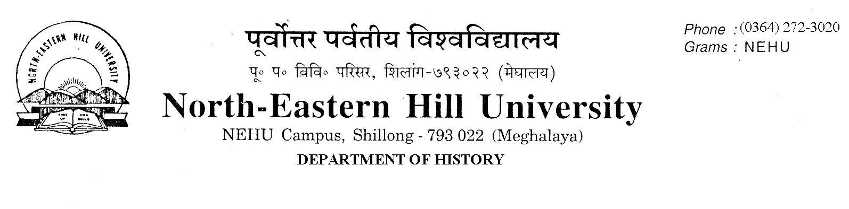
Prof. V. Rengsi
Head

No. DH/63/Ph.D./2018/ 433 Date: 08-02-2019

Admission Notice

The following candidates have been selected for admission to the Ph.D. and M. Phil. Programmes of study 2018 in the Department of History. For admission candidates are to pay the requisite fees and deposit the receipt of fees paid to the Department of History office latest by 20th February 2019 up to 4 PM failing which they will forfeit their seats.
NO FURTHER CLAIMS WILL BE ENTERTAINED THEREAFTER.
Classes will begin on the 25th of February 2019.
Employed candidates must produce ‘No Objection Certificate’ from their employers.

Sd/
V. Rengsi

Selected Candidates M. Phil. / Ph. D Admission
M. Phil.

Sl. No. | Name | Marks in Written Test 70% | Marks in Interview 30% | Weightage  NET/SLET  10%  Over and above | Total
 | Rajshree Pegu/7 | 54 | 20.14 | 00 | 74.14
 | L. Alice Mangzel/4 | 56 | 17.28 | 00 | 73.28
 | John Lalramhuna Hnamte/13 | 46 | 22.42 | 00 | 68.42
 | Nangtyngshain Hoojon/ 3 | 50 | 17.70 | 00 | 67.7

Ph.D.

Sl. No. | Name | Marks in Written Test 70% | Marks in Interview 30% | Weightage  M.Phil/ NET/SLET  10%  Over and above | Total
 | Visetonu Natso/22 | 62 | 22.57 | 10 | 94.57
 | Virjeet Ningthoujam/38 | 60 | 24.28 | 10 | 94.28
 | P Gracefulness Bonney/3 | 60 | 23 | 10 | 93
 | N. Rosa Kashena/24 | 60 | 20.28 | 10 | 90.28
 | T Khaikhogin Chongthu/1 | 54 | 22.28 | 10 | 86.28
 | Elimonhunlang Mary Jyrwa /23 | 60 | 21.14 | 00 | 81.14
 | Krishna Kumar Sharma/42 | 50 | 20.85 | 10 | 80.85
 | Kamei Kabinai/33 | 56 | 23.16 | 00 | 79.16
 | Adeno N Kithan/12 | 60 | 17.85 | 00 | 77.85
 | Kshyeera Sagara Rana/39 | 42 | 23 | 10 | 75
 | Langriangliu Lucy/8 | 44 | 20 | 10 | 74

Sd/
V. Rengsi

Copy to:
1. The Registrar, NEHU, Shillong.
2. The Finance Officer, NEHU, Shillong.
3. The Librarian, NEHU, Shillong.
4. The Dean Students’ Welfare, NEHU, Shillong.
5. Notice Board.

