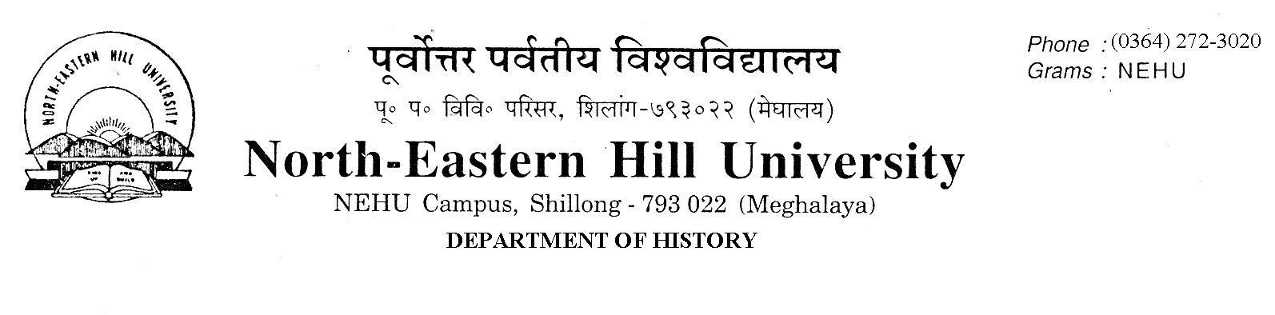Prof. V. Rengsi
Head

No.DH/63/Ph.D/2019/ 553 Date 28.11.2019.

List of Candidates called for Viva Voce
The following candidates who have successfully cleared the written test for M.Phil/ Ph.D Programme 2019 with 50% or more marks are hereby called for personal interview on 29/11/2019 at 11:00 A.M. They should report to the office of the Department of History by 10:30. A.M. with necessary documents in original.
Ph.D
Sl. No. | Form No. | Name | Sl. No | Form No. | Name
1. | 19140014 | LUNMINTHANG LHOUVUM | 14 | 19142009 | KIRTANA BARDALAI
2. | 19140110 | PANGKIME CH MOMIN | 15 | 19142033 | KHACHULO KEVEKHA ZEHOL
3. | 19140206 | RIPUNJAY NATH | 16 | 19142108 | MAITRAYEE RAI BARUAH
4. | 19140530 | DEEPAK KUMAR SHAHI | 17 | 19142372 | RIMA SARKAR
5. | 19140562 | VUNG LUN MAWI | 18 | 19142473 | SWEETTY QUEEN LYNGDOH MAWLONG
6. | 19140573 | SAURABH KUMAR SHANU | 19 | 19142598 | AMEBARI KHARKONGOR
7. | 19140786 | TENZING WANGDI COM | 20 | 19142726 | ROJA AHMED
8. | 19140960 | JASMINE KHARBTENG | 21 | 19142758 | ASWANI C
9. | 19141173 | ANKITA HATIBARUAH | 22. | 19142860 | SANSHI UPADHYA
10. | 19141536 | GUNJAN JYOTI DAS | 23. | 19142912 | SUNAINA GOGOI
11. | 19141691 | CHINGSHOM B KONYAK | 24. | 19143023 | TEMJENKALA JAMIR
12 | 19141708 | CHRISTINE ZENITH MYLLIEMNGAP | 25 | 19143044 | MEDOSANO MARY
13 | 19141942 | THANGLENMANG CHONGLOI

M.Phil
Sl. No. | Form No. | Name | Sl. No. | Form No. | Name
1. | 19130033 | DEEPAK KUMAR SHAHI | 5. | 19130143 | JONIO CHRISTOPHER L
2. | 19130049 | NILAM NEWAR | 6. | 19130159 | PRASANTA SARMA
3. | 19130078 | JOYASHREE BORAH | 7. | 19130205 | TS LAMKHOLIEN HAOKIP
4. | 19130117 | ANGHSUMALEE DUTTA

Sd/-
Vanlalruata Rengsi
Head of Department

