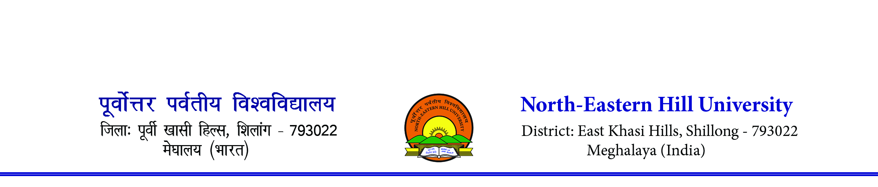Contact number- 0364-2721381/1383. Sports Department Emailnehusports@nehu.ac.in
F.No:3-3/SP/IC/2023 Dated: 10th July 2023

To,
The Director/Principal
All Affiliated College of the
North Eastern Hill University

Subject: Last Date of Entry for the NEHU Inter College Badminton (M & W) & Table Tennis (M & W) Tournament 2023

Sir/Madam,

The NEHU Inter College Badminton Men & Women and Table Tennis (Men & Women) Tournament will be organized from 18th to 20th July 2023.

Last Date of Entry-13th July 2023 till 4. pm.

This is for your kind information and necessary action.

Thanking you

Sd/-
N. Das
Asst. Director (Phyl. Ed. & Sports)

