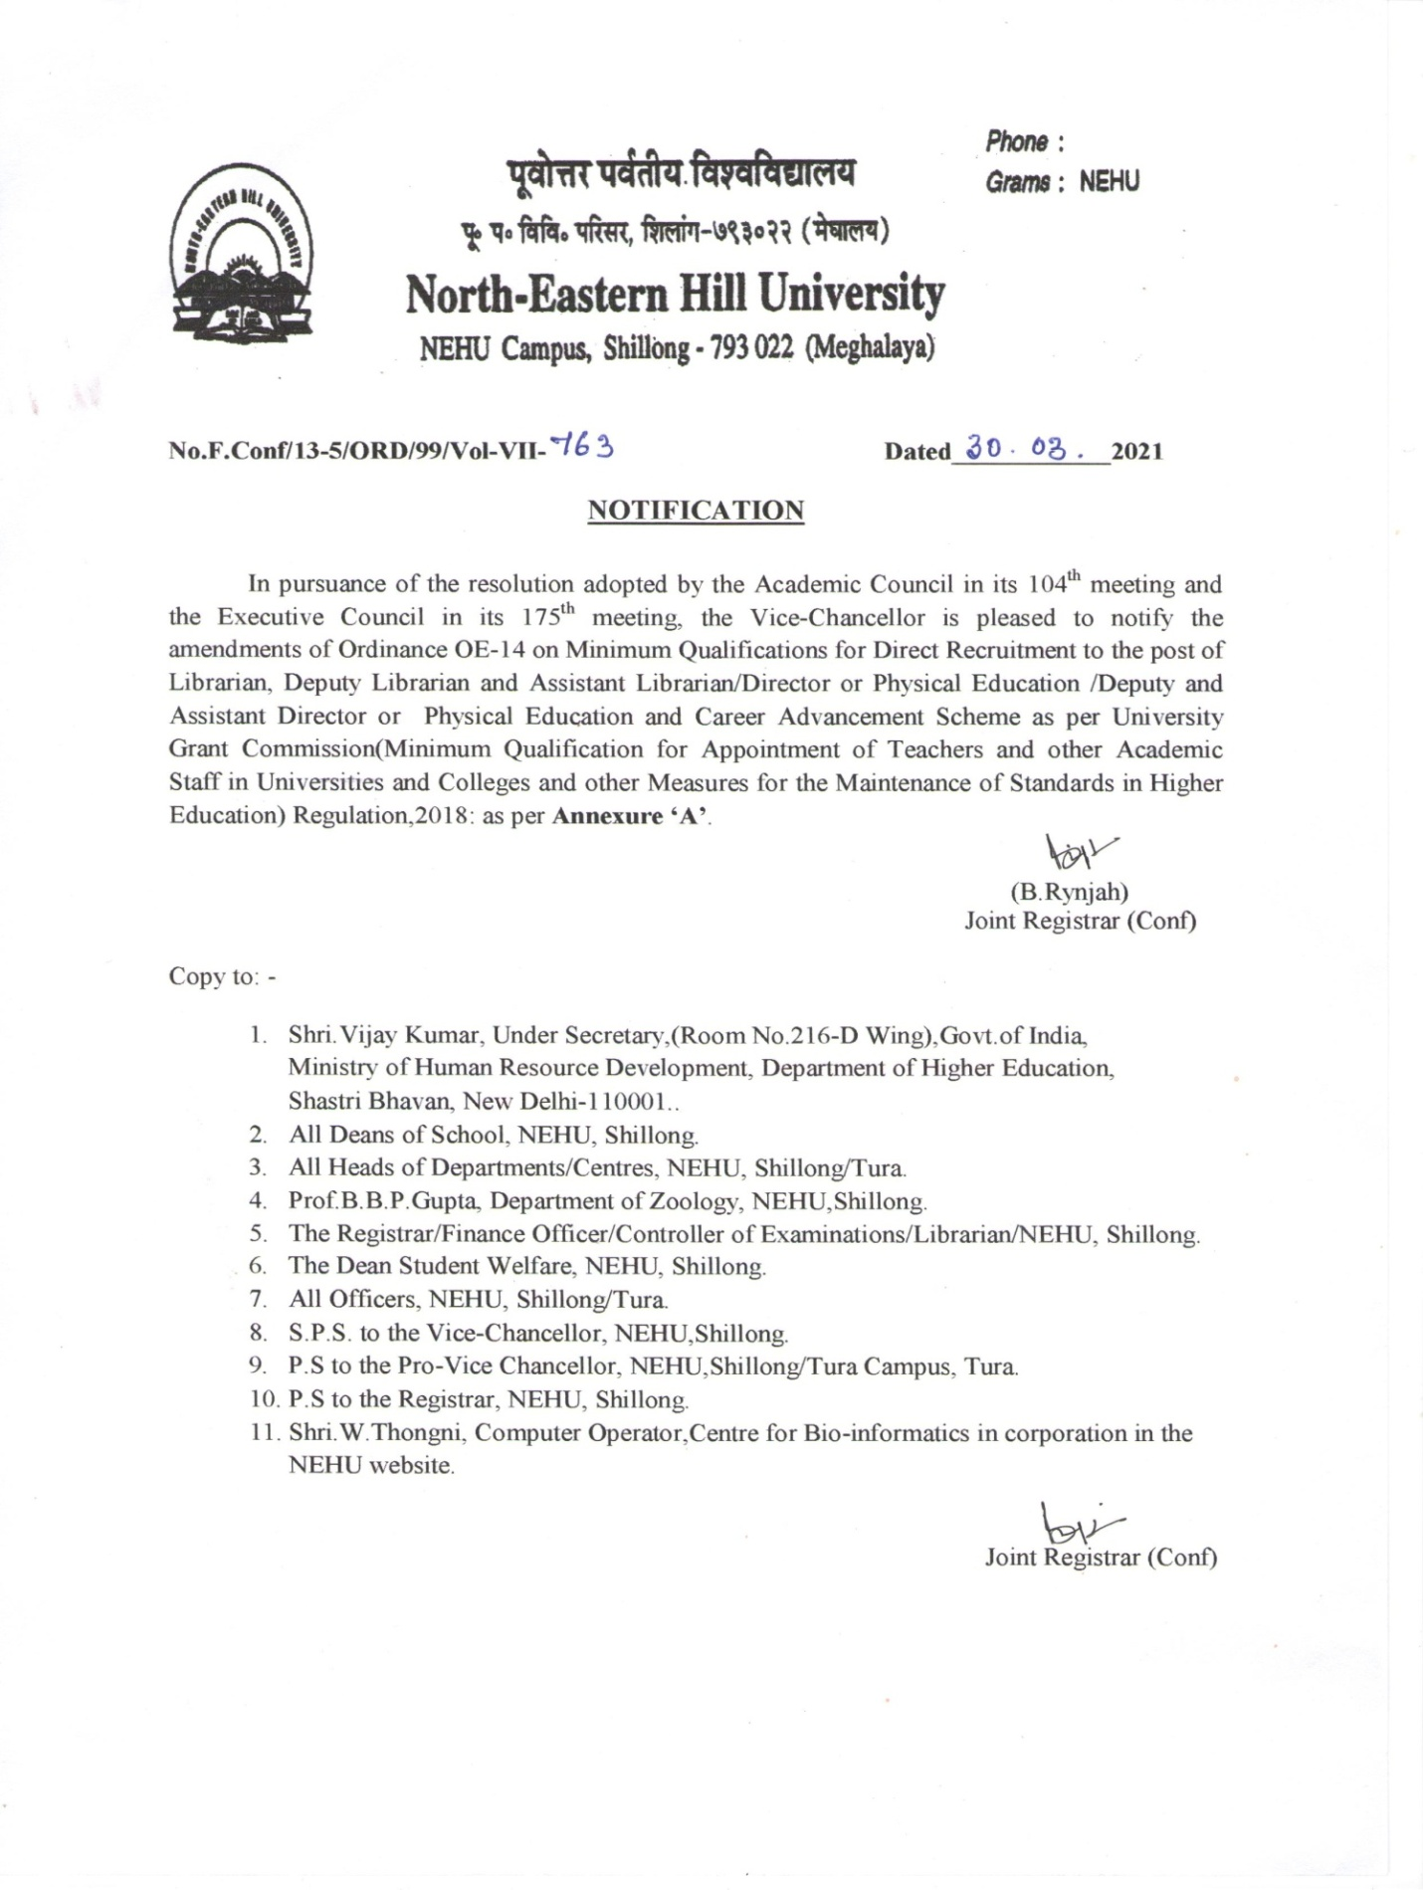

Annexure ‘A’
OE-14
ON MINIMUM QUALIFICATIONS FOR DIRECT RECRUITMENT TO THE POSTS
OF LIBRARIAN, DEPUTY LIBRARIAN AND ASSISTANT LIBRARIAN/DIRECTOR OF PHYSICAL EDUCATION/DEPUTY AND ASSISTANT DIRECTOR OF PHYSICAL EDUCATION AND CAREER ADVANCEMENT SCHEME
Under Section 26 (1) (n) of the NEHU Act, 1973

1. University Librarian
Minimum Qualification:
- A Master’s degree in Library Science/ Information Science / Documentation Science with at least 55% marks or an equivalent grade in a point-scale wherever the grading system is followed.
- At least ten years as a Librarian at any level in University Library or ten years of teaching as Assistant/ Associate Professor in Library Science or ten years’ experience as a College Librarian.
- Evidence of innovative Library services, including the integration of ICT in a library.
- A Ph.D. Degree in Library Science/ Information Science/ Documentation Science/Archives and manuscript-keeping.
2. University Deputy Librarian
Minimum Qualification:
- A Master’s degree in Library Science/ Information Science / Documentation Science, with at least 55% marks or an equivalent grade in a point-scale, wherever grading system is followed.
- Eight years experience as an Assistant University Librarian / College Librarian.
- Evidence of innovative Library Services including integration of ICT in library.
- A Ph.D Degree in Library Science/Information Science/ Documentation Science/Archives and manuscript keeping/computerization of library.
3. University Assistant Librarian / College Librarian / Documentation Officer
Minimum Qualification:
- A Master’s degree in Library Science/Information Science or Documentation Science or an equivalent professional degree, with at least 55% marks or an equivalent grade in a point-scale, wherever the grading system is followed.

- A consistently good academic record, with knowledge of computerization of a library.

- Besides fulfilling the above qualifications, the candidate must have cleared the National Eligibility Test (NET) conducted by the UGC, CSIR or similar test accredited by the UGC like SLET/SET or who are or have been awarded a Ph.D. Degree in accordance with the University Grants Commission (Minimum Standards and Procedure for Award of M.Phil./Ph.D. Degree) Regulations, 2009 or 2016 and their amendments from time to time as the case may be:

Provided that the, candidates registered for the Ph.D. degree prior to July 11, 2009 , shall be governed by the provisions of the then existing Ordinances /Bye-Laws/Regulations of the Institution awarding the degree, and such Ph.D. candidates shall be exempted from the requirement of NET/SLET/SET for recruitment and appointment of Assistant Professor or equivalent positions in Universities/Colleges/ Institutions subject to the fulfillment of the following conditions:-
- The Ph.D. degree of the candidate has been awarded in the regular mode;
- The Ph.D.thesis has been evaluated by at least two external examiners;
- Open Ph.D. viva voce of the candidate has been conducted;
- The candidate has published two research papers from his/her Ph.D. work out of which at least one is in a UGC-CARE listed journal;
- The candidate has presented at least two papers based on his/her Ph.D. work in conferences/seminars sponsored/ funded/ supported by the UGC/ICSSR/CSIR or any similar agency.
Note:
- The fulfillment of these conditions is to be certified by the Registrar or the Dean (Academic Affairs) of the University concerned.

- NET/SLET/SET shall also not be required for candidates in such Master’s Programmes for which NET/SLET/SET is not conducted by the UGC, CSIR or similar test accredited by the UGC like SLET/SET.
4. University Assistant Director of Physical Education and Sports/College
Director of Physical Education and Sports
Minimum Qualification:
Eligibility (A or B)
A.
- A Master’s degree in Physical Education and Sports or Physical Education or Sports Science with 55% marks (or an equivalent grade in a point-scale; wherever the grading system is followed).
- Record of having represented the university/college at the inter-university/inter-collegiate competitions or the State and/ or national championships.
- Besides fulfilling the above qualifications, the candidate must have cleared the National Eligibility Test (NET), conducted by the UGC or CSIR, or a similar test accredited by the UGC, like SLET/SET, or who are or have been awarded a Ph.D. Degree in Physical Education or Physical Education and Sports or Sports Science, in accordance with the University Grants Commission (Minimum Standards and Procedure for Award of M.Phil/Ph.D. Degree) Regulations, 2009 or 2016 and their amendments from time to time, as the case may be:
Provided that, candidates registered for the Ph.D degree prior to July 11, 2009, shall be governed by the provisions of the then existing Ordinances/ Bye-laws/Regulations of the Institutions awarding the degree and such Ph.D. degree holders shall be exempted from the requirement of NET/SLET/SET for

recruitment and appointment of Assistant Professors or equivalent positions in Universities/Colleges/ Institutions, subject to the fulfillment of the following conditions:-
- The Ph.D degree of the candidate has been awarded on regular mode.
- The Ph.D thesis has been evaluated by at least two external examiners.
- Open Ph.D viva voce of the candidate has been conducted.
- The candidate has published two research papers from his/her Ph.D work out of which at least one is in UGC-CARE listed journal;
- The candidate has presented at least two research papers in conference/seminar, based on his/her Ph.D.work
Note: The fulfillment of these conditions (a) to (e) is to be certified by the Registrar or the Dean (Academic Affairs) of the University concerned.
iv. NET/SLET/SET shall also not be required for such Masters Programmes in disciplines for which NET/SLET/SET is not conducted by the UGC, CSIR or similar test accredited by the UGC like SLET/SET.
v. Passed the physical fitness test conducted in accordance with these Regulations.

OR
B. An Asian game or Common Wealth games medal winner who has a degree at least at Post-Graduation level.
5. University Deputy Director of Physical Education and Sports.
Eligibility (A or B)
A.
i. A Ph.D in Physical Education or Physical Education and Sports or Sports Science. Candidates from outside the university system, in addition, shall also possess at least 55% marks (or an equivalent grade in a point scale wherever grading system is followed) at the Master’s Degree level by the university concerned.
ii. Eight years’ experience as University Assistant DPES/College DPES.
iii. Evidence of organizing competitions and conducting coaching camps of at least two weeks duration.
iv. Evidence of having produced good performance of teams/athletes for competitions like state/national/inter-university/combined university, etc.
v. Passed the physical fitness test in accordance with these Regulations.
OR
B. An Olympic games/ World Cup/ World Championship medal winner who has a degree at least at the Post-Graduation Level.
6. University Director of Physical Education and Sports.
Minimum Qualification:
- A Ph.D in Physical Education or Physical Education and Sports or Sports Science.

- Experience of at least ten years in Physical Education and Sports as University Assistant/ Deputy DPES or ten years as College DPES or teaching for ten years in Physical Education and Sports or Sports Science as Assistant/Associate Professor.

- Evidence of organising competitions and coaching camps of at least two weeks’ duration.

- Evidence of having produced good performance of teams/athletes for competitions like state/national/ inter-university/ combined university, etc
7. Career Advancement Scheme (CAS) for Librarians
I. From University Assistant Librarian (Academic Level 10)/College Librarian (Academic Level 10) to University Assistant Librarian (Senior Scale/Academic Level 11)/ College Librarian (Senior Scale/ Academic Level 11):
Eligibility:
An Assistant Librarian/ College Librarian who is in Academic Level 10 and has completed four years of service having a Ph.D degree in Library Science/ Information Science/ Documentation Science or an equivalent degree of five years’of experience, having at least a M.Phil. degree, or six years of service for those without a M.Phil. or a Ph.D. degree.
Provided that
- He/she has attended at least one Orientation course of 21 days’ duration;
And

- Training, Seminar or Workshop on automation and digitalisation, maintenance and related activities, of at least 5 days, as per Table I.

CAS Promotion Criteria :

An Assistant Librarian/ College Librarian may be promotes if:

  - He/she gets a ‘satisfactory’ or ‘good’ grade in the annual performance assessment reports of at least three/four/five out of the last four/five/six years of the assessment period as the case may be as specified in Table 1, and
  - The promotion is recommended by a Screening-cum-Evaluation Committee.
II. From University Assistant Librarian (Senior Scale/Academic Level 11)/College Librarian (Senior Scale/Academic Level 11) to University Assistant Librarian (Selection Grade/Academic Level 12/ College Librarian (Selection Grade/ Academic Level 12)
Eligibility:
- He/she has completed five years of service in that grade.

- He/she has done any two of the following in the last five years:
- Training/ Seminar/Workshop/Course on automation and digitalisation,
- Maintenance and other activities as per Table 1of at least two weeks (ten days) duration (or completed two courses of at least one week (five days)

duration in lieu of every single course/ programme of at least two weeks (ten days) duration)
- Taken/ developed one MOOCs course in the relevant subject (with e-certification), or
- Library up-gradation course.
CAS Promotion Criteria
An individual shall be promoted if:
- He/she gets a ‘satisfactory’ or ‘good’ grade in the annual performance assessment reports of at least four out of the last five years of the assessment period, as specified in Table 1, and;
- The promotion is recommended by a Screening-cum-Evaluation Committee.

III. From University Assistant Librarian (Selection Grade/Academic level 12)/College Librarian (Selection Grade/Academic level 12) to University Deputy Librarian (Academic Level 13A)/ College Librarian (Academic Level 13A)
Eligibility:
- He/she has completed three years of service in that grade.

- He/she has done any one of the following in the last three years:

- Training/Seminar/Workshop/ Course on automation and digitalization.
- Maintenance and related activities as per Table 1 of at least two weeks’ (ten days) duration.
- Completed two course of at least one week (five days) duration in lieu of every single course/programme of at least two weeks (ten days) duration),
- Taken/developed one MOOCs course in the relevant subject (with e-certification and
- Library up-gradation course.
CAS Promotion Criteria:
An individual shall be promoted if:
- He/she gets a ‘satisfactory’ or ‘good’ grade in the annual performance assessment reports of at least two out of the last three years of the assessment period, as specified in Table 1; and
- The promotion is recommended by a Selection Committee constituted as per these Regulations on the basis of the interview performance.
IV. From University Deputy Librarian/College Librarians (Academic Level 13A) to University Deputy Librarian/College Librarians (Academic Level 14) shall be the following:
Eligibility:
- He/she has completed three years of service in that grade.
- He/she has done any one of the following in the last three years;
- Training /Seminar/Workshop/Course on automation and digitalization.
- Maintenance and related activities as per Table 1 of at least two weeks’ (ten days) duration.

- Completed two courses of at least one week (five days) duration in lieu of every single course/programme of at least two weeks (ten days) duration).
- Taken/developed one MOOCs course in the relevant subject (with e-certification), and
- Library up-gradation course.
- Evidence of innovative Library Services, including the integration of ICT in a library.
- A Ph.D Degree in Library Science/Information Science/Documentation/Archives and Manuscript Keeping.
CAS Promotion Criteria:
An individual shall be promotes if:
- He/she gets a ‘satisfactory’ or’ good’ grade in the annual performance assessment reports of at least two out of the last three years of the assessment period, as specified in Table 1; and
- The promotion is recommended by a Selection Committee constituted as per these Regulations on the basis of the interview performance.

8. Career Advancement Scheme (CAS) for Directors of Physical Education and Sports.
I. From Assistant Director of Physical Education and Sports (Academic Level 10)/College Director of Physical Education and Sports (Academic Level 10) to Assistant Director of Physical Education and Sports (Senior scale/Academic level 11)/College Director of Physical Education and Sports (Senior Scale/Academic Level 11)
Eligibility:
- He/she has completed four years of service with a Ph.D. degree in Physical Education or Physical Education & Sports or Sports Science or five years of service with an M.Phil. degree or six years of service for those without an M.Phil. or Ph.D. degree.

- He/ she has attended one Orientation course of 21 days’ duration; and
iii He/ She has done one of the following:
- Completed Refresher/Research Methodology Course/ workshop,

- Training Teaching- Learning-Evaluation Technology Programme/ Faculty Development Programme of at least 5 days duration, and

- Taken/developed one MOOCs course (with e-certification)

CAS Promotion Criteria:
An individual may be promoted if:
- He/ She gets a ‘satisfactory’ or ‘good’ grade in the annual performance assessment reports of at least three/ four/ five of the last four/ five/ six years of the assessment period as the case may be, as specified in Table 2; and

- The promotion is recommended by a Screening-cum- Evaluation committee.

II. From Assistant Director of Physical Education and Sports (Senior Scale/ Academic Level 11) / College Director of Physical Education and Sports (Senior Scale/ Academic Level 11) to University Assistant Director of Physical Education and Sports (Selection Grade/ Academic Level 12)/ College Director of Physical Education and Sports (Selection Grade/ Academic Level 12)

Eligibility:
- He/ She has completed five years of service in that grade.

- He/ She has done any two of the following in the last five years:
- Completed one course/ programme from among the categories of refresher courses, research methodology workshops,
ii. Teaching-Learning-Evaluation Technology Programmes/ Faculty Development Programmes/ Faculty Development Programmes of at least two weeks (ten days) duration,
iii. Completed two courses of at least one week (five days) duration in lieu of every single course/ programme of at least two weeks (ten days) duration, and
iv. Taken/developed one MOOCs course in the relevant subject (with e-certification).

Criteria:
An individual may be promoted if:
- He/ she gets a ‘Satisfactory’ or ‘Good’ grade in the annual performance assessment reports of at least four out of the last five years’ of the assessment period as specified in Table 2, and

- The promotion is recommended by a Screening-cum-Evaluation Committee.

III. From University Assistant Director of Physical Education and Sports (Selection Grade/Academic Level 12)/ College Director of Physical Education and Sports (Selection Grade/Academic Level 12) to University Deputy Director of Physical Education and Sports (Academic Level 13 A)/ College Director of Physical Education and Sports (Academic Level 13 A)

Eligibility:
- He/ she has completed three years of service.
- He/ she has done any one of the following during last three years:
- Completed one course/programme from among the categories of Refresher Courses, Research Methodology Workshop,
- Teaching-Learning Evaluation Technology programmes/ Faculty Development Programmes of at least two weeks (ten days) duration (or completed two courses of at least one week (five days) duration in lieu of every single course/programme of at least two weeks (ten days) duration),
- Taken/developed one MOOCs course in relevant subject(with e-certification).

CAS Promotion Criteria:

An individual may be promoted if:
- He/ she gets a ‘satisfactory’ or ‘good’ grade performance assessment reports of at least two out of the last three years of the assessment period as specified in Table 2, and
- The promotion is recommended by a selection committee constituted as per these Regulations on the basis of the interview performance.
IV. From University Deputy Director Physical Education and Sports/ College Director Physical Education and Sports (Academic Level 13A) to University Deputy Director Physical Education and Sports/ College Director Physical Education and Sports (Academic Level 14)
Eligibility:
- He/ she has completed three years of service.
- He/ she has done any one of the following during last three years:
- Completed one course/ programme from among the categories of Refresher Courses, Research Methodology Workshop,

- Teaching-Learning-Evaluation Technology Programmes/ Faculty Development Programmes of at least two weeks (ten days) duration (or completed two courses of at least one week (five days) duration in
lieu of every single course/programme of at least two weeks (ten days) duration

- Taken/developed one MOOCs course in relevant subject (with e-certification).
- Evidence of organising competitions and coaching camps of at least two weeks duration.
- Evidence of having produced good performance of teams/athletes for competitions like state/national/inter-University/combined University, etc.
- A Ph.D. in Physical Education or Physical Education and Sports or Sports Science.

Criteria:
An individual may be promoted if:
- He/ she gets a ‘satisfactory’ or ‘good’ grade performance assessment reports of at least two out of the last three years of the assessment period as specified in Table 2, and
- The promotion is recommended by a selection committee constituted as per these Regulations on the basis of the interview performance.

Note: Discretionary award of advance increments for those who enter the profession as Associate Professor or Professor with higher merit, high number of research publications of high quality and experience at the appropriate level, shall be within the competence of the appropriate authority of the University concerned or recruiting institution based on the recommendations of a selection committee while considering the case of individual candidates in the context of the merits of

each case, taking into account the pay structure of other teachers in the faculty and other merit-specific factors. Discretionary award of advance increments is not applicable to those entering the profession as Assistant Professor/ Assistant Librarian/Assistant Director of Physical Education and Sports and to those who are entitled for grant of advance increments for having acquired a Ph.D., M.Phil. or M. Tech. And LLM degree. However, those entering the service as Assistant Professor/Assistant Librarian/Assistant Director of Physical education and Sports, having a post-doctoral teaching/research experience, after obtaining a Ph.D. degree and proven credentials, may be eligible for discretionary award of advanced increments to be given to the person, as decided and recorded by the Selection Committee in the minutes of its meeting.

TABLE 1
Assessment Criteria and Methodology for Librarian
S.No. | Activity | Grading Criteria
1. | Regularity of attending library (calculated in terms of percentage of days attended to the total number of days he/she is expected to attend) While attending in the library, the individual is expected to undertake, inter alia, following items of work.  - Library Resource and Organisation and maintenance of books, journals and reports.  - Provision of Library reader services such as literature retrieval services to researchers and analysis of report.  - Assistance towards updating institutional website. | 90% and above- Good  Below 90% but 80% and Above- Satisfactory  Less than 80%- Not Satisfactory
2. | Conduct of seminars/workshops related to library activity or on specific books or genre of books. | Good- 1 National level seminar/ workshop + 1 State/ institution level workshop/Seminar.  Satisfactory- 1 National level seminar/workshop or 1 State level seminar/ workshop + 1 Institution level seminar/workshop or 4 institution seminar/ workshop.  Unsatisfactory- Not falling in above two categories.
3. | If library has a computerized database then  OR  If library does not have a computerized database. | Good- 100% of physical books and journals in computerized database.  Satisfactory- At least 99% of physical books and journals in computerized database.  Unsatisfactory- Not falling under good or satisfactory.  OR  Good- 100% Catalogue database made up to date  Satisfactory- 90% catalogue database made up to date.  Unsatisfactory- Catalogue database not up to mark.  ( To be verified in random by the CAS Promotion Committee)

4. | Checking inventory and extent of missing books. | Good- Checked inventory and missing book less than 0.5%.  Satisfactory- Checked inventory and missing book less than 1%.  Unsatisfactory- Did not check inventory.  OR  Checked inventory and missing books 1% or more.
5. | (i) Digitisation of books database in institution having no computerized database.  (ii) Promotion of Library network.  (iii) Systems in place for dissemination of information relating to books and other resources.  (iv) Assistance in college administration and governance related work including work done during admissions, examinations and extracurricular activities.  (v) Design and offer short-term courses for users.  (vi) Publications of at least one research paper in UGC approved journals. | Good: Involved in any two activities.  Satisfactory; At least one activity.  Not Satisfactory: not involved/undertaken any of the activities.

Overall Grading | Good: Good in item 1 and satisfactory/good in any two other items including Item 4.  Satisfactory: Satisfactory in Item 1 and satisfactory /good in any other two items including Item 4.  Not Satisfactory: If neither good nor satisfactory in overall grading.
Note:
- It is recommended to use ICT technology to monitor the attendance of library staff and compute the criteria of assessment.
- The Librarian must submit evidence of published paper, participation certificate for refresher or methodology course, successful research guidance from Head of Department of the concerned department, project completion.
- The system of tracking user grievances and the extent of grievances redressal details may also be made available to the CAS promotion committee.

TABLE 2
Assessment Criteria and Methodology for Directors of Physical Education and Sports
S. No. | Activity | Grading Criteria
1. | Attendance calculated in terms of percentage of days attended to the total number of days he is expected to attend. | 90 and above- Good  Above 80 but below 90- Satisfactory  Less than 80- Not Satisfactory
2. | Organizing intra college competition. | Good- Intra College competition in more than 5 disciplines.  Satisfactory- intra college competition in 3-5 disciplines.  Unsatisfactory- Neither good nor satisfactory.
3. | Institution participating in external Competitions. | Good- National level competition in at least one discipline plus State/District level competition in at least 3 disciplines.  Satisfactory- State level competition in at least one discipline plus district level competition in at least 3disciplines Or District level competition in at least 5 disciplines.
4. | Up-gradation of sports and physical training infrastructure with scientific and technological inputs.  Development and maintenance of playfields and sports and physical Education facilities. | Good/Satisfactory/Not Satisfactory to be assessed by the promotion committee.
5. | (i) At least one student of the institution participating in national/state/university (for college levels only) teams. Organizing state/national/inter university/ inter college level competition.  (ii) Being invited for coaching at state/national level.  (iii) Organizing at least three workshops in a year.  (iv) Publications of at least one research paper in UGC approved journal Assistance in college administration and governance related work including work done during admissions, examinations and extracurricular college activities. | Good: Involved in any two activities.  Satisfactory: 1 activity.  Not Satisfactory: Not involved/undertaken any of the activities.
Overall Grading | Good: Good in item 1 and satisfactory/good in any two other items.  Satisfactory: Satisfactory in Item 1 and satisfactory /good in any other two items.  Not Satisfactory: If neither good nor satisfactory in overall grading.
Note:
- It is recommended to use ICT technology to monitor the attendance of sports and physical education and compute the criteria of assessment.
- The Institution must obtain student feedback. The feedback must be shared with the concerned Director of Physical and Education and Sports and also the CAS Promotion committee.
- The system of tracking user grievances and the extent of grievance redressal details may also be made available to the CAS Promotion committee.

