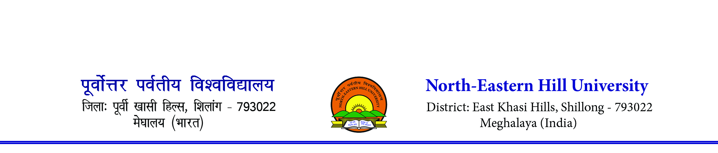
Sports Department
Contact number- 0364-2721381/1383. Email –nehusports@nehu.ac.in
-------------------------------------------------------------------------------------------------------------------------------
F. No. 3-3/SP/IC/2023-058 Dated – 21st July 2023
To,
The Dean/Director/Principal
All Affiliated Colleges to the North-Eastern Hill University

Subject: - NEHU Inter College Football (Men) Tournament 2023
Sir/Madam,
The Sports Department of the North-Eastern Hill University will be organizing the NEHU Inter College Football (Men) Tournament. Interested colleges may send your entries on or before the last date of entry.
Participating colleges needs to produce payment receipt of Mandatory Annual Sports Affiliation Fee paid to the North-Eastern Hill University. Those participating colleges who have not paid, they may pay the same at the venue before starting of their 1st Match.

There will be an entry fee of Rs. 1,000/- for participation in the Football Tournament. Entry fee will be collected at the Venue with receipts.
Sl. No. | Name of the Tournament | Last date of Entry | Date of Commencement | Venue | Max. Players
01 | Inter College Football (Men) Tournament 2023 | 14/08/2023 | 21/08/2023 | Shillong | Men-18 players
Any entries received after the last date of entry will not be entertained.
Colleges may send entries through email nehusports@nehu.ac.in; email sent on any other email will not be entertained.

Thanking you
Sd/-
(N. Das)
Asst. Director (PE & Sports)

