REPORTS ON THE PMMMNMTT PROGRAMMES COMPLETED DURING JULY to DECEMEBER, 2019

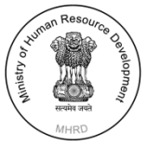 | CENTRE FOR PRE-SERVICE TEACHER EDUCATION  SCHOOL OF EDUCATION  NORTH-EASTERN HILL UNIVERSITY: SHILLONG | 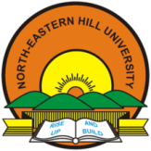

COMPLETED PROGRAMME SCHEDULE OF PMMMNMTT
CENTRE OF PRE-SERVICE EDUCATION
SCHOOL OF EDUCATION
Sl no. | Particulars | Period | Beneficiaries
1 | Two- Day Workshop on Professional Component of the Course (Prof C.Nongbri) | July 2-3, 2019 | 50 (Kiang Nangbah Guest House, NEHU)
2. | MOOC Swayam and OER for Teacher Education (Dr Amareshwaran) | August 21, 2019 | 120 (CTE PGT Shillong)
3 | One- Day Workshop for finalisation of the Professional Component of the Course  (Prof C.Nongbri & Prof S.M. Sungoh) | Aug 23, 2019 | 50 (Kiang Nangbah Guest House, NEHU)
4 | Pre-service Teachers’ Workshop on Curriculum Planning and Reforms (Dr Rihun Rymbai) | August 27 & 30, 2019 | 49 ( NEHU Shillong)
5 | MOOC Swayam and OER for Teacher Education (Dr Amareshwaran) | August 30, 2019 | ( CTE Tura) 120
6 | Workshop on Preparation of training Module for Pre-Service Teacher Education ( Dr Vandana and Dr. Euodia B. Myrthong ) | September 3-4, 2019 | 17 (NEHU Shillong)
7 | MOOC Swayam and OER for Teacher Education (Dr Amareshwaran) | September 6, 2019 | 120 ( CTE SMS)
8 | Two Day National Workshop on Quality Assurance : Constructivist Pedagogy for Pre Service Student Teachers (Prof I. Syiem, Dr Ashok Kumar, Prof S.M. Sungoh) | September 11-12, 2019 | 119 ( CTE SMS, Shillong)
9 | One- Day Workshop for Preparation of the Syllabus General Component of B.A.B.Ed/ B.Sc .B.Ed (Prof C.Nongbri & Prof S.M. Sungoh) | September 12, 2019 | 145(Cluster of Classrooms other than Science)
10 | Invited lecture on Periodic Student Teacher Assessment (Prof I. Syiem, Dr Ashok Kumar, Prof S.M. Sungoh) | September 13, 2019 | 89 (NEHU Shillong)
11 | MOOC Swayam and OER for Teacher Education (Dr Amareshwaran) | September 16, 2019 | 172 ( CTE DonBosco Tura)
12 | Invited lecture Accountability System  (Prof. B.B Kharbyrymbai) | September 20th & 23rd , 2019 | 90 (DIET-Nongpoh.)
13 | Workshop on Preparation of the 4 years Integrated course syllabus (Prof C. Nongbri and Prof S.M. Sungoh). | September 24, 2019 | 132 (NEHU Shillong)
14 | First national Workshop on Applications of SPSS in ICT integrated educational research, NEHU, Shillong (Dr. N. Amareshwaran) | October 29-30, 2019 | 25 (NEHU , Shillong)
15 | Workshop on Innovative Methods of Teaching  (Prof Brinda Kharbyrymbai) | October 31to November 1st , 2019 | 120 ( CTE SMS, Shillong)
16 | Two-Day Workshop for finalisation of the General and Professional Components of B.A.B.Ed/ B.Sc .B.Ed Syllabus (Prof C.Nongbri & Prof S.M. Sungoh) | November 5-6,  2019 | 220 (Multi-Use Convention Hall)
17 | Invited lecture on Constructivist Approach to Teaching (Prof I. Syiem, & Dr Ashok Kumar, Prof) | November 6, 2019 | 50 ( NEHU Shillong)
18 | Research Methodology in Education through FLIP Learning Approach (Dr Amareshwaran) | November 11, 2019 | 51 ( Savitribi Phule Pune University: Pune)
19 | Orientation Programme on Research Methodology (Dr Vandana) | November 13-14, 2019 | 25 ( NEHU Shillong)
20 | National Workshop on Integration Of Theory and Practice of Education through ICT (Dr Amareshwaran) | November 19, 2019 | 120 ( DIET Tura)
21 | National Workshop on Integration Of Theory and Practice of Education through ICT (Dr Amareshwaran) | November 19, 2019 | 149 ( NEHU Tura)
22 | Second National Workshop on Application of SPSS in ICT Integrated Educational Research (Dr Amareshwaran) | November 21-22 , 2019 | 25 ( NEHU Shillong)
23 | Invited Lecture on Knowledge Level, Understanding Level and Reflective Level of Teaching (Prof I. Syiem, Dr Ashok Kumar, Prof S.M. Sungoh) | December 4,2019 | 50 DIET ( RiBhoi Meghalaya)
24 | Workshop on Journal Writing and Publications (Dr Euodia and Dr Vandana) | December 5-6, 2019 | 37 (NEHU)

Report of the Workshops for Preparation of Four years Integrated B.Ed Syllabus
(Refer to sl no.1, 3, 9, 13 & 16)
(Prof C.Nongbri & Prof S.M. Sungoh)
Combined:
Phase I: Two- Day Workshop on Professional Component of the Course
July 2-3, 2019 (50 Participants)
Phase II: One- Day Workshop for finalization of the Professional Component of the Course
Aug 23, 2019 (50 Participants)
Phase III: One- Day Workshop for Preparation of the Syllabus General Component of B.A.B.Ed/ B.Sc .B.Ed. September 12, 2019 (145 Participants).
Phase IV: Two-Day Workshop for finalisation of the General and Professional Components of B.A.B.Ed/ B.Sc .B.Ed Syllabus; November 5-6, 2019 (220 Participants ).

Summary of Reports for the 4 Phases

The National Council of Teacher Education (NCTE), New Delhi has announced the NCTE (Recognition, norms and procedure) Amendment Regulations 2019 vide the Gazette Notification No. F. NCTE Reg.1011/80/2018 -MS (Regulation)-HQ Dated 29th March 2019.

According to this Regulations the Four Year Integrated Teacher Education programme (ITEP) Arts Stream and Science Stream is offered after Senior Secondary (+2) and aims at preparing committed, responsible and professional teachers. This programme is intended to result in a paradigm shift in teacher preparation. The curriculum of this Four Year Integrated Teacher Education programme is designed inculcating the world best practices in the field of teacher education sector. This is a specialized course with integration of pedagogy and content, along with the sustained engagement with liberal disciplines of knowledge and field of education. Opportunity for vertical mobility is visualized through this programme.

This programme integrates general studies comprising mathematics and science, social science and Humanities and also professional studies comprising perspective in education, Other core education courses, Curriculum and pedagogy of school subject and practicum related to the tasks and function of school teacher.

It maintains a balance between theory and practice and ensures coherence and integration among the various components of the programme. It is expected to equip the aspirant school teacher with requisite attitude, skills and knowledge to address the challenges of becoming an effective school teacher.

The integrated teacher education Program (ITEP) shall be located in multi and inner interdisciplinary academic environment which means a duty recognised higher education institution offering under graduates or post graduate programmes of study in the field of liberal arts and humanities or social sciences or commerce or mathematics as the case may be.

The National Council of Teacher Education (NCTE), New Delhi has invited application from existing recognised colleges for starting the Four Years Integrated Teacher Education Programme vide public notice F. NCTE Reg/011/326/2017-US(Reg) -HQ Dated 20th May 2019. The Kiang Nangbah Government College, Jowai has already been registered to apply for the said courses.

In this connection, it may be mentioned that the said courses is not in existence in our University so it is the duty of the University as the Affiliating Body to prepare the Syllabus for the said Teacher Education Programme.

The Department of Education, NEHU, Shillong has taken this responsibility and one of the programmes under the Proposed Programme Schedule of PMMMNMTT Centre of Pre-Service Education, School of Education, NEHU Shillong is Preparation of the Syllabus for Four Year B.Ed Integrated Course. A Plan of Action for the same is proposed tentatively as below:

As mentioned above, this programme integrates the general studies comprising mathematics and science, social science and Humanities and also professional studies comprising perspective in education, Other core education courses, Curriculum and pedagogy of school subject and practicum related to the tasks and function of school teacher. So the programmes were planned as below:
Sl.No | Particulars | Period | Participants | No. Attended | Venue | Tentative Dates
1. | Two- Day Workshop on Professional Component of the Course | 2 days | Principals and Faculty members, CTEs | 36 | Kiang Nangbah Guest House | July 2-3, 2019
2. | One- Day Workshop for finalisation of the Professional Component of the Course | 1 day | Principals and Faculty members, CTEs | 26 | Kiang Nangbah Guest House | Aug 23, 2019
 | One- Day Workshop for Preparation of the Syllabus General Component of B.A.B.Ed/ B.Sc .B.Ed | 1 day | Heads, Department from the General Colleges | 145 | Cluster of Classrooms other than Science | September 12, 2019
3. | Two-Day Workshop for finalisation of the General and Professional Components of B.A.B.Ed/ B.Sc .B.Ed Syllabus | 2 days | Faculty members CTEs and General Colleges | 148 | Multi –Use Convention Hall | November  5-6,  2019
4. | Proposed Two-Day Workshop for Integration of the General and Professional Components of BA.B.Ed and BSc.BEd Syllabus | 2 days | Principals and Faculty members, CTEs | 50 | Multi –Use Convention Hall | February 2020

The Two- Day Workshop for Preparation of Four years Integrated B.Ed Syllabus was held in NEHU Old Guest House on July 2-3, 2019 was attended by the Head Department, Education, Tura Campus, Five Principals of CTEs and the faculty members from all the Six CTEs in Meghalaya and the Faculty members, Department of Education, NEHU Shillong. The then Dean, School of Education & Convener of the PMMMNMTT Project, Prof S.M. Sungoh as the Chairperson of the Two- day Workshop welcomed all the members present and thanked them for responding to the call by the Department. She requested the then Head of Department, Education NEHU, Shillong& Coordinator of the Programme, Prof C. Nongbri to brief the purpose of the Workshop.
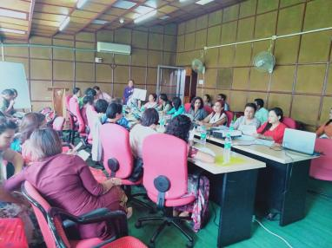 | 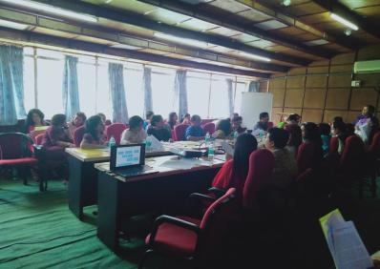

Prof C. Nongbri proposed a formal welcome address and briefed the House about the purpose of the workshop. She also reminded the members on the emphasis stressed in the Draft National Education Policy, 2019 about the intention of the Government to start the Four Year Integrated Course in the composite Institutions. She also reported that this initiative was taken since the Government of Meghalaya has decided to start the Four year integrated Course in Kiang Nangbah College, Jowai, in the academic session 2020-2021. She explained the NCTE Curriculum Model is not available yet and the University as the Affiliating body has to make the syllabus available to the Teacher education Institutions. The RIE Bhubaneswar Four Year Integrated B.Ed Course is taken as a model for preparing the Syllabus as it includes the Degree Syllabus as per the University Grants Commission’s Choice Based Credit System Guidelines and also the NCF 2005 and NCFTE 2009 as per the NCTE norms. She placed before the House the Structure for RIE, Bhubaneswar Integrated BA/Bed Programme which comprised of the General and Professional components.

The Chairperson briefed the members about the NCTE (Recognition, Norms and Procedure) Amendment Regulations, 2019 and sought the suggestions of the members on the matters as they are all in the field. The Principal, CTE (PGT) expressed her concern on the uncertainty of the Two Year B. Ed Programme on the intention of the government to start the Four years Integrated B. Ed Programme and to phase out the Two Year B.ED programme. The concern was discussed at length but the members felt that this is the policy that was outlined by the Government and nothing is known what will happen next. After a long deliberation, it was emphasised that there is a need to impress upon the Government the importance of creating a conducive environment where Man power and infrastructural requirement be facilitated.

The morning session was devoted to the discussion of the Structure of the Four years Integrated B.Ed Syllabus taking the model of the RIE Bhubaneswar. After a long deliberation, the members unanimously agreed on the Structure of the Four years Integrated BA/B.Ed.

The Post Lunch Session of the first day and the whole day of the second day was devoted to Syllabus of the Structure of BA,B.Ed Programme (Professional Education Component). The work was done as a group looking at the RIE Bhubaneswar Syllabus and also taking the NEHU Two-Year B. Ed Programme into consideration.

At the end of the day, a review of the progress was done and only Perspective of Education of the Structure of BA/B.Ed Programme- (Professional Education Component) was completed. Curriculum and Pedagogic Studies (CPS), Enhancing Professional Capacities (EPC) and Field Engagement are yet to be taken up.

The Second workshop was held on August 23, 2019. It was well attended by the Principals and Faculty members of the Six CTEs. After the warm welcome from the Chair who is the convener of PMMMNMTT, the members started the work together and prepared a draft framework of syllabus taking the RIE Bhubaneswar model and the NEHU Two-Year Syllabus on the Curriculum and Pedagogic Studies (CPS), Enhancing Professional Capacities (EPC) and Field Engagement. It was further resolved that the CTEs will bring their suggested framework to be discussed in the next Workshop to be held later.
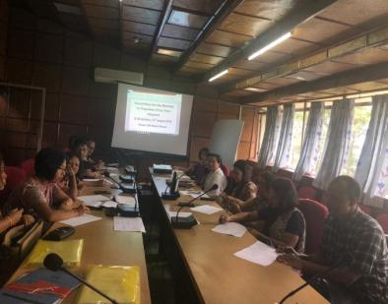 | 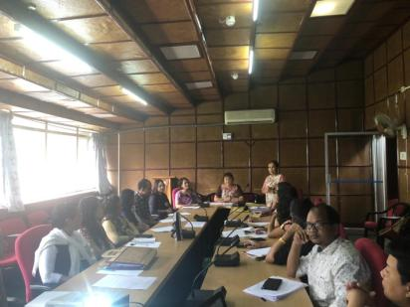

Regarding the General Studies for both B.A.B.Ed and B.Sc. B.Ed this workshop is being organised with the help of the expertise of the Faculty members from the General Colleges.

One Day Workshop for Preparation of Four Year Integrated B.A.B.ED/B.SC.B.ED Syllabus was held on September 24, 2019. The Programme started with the brief inaugural programme and warm welcome to all the participants. The Pro-Vice Chancellor was the Chief Guest of the Function who lauded the initiative taken by the Education Department, NEHU, Shillong for undertaking this very important exercise. He noted with appreciation the overwhelming response of the Faculty members from the general Colleges and expressed his confidence in the wisdom of the group for finalization of the Syllabus.
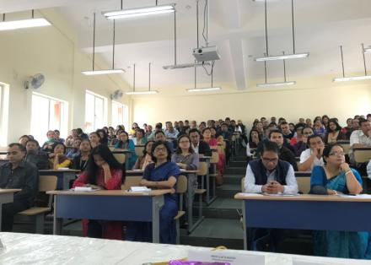 | 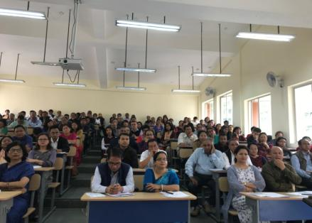

During the one day programme, the Faculty Members brainstormed on the Programme Structure, Provision of Honours/ Core Course (CC) and Generic Elective, the UGC minimum course curriculum for undergraduate courses under choice based credit system and related issues. There were questions and answer session where the members raised the concerns of the feasibility of running the programme in the composite institutions with no trained faculties and basic infrastructure. The Post lunch session was devoted to group work where the participants were divided in groups on different subject areas. The group resolved that they will work on it and will bring the inputs in the Two- Day Workshop which will be held on November 5-6, 2019.

The Two- Day workshop for finalisation of the Syllabus for both the General and Professional Studies was held on November 5-6, 2019. The Pro-Vice Chancellor was the Chief Guest of the Function. He was very impressed with the responsibilities taken by the participants and appreciated the arrangement of the programme where the Faculty members already took position for the group work.
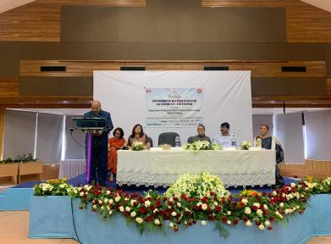 | 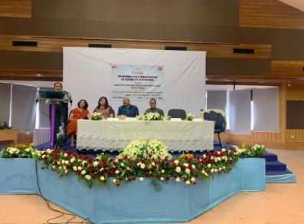

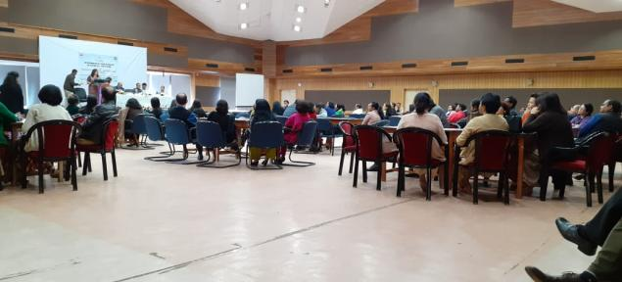

After a warm welcome from the Coordinator of the programme, the Faculty members were divided in groups for finalisation of the Syllabus. The second day started with the presentations of the works of the Groups of the Syllabus of both Professional and General Studies.

The discussion from the Two-Day Workshop resulted in the Finalisation of the General and Professional Studies of Four Year Integrated Syllabus for BA.B.Ed and BSc.BEd.

The Resource Persons for the Programme were Prof Elizabeth Hangsing, Department of Education, Rajiv Gandhi University and Dr Nil Ratan Roy, Department of Education, Tezpur University. They were involved only for the last two Workshops i.e. the One Day workshop on 24th September, 2019 and the Two-Day Workshop on November 5-6, 2019.
The forth coming Two Day Workshop is proposed to be held in the months of February 2020 for integration of the General and Professional Studies and finalization of the Four Year Integrated Syllabus for BA.B.Ed and BSc.BEd.

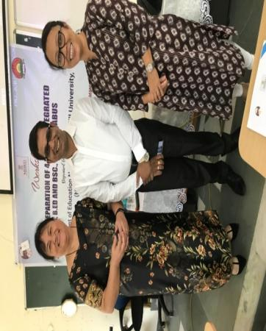

Prof. S. M. Sungoh Prof C. Nongbri
Convener, PMMMNMTT, Co-ordinator
Department of Education, Department of Education,
NEHU, Shillong NEHU, Shillong

Report of the One-Day National Workshop on MOOC, SWAYAM and OER for Teacher Education
(Refer to sl no.2)
(Dr N. Amareswaran)
August 21, 2019

A One-Day National Workshop on MOOC, SWAYAM and OER for Teacher Education was organized at College of Teacher Education (PGT), Shillong on 21st August 2019. The target groups of workshop were Student-Teachers and Teacher Educators. The total number of participants were 120 (one hundred and twenty only); among them 100 student-teachers and 9 teacher educators, 2 subject experts from NEHU, Shillong and 9 technical staff of PGT college have participated actively throughout the programme.

Dr. M. A. Jyrwa, the Workshop Co-ordinator from CTE (PGT) side welcomed the dignitaries on to the Dias. The Workshop was inaugurated by Prof. S.M. Sungoh, Project Co-ordinator, PMMMNMTT, School of Education, Dept of Education, North-Eastern Hill University, Shillong, Meghalaya. Prof. Sungoh stressed the need of MOOC, SWAYAM, and OER for Teacher Education Programme. She spoke about the types of MOOC courses by also giving suitable examples. She urged the student-teacher and teacher educators to utilize the programme for an individual betterment. Dr. Kharmawphlang, the Principal, CTE (PGT) delivered her presidential remarks briefly. She felt happy and informed to the audience that, it was the first programme on MOOC in their college. She expressed her willingness to organize some more programmes for the benefits of student-teachers and teacher educators. Dr. N. Amareswaran, the workshop co-ordinator from School of Education (NEHU) side delivered vote of thanks for providing a wonderful platform to share digital information/knowledge and skills with young and dynamic student-teachers.

The workshop was insightful as it enlightened the student-teachers with the platform of SWAYAM (Study Webs of Active Learning for Young Aspiring Minds) which offered the numerous and various MOOC (Massive Open Online Course) courses, and a brief introduction to the OER (Open Educational Resources) available to us.

The workshop was divided into three parts to cater to the three different topics. The first part consisted of an introduction to MOOC. MOOC offers two kinds of courses – credit and non-credit courses. The credit courses are taught for at least one semester as part of a subject or programme. While the non-credit courses can be viewed more as an awareness gaining programme and/or training of specific skill sets.

The conductor, Dr. M. Rajendra Nath Babu, took the students on a step by step procedure tutorial to enrol onto SWAYAM to get access to the MOOC courses. This was especially useful since both SWAYAM and MOOC were alien to the students prior to this workshop. The students were also briefed about another digital institute e-PG Pathshala.

The main difference between MOOC and e-PG Pathshala is that while both digital institutes offer a large and massive e-content, only MOOC offers access to discussions and questions to be answered by experts in the field.

The second session was conducted by Dr. N. Amareswaran who discussed about the 6 Ss – Search, Select, Study, Skilful, Store and Share. He has delivered his lecture and concentrated on hands-on practices of all the participants through his blog (https://hamsareddy.blogspot.com) which gives access to various topics such as ‘Teacher Education and Education e-Resources’, ‘e-Resources for higher education students and scholars’, ‘Teacher Education’, ‘Artificial Education’, ‘SWAYAM Guidelines’ to name a few. He has also shared another blog (https://shillongeducation.blogspot.com). The participants have enjoyed the entire session with the humorous way of teaching and it was a very interactive session. He enlightened the students on certain ‘tricks’ to enhance Google searches and how to operate Google Drive more effectively.

The third and last session was conducted by Dr. Manoj Rana, Assistant Librarian at NEHU. He introduced the concepts of the OER – Open Educational Resources, such as electronic journals, scholarly databases and information gateways. Dr. Rana also discussed digital libraries and how we as student-teachers need to be constantly updated on the information of our times else we shall become obsolete. A brief video of how the Khan Academy teaches via audio-visual techniques was showed as well. Dr. N. Amareswaran, the workshop co-ordinator has helped student-teachers during hands-on at all the sessions. The other two resource persons have also spent their valuable time with the participants after completing their sessions.

The session came to a close with the distribution of the certificates to all the student-teachers and teacher educators including the resource persons. Overall, it was a fruitful learning experience, and with his new knowledge gained, hopefully, the student-teachers will carry it forward into their own future classrooms.

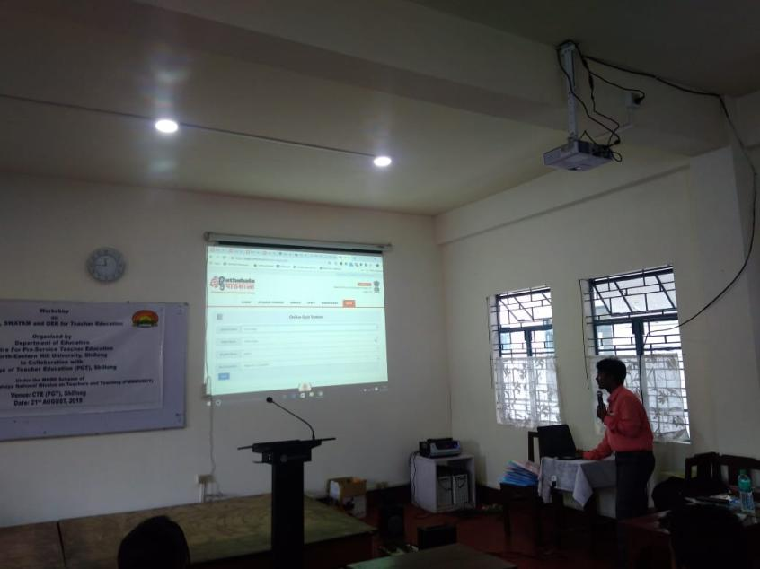

Dr. Amareswaran
Programme Coordinator
Centre for Pre-Service Teacher Education
School of Education, NEHU, Shillong

Report on Two-Day Pre-service Teachers Training Workshop on Curriculum Planning and Curriculum Reform
(Refer to sl no.4)
(Dr. Rihunlang Rymbai)
August 27 & 30, 2019
The Two-Day Pre-service Teachers Training Workshop on Curriculum Planning and Curriculum Reform was held by the Department of Education,North-Eastern Hill University, Shillong, on the theme Curriculum Planning and Curriculum Reformon 27th and 30th August 2019. The Pre-service Teachers Training Workshop was carried out under the MHRD sponsored PMMMNMTT Scheme of the School of Education, NEHU, Shillong.
The details of the first day programme i.e. on 27th August, 2019 are as follows:
Day 1 - Session 1: Inaugural Function
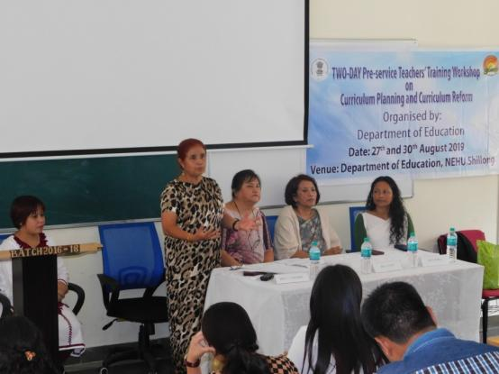
- The Inaugural Function, started at 10:00 AM. Prof. C. Nongbri, Dean, SOE, was the Chairperson of the programme.
- The Programme Coordinator,Dr. RihunlangRymbai gave a welcome address on behalf of Department of Education. She presented the detail of the workshop and stated the need and relevance of the workshop theme in the field of education. She also gave her warm welcome to all the participants and the resource persons of the two-day workshop.
- Prof. C. Nongbri, Dean, SOE, NEHU, Shillongalso extend her welcome to the participants. In her speech she greeted all the faculty members and the participants to the workshop. She also gave a brief introduction of the programme for the day.
- An address on Introduction of the PMMMNMTT Scheme was given by Prof S. M. Sungoh, Convener of the Project, NEHU, Shillong. The proposed mission of the scheme was highlighted. She also addressed the mission, objectives, benefits and the main goals of the mission.
- The Vote of Thanks was addressed by Prof I. Syiem, Head, Department of Education, NEHU. She also extended her gratitude to the Dean, SOE, and the Convener of the PMMMNMTT project, the ProgrammeCoordinator, the Resource Persons and the participants.
- The Inaugural Function ended which was followed by light refreshment.

Day 1 - Session 2: Class and Presentation by Prof C. Nongbri

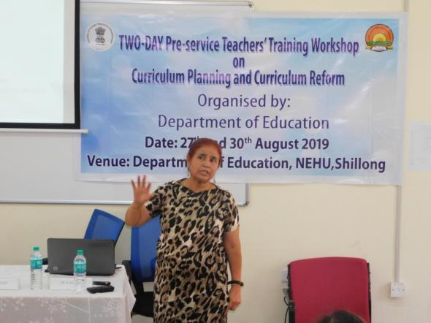
- The Resource Person of the programmeon the first day was Prof. C. Nongbri, Dean, SOE, NEHU, Shillong. The Resource Person carried out a detailed and comprehensive interactive class on the topic Curriculum Planning. She highlighted the introduction, needs, principles of the Curriculum Planning, Curriculum Framework, Theories of Curriculum Planning and the Components of Curriculum Planning.
- The Session 2 was followed with alunch break.
Day 1 - Session 3: Group Work on Curriculum Planning
- After the lunch break,an interactive Group work followed, where initially, the participants put themselves into five groups. Each group was asked to choose the topic on curriculum planning to discuss. The groups carried out discussion on the selected topics and the presentation was done by a member of each group on the topic discussed. The group work carried out in great fervor.
- At the end of the presentation, an overall talked on the topics as a whole was concluded by the Resource Person, and the Session 3 was concluded.

The following are the topics presented on Curriculum Planning in the first day of the Two-Day Pre-service Teachers Training Workshop on Curriculum Planning and Curriculum Reform:
.Group I: Identifying and Formulating the Teachers Education Curriculum (Appendix 1).
Group II: Curriculum on Vocational Education at Secondary Level (Appendix 2).
Group III: A Comparative Account of the Curriculum Planning of Pre-Service Teacher Education Programme of India with reference to United State of America (Appendix 3).
Group IV: Curriculum Planning for Pre-School (Appendix 4).
Group V: Comparison of Education System in Finland and India in Primary level (Appendix 5).
The groups had designed and submitted the Templates on the above topics.
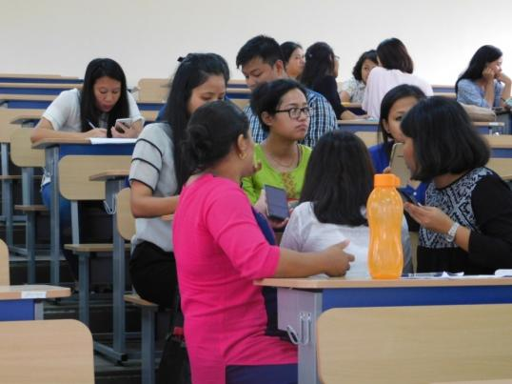

Two-Day Pre-service Teachers Training Workshop on
Curriculum Planning and Curriculum Reform
The details of the second day programme i.e. on 30th August, 2019 are as follows:
Day 2 - Session 4: Class and Presentation by Prof S. M. Sungoh
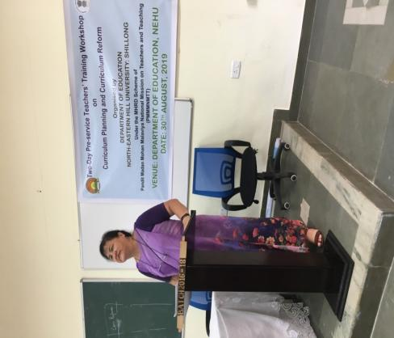
- The second day Session 4 started at 10:00 AM
- The Resource Person of the second day was Prof. S.M. Sungoh, Former Dean, SOE and Convener of the MHRD sponsored PMMMMNMTT Scheme, Department of Education, NEHU, Shillong. Prof S. M. Sungoh gave a presentation on the topic Curriculum Reform and also highlighted on the Aspect of Curriculum, Basis of Curriculum Reform, Strategies to prepare the Curriculum Reform and Guidelines for Curriculum Reform and also demonstrated the designing of Templates on the selected topics underCurriculum Planning and Curriculum Reform.
- The Session 4 ended and followed by a tea break.
Day 2 - Session 5: Group Work on Curriculum Reform
- After the lunch break, an interactive Group work followed, where the previous five groups from day one again selected the same topic from Curriculum Planning and carried out discussion in the light of Curriculum Reformandbring curriculum reforms to it. The presentation was done by the member of each group on the topic discussed. The group work was carried out with equal fervor as in Day 1.
- At the end of the presentation, an overall talked on the topics as a whole was concluded by the Resource Person, and the Session 5 was concluded.
- The five Groups worked on the following topics:
Group I: Curriculum Reform of Vocation in Secondary Level (Appendix 6).
Group II: Aspects of Curriculum Reform in the MEd Programme (Appendix 7).
Group III: A Comparative Account of the Curriculum planning of Teacher Education Programmes of India with reference to United States of America (Appendix 8).
Group IV: Pre-School Education (Appendix 9).
Group V: Questionnaire on Health-Risk Behaviors among Secondary School Student in Umsning Block, Ri-Bhoi District (Appendix 10).
The groups had designed and submitted the Templates on the above topics.
Day 2 - Session 6: Workshop Feedback
- The Feedback form was distributed to each participant and the participants were asked to fill up the forms at the workshop.
Day 2 - Session 6: Valedictory Function
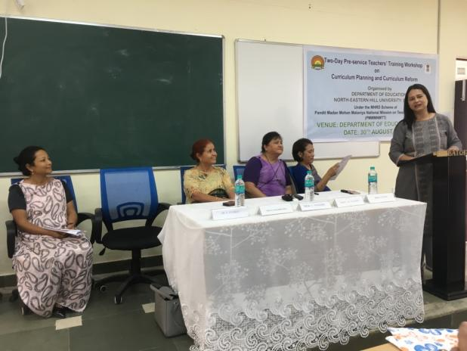
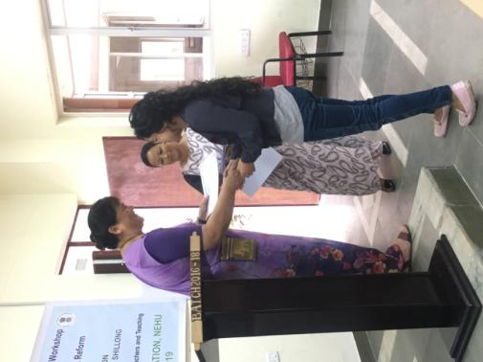
- Prof. I Syiem, Head of the Department was the Chairperson of the programme.
- The Welcome address was of the Valedictory Function was given by Prof. B.B. Kharbirymbai. She extended her warm welcome to Prof C. Nongbri, Dean, SOE, Prof S. M. Sungoh, Convener PMMMNMTT, Prof I. Syiem, Head, Department of Education, Dr R. Rymbai, Programme Coordinator, faculty members and all the participants.
- Prof. I Syiem, Head of the Department requested two participants to give their feedback on the Two-Day workshop.
- Two participant of the workshop gave their oral feedbacks. They expressed their gratitude to the Department of Education for organizing workshop and they also mentioned that how the workshop is crucial to bring uniform in the curriculum system and how they are benefitted by the workshop in planning, reforming and identifying the gap in the curriculum.
- The Certificates were distributed to the participants by Prof. C. Nongbri and Prof. S.M. Sungoh.
- The Vote of Thanks was addressed by Dr. RihunlangRymbai, Programme Coordinator. She expressed her gratitude to Prof C. Nongbri, Dean, SOE, Prof S. M. Sungoh, Convener PMMMNMTT, Prof I. Syiem, Head, Department of Education, Prof B. B. Kharbirymbai, faculty members for their presence and support, and to the participants for spending time and being benefitted from the workshop. She also gave a short report of theTwo-Day Pre-service Teachers Training Workshop on Curriculum Planning and Curriculum Reform.
- The Two-Day Pre-service Teachers Training Workshop on Curriculum Planning and Curriculum Reform was announced closed.
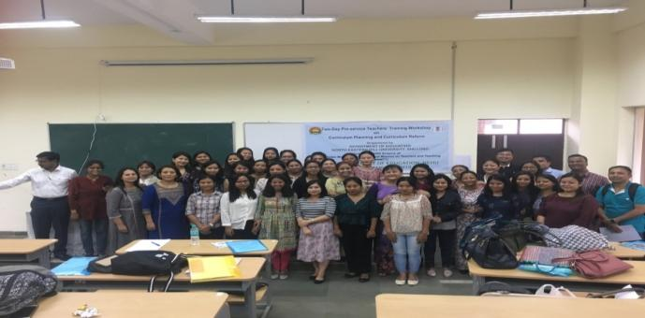
Dr. R. Rymbai
Programme Coordinator
Centre for Pre-service Teacher Education
School of Education, NEHU, Shillong-793022

Report on One-Day National Workshop MOOC, SWAYAM and OER for Teacher Education, In Collaboration with College of Teacher Education (CTE), Tura
(Refer to sl no.5)
(Dr N. Amareswaran)
August 30, 2019

A One-day National Workshop on MOOC, SWAYAM and OER for Teacher Education was organized at College of Teacher Education (CTE), Tura on the 30th August 2019. Even though, the target groups of workshop were Student-Teachers and Teacher Educators, 15 in-service teachers were also participated. There were 120 (one hundred and twenty only) participants; among them 95 student-teachers, 7 teacher educators, and 3 subject experts from NEHU, Tura Campus and DIET, Tura have participated actively throughout the programme.

Dr. Silse D Marak, the senior Assistant Professor of CTE, Tura welcomed the dignitaries on to the Dias. The Workshop was inaugurated by Dr. Manoj Rana, Assistant Librarian Cum National Resource Person, NEHU Library, North-Eastern Hill University, Shillong, Meghalaya. Dr. Rana has stressed the importance of MOOC, SWAYAM, and OER for Teacher Education Programme. He has also requested all the student-teachers and teacher educators to use ICT in teaching-learning process for fruitful learning of the students at all levels. Mr. Samir Bhowmik, Principal, CTE, Tura delivered his presidential remarks by expressing his thankfulness that this type of programme was organised in Tura. He also stressed on the need and importance of SWAYAM platform for active learning in the present digital world. Dr. N. Amareswaran, the workshop co-ordinator from School of Education (NEHU) has delivered vote of thanks for providing for each and every one those who helped directly and indirectly to organize the workshop in a grand way.

The workshop was divided into three parts to cater to the three different topics. The first session was conducted by Dr. Manoj Rana, Assistant Librarian at NEHU. He introduced the concepts of the OER – Open Educational Resources, such as electronic journals, scholarly databases and information gateways. Dr. Rana asked many questions to the participants to motivate them towards digital learning. He has given the live examples to the participants to understand the given topic easily and quickly. Dr. Rana also discussed on the concept of digital libraries and how student-teachers need to be constantly updated on the information of our times else we shall become obsolete. A brief video of how the Khan Academy teaches via audio-visual techniques was showed as well.

The second session was handled by Dr. N. Amareswaran, Assistant Professor cum Workshop Co-ordinator, Dept of Education, NEHU Shillong part consisted of an introduction to MOOC (Massive Open Online Courses). The resource has completed 96 MOOC courses at various platforms. He has introduced the FutureLearn MOOC platform (https://www.futurelearn.com) for better learning. He has also showed 43 MOOC providers through his blog (https://hamsareddy.blogspot.com). The resource person motivated the participants to enrol at futurelearn platform. Majority of the participants have created their account at FutureLearn platform.

The third and final session was conducted by Dr. N. Amareswaran, NEHU, Shillong. He has concentrated on SWAYAM (Study Webs of Active Learning for Young Aspiring Minds) and Digital Initiatives of Govt of India. He has used his 7 Ss Model of Learning and Teaching through Online (Search, Select, Study, Skilful, Store, Share and Smart). He gave insight into his blog ‘Look Up Aim High’ (https://hamsareddy.blogspot.com) which gives access to various topics. He provided a complete study material of B.Ed. and M.A. Education of seven educational institutions of India. He also shared another blog (https://shillongeducation.blogspot.com). He provided many live examples through hands-on to understand the concepts nicely. He enlightened the students on certain ‘tricks’ to enhance Google searches and how to operate Google Drive more effectively. . The two resource persons have spent their valuable time (whole day) with the participants. Dr. Challang R Mark, Assistant Professor, DIET, Tura interacted with the participants towards joyful learning. Dr. Duggirala Sesi, Assistant Professor, Don Bosco CTE, Tura has also attended along with her colleague to the participants during hands-on session.

Prof. Nikme SC Momin, Head, Dept of Education, NEHU, Tura Campus; and Dr. A.J. Sing, Librarian, NEHU, Tura Campus; Dr. Manoj Rana; and Dr. N. Amareswaran distributed the certificates to all the student-teachers and teacher educators. The Principal of CTE distributed the certificates to the resource persons.

Overall, the workshop motivated the participants to practice and use OER resources through MOOC and SWAYAM in their teaching-learning process in the digital world.

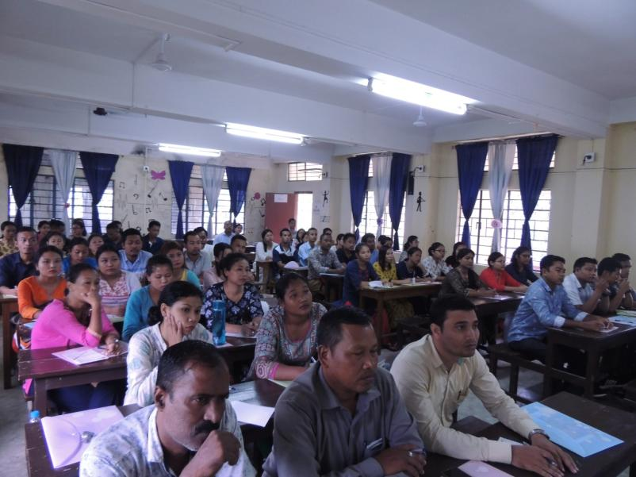

Dr. Amareshwaran
Programme Coordinator
Centre for Pre-Service Teacher Education
School of Education, NEHU, Shillong

Report of the workshop on Development of Training module on Digital Skills for Pre-service Teachers
(Dr Vandana & Dr. Euodia B. Myrthong)
(Refer to sl no.6)
September 3-4, 2019
The Two-day workshop on “Development of Training module on Digital Skills for Pre-service Teachers” (Under MHRD Scheme of PMMMNMTT) was conducted on the 3rd & 4th of September, 2019 by the Department of Education in the New Guest house, NEHU, Shillong. The organising secretaries for this workshop were Dr. Vandana and Dr. E. B. Myrthong, Assistant Professors of the department. The target group for this workshop were the pre-service teacher educators; therefore the participants of the workshop were the DIET teacher educators of the state. The main objective of the workshop to develop awareness among teacher educators towards the usage of digital skills in teaching and learning and to enable them to develop the need based training module on digital skills for pre-service teachers. The total number of participants present was seventeen.

The workshop started off with an informal inaugural function whereby the Project co-ordinator and convener of the PMMMNMTT, Prof. S.M Sungoh introduced the project and the programme of the participants. In the first session on the first day of the workshop we have Dr. Shubhra Srivastava who introduced the participants to the development and designing of module training. Dr. Shubhra Srivastava outlined the information, skills and procedural steps along with instructions for developing module in teaching-learning process. Dr. Shubhra Srivastava stressed on the ADDIE cycle for module design.

In the second session of the first day we have Dr. Mary Anne Jyrwa who provided hands on experience in training module. Dr. Jyrwa emphasised on the use of various softwares for developing training module on digital skills for pre-service teachers. Some of the software she introduced included SCORM and Steps hot guide software.

In the third session of the day, Dr. Vandana gave a comprehensive input on digital skills concept and components. Dr. Vandana also enhanced the knowledge of the participants regarding the basic skills and advanced digital skill. Web surfing, internet security and e-communications was discussed in-depth.

The second day of the workshop started off with Dr. E. B Myrthong presenting to the group the status of digital skills of pre-service student-teachers in the DIETs of Meghalaya. This was based on the data collecting in identifying the needs of pre-service teachers. Dr. Myrthong stressed on the need and importance for developing digital skills modules for pre-service teachers in the state in order to help the student-teachers.

For the second session four core digital skills were chosen for module development. All participants were divided into groups to prepare the draft module on digital skills. Thus, from the second session onwards the participants were divided into four groups. Each group was given a topic to work on in developing the module for pre-service teachers. There were four moderators working with different group. In the first group we had Prof. B.B Kharbirymbai working with the group on basic knowledge of computers. In the second group we had Dr. Srivastava working and the topic for the group was on web-surfing. The third group under the supervision of Dr. Vandana worked on internet security and the fourth group under Dr. E.B. Myrthong worked on MS office, specifically on excel and PowerPoint. The group work was carried out for 3 hours and at the end each group gave a PowerPoint presentation of the draft module. 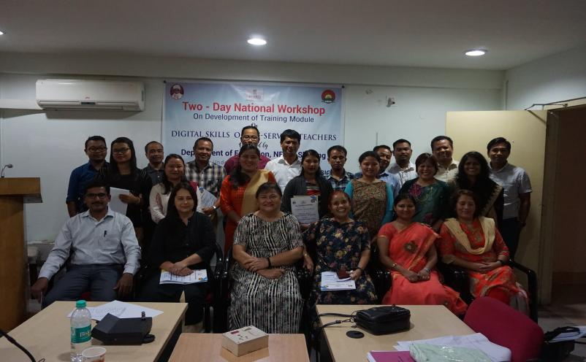
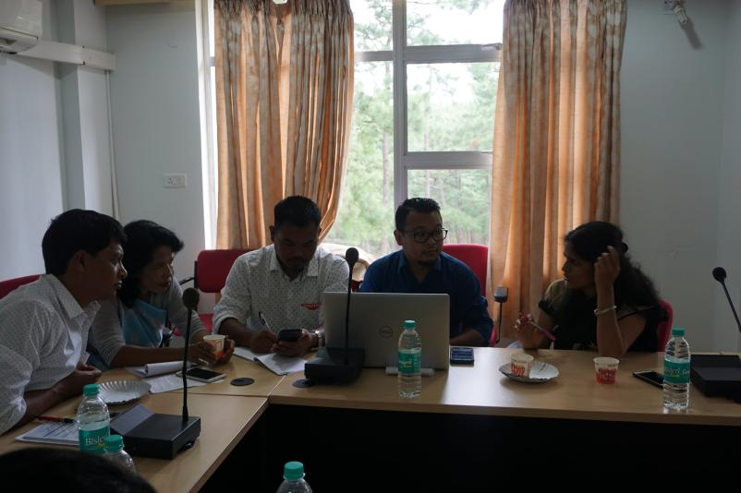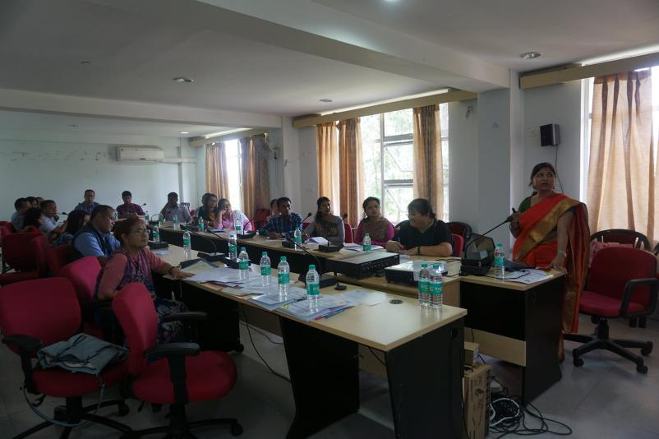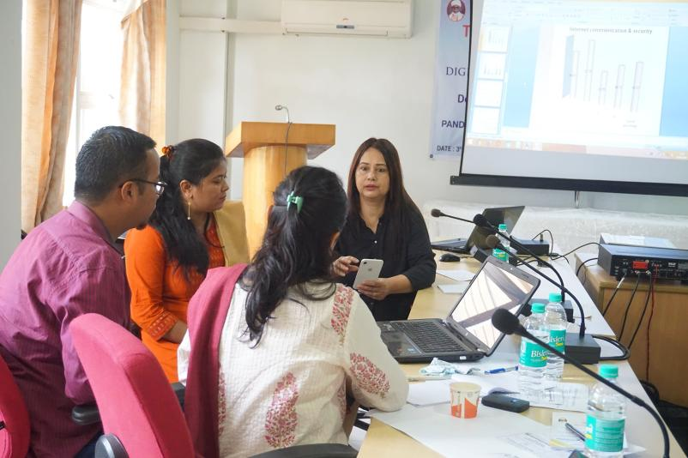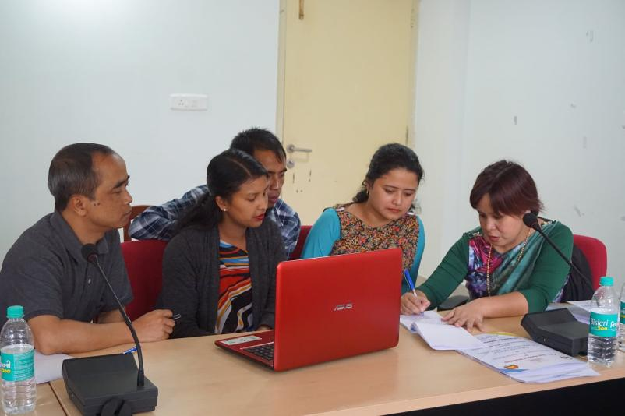
The workshop was concluded with a valedictory function where the report of the two-day was presented by Dr E. B. Myrthong. Participants’ feedback was also invited and participants expressed their desire to learn more about digital skill. They reiterated that they found the workshop beneficial and will look forward to the module. From the participants’ feedback it can be concluded that they have gained a better insight of the digital skills and module making and as well as on the position of their students’ knowledge regarding digital skills. This was followed by the valedictory speech from the Dean School of Education and the distribution of certificates by the Project co-ordinator and convener of the PMMMNMTT, Prof. S.M Sungoh. Workshop ended with vote of thanks by Dr. Vandana.

Organizing Secretaries:
Dr Vandana Dr Euodia B Myrthong
Asstt. Professor, Asstt. Professor,
Deptt of Education Deptt of Education

Convener-
Prof. S.M. Sungoh
Co-ordinator (PMMMNMTT)

Report on MOOC Swayam and OER for Teacher Education, in Collaboration with St. Mary’s College of Teacher Education, Shillong

(Refer to sl no.7)
(Dr N. Amareswaran)
September 6, 2019
A One-Day National Workshop on MOOC, SWAYAM and OER for Teacher Education was organized at St. Mary’s College of Teacher Education, Shillong on 6th September 2019. The target groups of workshop were Student-Teachers and Teacher Educators. All student-teachers i.e. 99; 10 teacher educators, two out-side in-service teachers, 2 subject experts and 7 technical staff have attended the workshop. The total numbers of participants were 120 (one hundred and twenty only).

Dr.Alfa Mary Kurbah, the Workshop Co-ordinator from St. Mary’s CTE side welcomed the dignitaries on to the Dias. The Workshop was inaugurated by Dr. Rajendra Nath Babu, Assistant Professor, Dept of Teacher Education, Nagaland University, Kohima, Nagaland. Dr. Babu stressed the present need and importance of MOOC, SWAYAM, and OER for Teacher Education Programme. He has addressed various types of MOOC courses at different online platforms. Dr. (Sr) Clarissa Wallang, the Principal, St. Mary’s CTE, Shillong delivered her presidential remarks briefly and excellently. She expressed her willingness to organize some more programmes in coming days for the benefits of student-teachers and teacher educators. Dr. N. Amareswaran, the workshop co-ordinator from School of Education (NEHU) side delivered vote of thanks for providing a wonderful platform to share digital information/knowledge and skills with young and dynamic student-teachers.

The workshop focussed on mainly on MOOC (Massie Open Online Courses), SWAYAM (Study Webs of Active Learning for Young Aspiring Minds), OER (Open Educational Resources, Digital Library and Digital Initiatives of Govt of India.

The first session was handled by Dr. Rajendra Nath Babu, Assistant Professor, Dept of Teacher Education, Nagaland University, Kohima, Nagaland. He stressed on SWAYAM and Digital Initiatives of Govt of India. The conductor, Dr. Babu, took the students on a step by step procedure tutorial to enrol onto SWAYAM to get access to the MOOC courses. This was especially useful since both SWAYAM and MOOC were alien to the students prior to this workshop. The students were also briefed about another digital institute e-PG Pathshala. The resource person has motivated all the participants to create an account at SWAYAM platform. The hands-on session also covered nice with fruitful interaction.
The second session was conducted by Dr. N. Amareswaran who discussed about the 7 Ss – Search, Select, Study, Skilful, Store and Share. He gave insight into his blog ‘Look Up Aim High’ (https://hamsareddy.blogspot.com) which gives access to various topics, such as ‘e-Resources for higher education students and scholars’, ‘Teacher Education’, ‘Artificial Education’, ‘SWAYAM Guidelines’ to name a few. The principal of the college arranged a session for the participants to interact which each other during hands-on session. Dr. Amareswaran provided all the learning material of 9 Educational Institutions of India with special reference to Teacher Education and Education. He has also shared another blog (https://shillongeducation.blogspot.com). His session was riddled with jokes and laughter and it was a very interactive session. He enlightened the students on certain ‘tricks’ to enhance Google searches and how to operate Google Drive more effectively.

The third and last session was conducted by Dr. Manoj Rana, Assistant Librarian at NEHU. He introduced the concepts of the OER – Open Educational Resources, such as electronic journals, scholarly databases and information gateways. Dr. Rana also discussed digital libraries and how we as student-teachers need to be constantly updated on the information of our times else we shall become obsolete.

Dr. Rana showed a video lecture on ‘Algebra’ at Khan Academy, all the participants have showed their interest to use this in their teaching-learning practices via audio-visual technique. Dr. N. Amareswaran, the workshop co-ordinator has helped student-teachers during hands-on at all the sessions. The other two resource persons have also spent their valuable time to help all the participants irrespective of the sessions.

The session came to an end with the distribution of the certificates to all the student-teachers and teacher educators including the resource persons. Overall, the programme went excellent way by sharing many innovative things with student-teachers and teacher educators. The participants have expressed their gratitude for organizing such a wonderful programme at their institution.

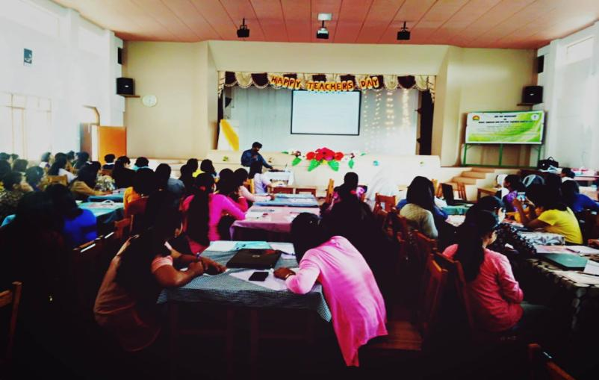
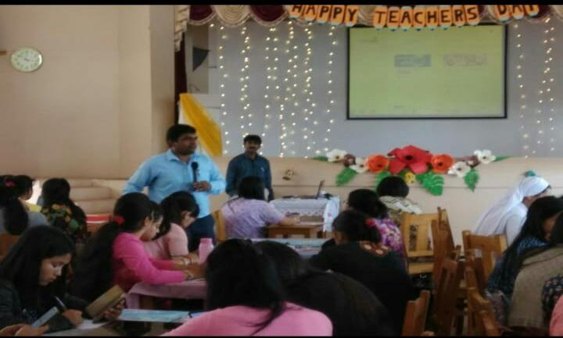

Dr. Amareshwaran
Programme Coordinator
Centre for Pre-Service Teacher Education
School of Education, NEHU, Shillong

Report of a Two Day National Workshop on Quality Assurance : Constructivist Pedagogy for Pre Service Student Teachers
(Refer to sl no.8)
(Prof I. Syiem, Dr Ashok Kumar, Prof S.M. Sungoh)
September 11-12, 2019
Quality education is possible when meaningful learning experiences are created by teachers. The teacher education programs hold the responsibility of preparing teachers, hence it becomes the accountability of teacher education programs to inculcate a variety of skills in our teachers through pre-service and in-service education. Consequently, a constructivist approach to teacher education is needed so that students can develop problem-solving and critical-thinking skills and construct the knowledge in the context. The focus of the teacher education programmes should be to make teachers ready to rethink , modify the present practices of the teaching profession and realign it with new paradigms than mere giving of instructions. The 21st century education requires dynamic interaction between task, teacher and learner which can be addressed effectively with constructivist pedagogy. Recognising the importance, New Education Policy draft, 2019 and the NCF, 2005, NCFTE, 2009 emphasised the constructivist and learner-centred approach in education. In this context The Dept of Education, North-Eastern Hill University under the MHRD Scheme of Pandit Madan Mohan Malviya National Mission on Teachers and Teaching has planned and organised an invited lecture on Constructivist Pedagogy for Pre-service Student Teachers.

Objectives
- To promote constructivist pedagogy in pre-service teacher education institutes
- To sensitise student-teachers and teacher educators to use constructivist pedagogy.
- To promote democratic, interactive and student centred learning
- To create an active-learning environment in the in pre-service teacher education institutes with the constructivist pedagogy.

Date & Venue
The One –Day Invited lecture took place on 19th November, 2019 at the Department of Education NEHU , Shillong.

Total number of Participants: 50
Resource Persons:
Prof.S. M. Sungoh, Dept. of Education, NEHU, Shillong
Prof. I . Syiem, Dept. of Education, NEHU, Shillong
Dr. Anand Valmiki, NERIE, Shillong.
Dr. Ashok Kumr, Dept. of Education, NEHU, Shillong

Inaugural Session

The invited lecture on Constructivist Pedagogy for Pre-service Student Teachers commenced with the registration of pre service teachers who were the participants of the programme at 9.30 am . This was followed by the formal Inaugural function at 10.00am.
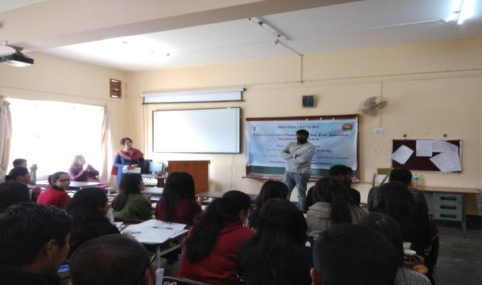

The opening Session began with a warm welcome by the Head Department of Education Prof. I. Syiem who graciously acknowledged and welcomed the all the participants, resource persons and invited guests.
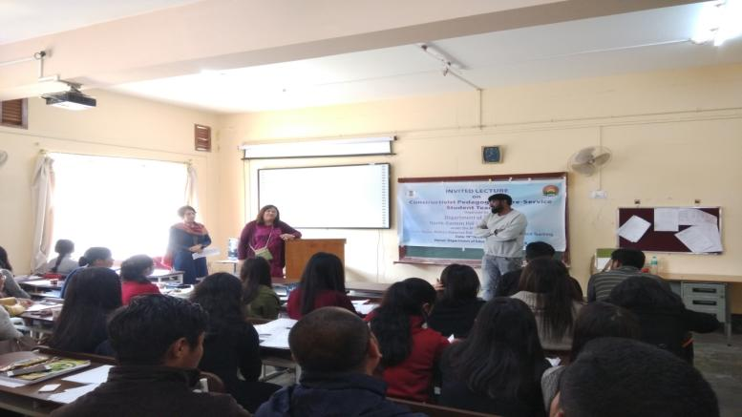

Prof. S.M. Sungoh (Co-ordinator PMMMNMTT), elaborated on the project, its Mission & significance to achieving quality in teacher education in her keynote address .

The Inaugural function was then followed with a refreshments which was followed by technical sessions of the program.
Technical Session 1: commenced at 11.00 am wherein Resource persons gave their presentations.
The First speaker of Technical Session – I was Prof.S. M. Sungoh, Dept. of Education, NEHU, Shillong who gave an Introduction of the concept of Constructivism with its need and importance in the present context.
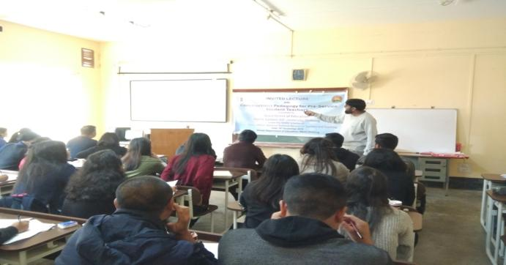

The second presentation was given by Dr. Anand Valmiki , Assistant Professor NERIE Shillong who introduced the Conceptual background & theoretical aspects of Constructivism with countless examples. The session end at 11.20am
Technical Session – II : commenced at 12.30 pm
The 2nd sessions started with lecture of Prof. I. Syiem on 5E model of Constructivism and followed by Dr. Anand Valmiki’s Lecture on How to make Lesson Plan using this 5E model. Supporting materials were provided. This was followed with Hands on Experience, where participants were divided into groups and given tasks to prepare Lesson Plan using 5E model. The session ended at 1 pm.
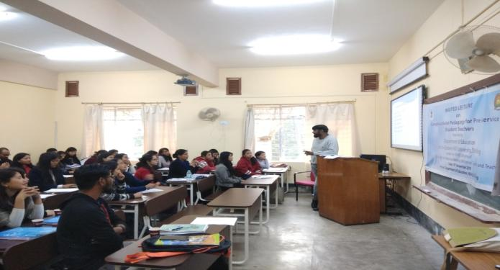
Lunch break 1.00pm-2.00pm
Technical Session – III commenced at 2.00pm
Students worked in groups to prepare Lesson Plans using 5E model. They have chosen a topic of their own interest and prepare the lesson plan. Resource persons Dr.Anand Vamiki and Dr.Ashok Kumar supervised, guided and clarified their doubts.
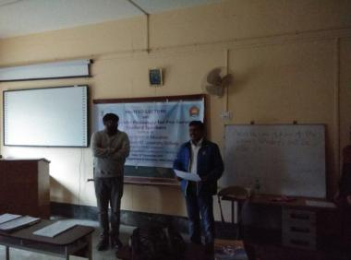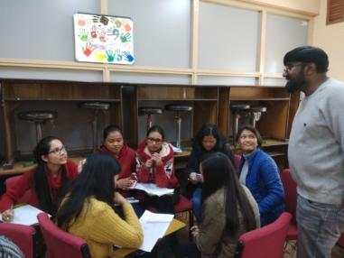
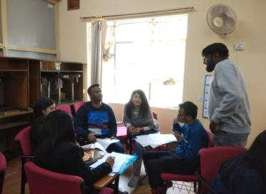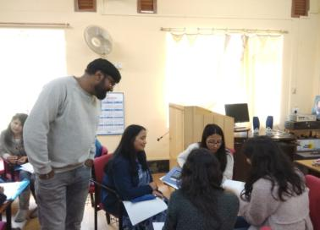
Technical Session – IV commenced at 3.00pm
In the session Each Group presented their lesson plans as mentioned below. Dr.Anand Vamiki and Dr.Ashok Kumar acted as moderators and gave their inputs.
Group- I : Micro-organisms: Friend and Foe
Group – II : Diffusion
Group –III : The Noun
Group –IV : Adjectives of Quality and quantity
Group –V : Saving energy
Group – VI : Advantages and Disadvantages of Democratic Government
Group –VII : Natural resources
Group –VIII : Natural Vegetation and wild life
Group – IX : Photosynthesis

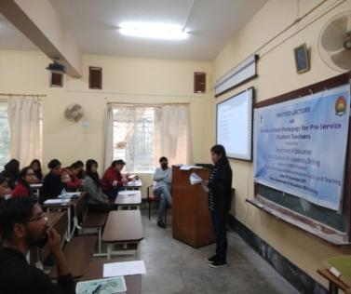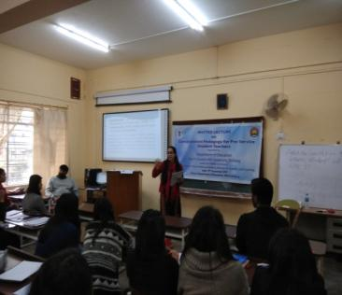

It may be reported that Student teachers had participated very actively & worked out effectively in groups and presented the prepared Lesson Plans using 5E model wonderfully with lot of confidence.
Resource Persons then gave given their reflection on Lesson Plans after every presentation of student teachers. .
The Workshop concluded with a Certificate distribution and Vote of thanks.

1. | Prof. I. Syiem  Organising Secretary  Head, Dept of Education  NEHU, Shillong  3. Prof. S.M. Sungoh  Project Co-Ordinator (PMMMNMTT)  North-Eastern Hill University  Shillong, Meghalaya. | 2. | Dr. Ashok Kumar  Organising Secretary  Dept of Education  NEHU, Shillong

Report on Invited lecture on Periodic Student Teacher Assessment
(Refer to sl no.10)
(Prof I. Syiem, Dr Ashok Kumar, Prof S.M. Sungoh)
September 13, 2019
Assessment of student’s learning, their knowledge and understanding is an implicit and integral part of instruction and it is important to review periodically so as to identify strengths and weaknesses as well as bring improvement in teaching and. Learning. Effective periodic assessment and evaluation of student- teachers will play a vital role in developing the quality of teacher education. By conducting periodic assessment, teachers will improve the student's progress in learning. Formative assessment will give one an overview of students progress in the beginning of instruction and provide the opportunity to improve the instruction. Summative will give one the outcome of the entire instruction. Knowledge and application of assessment for student teachers and teacher educators can make a difference in quality of the whole gamut of teacher education program. To meet the modern educational needs we should gear up the assessment and evaluation mechanisms to global standards with the help of advanced technologies. In this context, recognising the importance of periodic assessment of students, the Department of Education, North-Eastern Hill University under the MHRD Scheme of Pandit Madan Mohan Malviya National Mission on Teachers and Teaching has organised an Invited Lecture on ‘Periodic Student Teacher Assessment’. The lecture aims to sensitize the student-teachers and teacher educators on assessment and evaluation of learners.
Objectives of the Workshop
- To sensitize student-teachers and teacher educators on assessment and evaluation.
- To develop insights on various types of assessments among student-teachers and teacher educators
- To improve the quality in teacher education with special reference to North-East
- To suggest measures to improve quality in assessment and evaluation of students
Date & Venue
One day Invited lecture took place on 13th September, 2019 at Cluster class room no.304, Department of Education , NEHU, Shillong.
Total number of participants: 89
Invited Resource Persons:
Prof.Amruth G Kumar, Central University of Kerala
Prof. C Rajamouli, Dr.B.R.Ambedkar Open University, Hyderabad

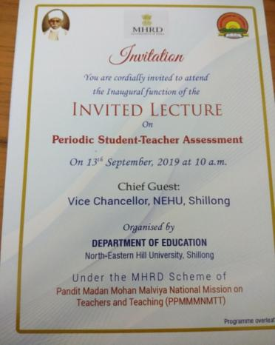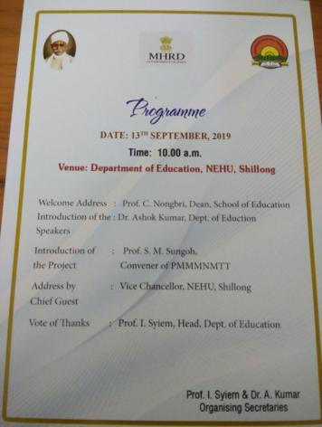

The programme started with a formal Inaugural function wherein Prof. C. N. Nongbri, Dean School of Education gave the Welcome Address and extended a warm welcome to all the dignitaries including all the Pre Service teachers. She also addressed the audience on the Periodic Assessment system that is practiced in Higher educational institutions in India and mentioned its importance.

Dr.Ashok Kumar, Organising Secretary of the programme formally introduced the Resource Persons of the One Day programme and conveyed to the audience the sequence of lectures that day. Firstly, he introduced Prof. Amruth G Kumar, Head, Dept of Education, Central University of Kerala who delivered on ‘Examination: An Organised Violence on Students’and Secondly, introduced Prof. C. Rajamouli, Dr.B. R. Ambedkar Open University, Hyderabad who delivered on ‘Periodic Student Teacher Assessment: Testing, Measurement and Evaluation’.

This was then followed by Prof. S. M. Sungoh, Project Co-ordinator, PMMMNMTT who introduced about the project and also highlighted the significance of this project for the present education system especially in North-East India. She outlined the standards set for teachers and students in higher education, sensitized them on the need of quality assessment to attain quality education in higher education.

Prof. H. Lamin, Pro Vice-Chancellor, NEHU, Shillong, graced the occasion as Chief Guest and spoke about nation development and the underlying role of education specifically the role of teachers and teacher-educators in the development of the nation. While defining education he emphasized on social observation and exposures to different situations. He recognized and appreciated the inspiring and thought provoking role of teachers in shaping and moulding student’s personality and availing them for future nation development. He related nation development as an outcome of educational prosperity and learning outcomes of students, teachers and institution as a whole.

The Inaugural function ended with a vote of thanks by Prof. Ibadani Syiem (HoD), Organising secretary of the program who extended her gratitude to all dignitaries, resource persons , teaching faculty, pre-service teachers and non teaching staff who were present in the programme and had rendered help in every way.
Thereafter, refreshment was distributed to all present which was then followed immediately by the lecture.
Invited Lecture-1
Speaker: Prof. Amruth G Kumar, Head, Dept of Education, Central University of Kerala
Topic: Examination: An Organised Violence on Students

The lecture started with the speaker’s reference to stories, one was cinema based followed by a story of Ishwaran (R. K. Narayan’s collection). The speaker related these stories with the story of diversified students and emphasized the individual identity of each student with the illustration of individuals with different musical instruments. The lecture advanced to another level where the speaker deliberated on the theoretical premises of objective based system of assessment.

In this connection ,key premises on objective assessment highlighted were 1. A system of assessment where answers can be assessed objectively. 2. Unbiased( implying free of personal judgement).3 .External related, not internal.4.A system which promotes homogeneity and standardization. The speaker also projected the reasons behind objectivity as central to assessment which was attributed to psychological influences, Bloomian effect and free of biasness. The speaker justified the critical stance towards the prevailing objective based system of assessment by referring to Karl Popper , Frankfort’s attack on positivism based on science as an oppressive instrument (Adorno & Harkhier) , scientific tools and associated polities exploit common people (Tools of conviviality) ,damage of seeing the world as it considers everything in data forms (human not data, emotions, including stories & poems), teachers look at students in quantified forms, etc.
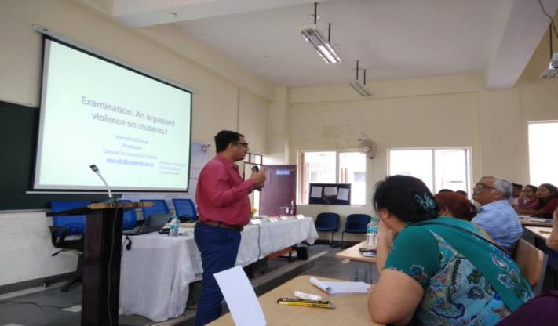

The speaker also referred to Post-modernism theories of Lyotard, Michael Faucault and Derrida who discussed the attack on western metaphysics and its over reliance on objectivity. Educational dilemma such as deculturalisation of educational assessment through objectivity leading to dehumanization of students was a concern since it implied individuals’ culture being scrapped away through the process of objective assessment. Thus, one important aspect according to the speaker was the alienation of students as the consequence in the process of objective assessment since education is not related to one’s own culture and personal objectivity . Depth of meaning and notions have been reduced to value points in the present assessment system.

A New Vision that all knowledge is socially situated and constructed (Vygotsky, Horkhiemer & Azevedo) was expressed by the speaker .Hence , society, culture and locality should be placed in the core of curriculum framework ,culturally relevant pedagogy and individual priority in organizing lesson unit and transactional methodology were some of the alternatives to objective system of assessments according to the speaker. In Conclusion, Prof. A. G. Kumar opened the floor for interaction and participants including faculty of the Department of Education, research scholars and students asked questions to which clarifications were provided .This was followed by providing feedback to the speaker . The first session was followed by Lunch break.

Invited lecture-2
Speaker: Prof. C. Rajamouli, Dr.B. R. Ambedkar Open University, Hyderabad.
Topic: Periodic Student Teacher Assessment -Testing, Measurement and Evaluation

The lecture session resumed with Prof. C. Rajamouli, Dr.B. R. Ambedkar Open University, Hyderabad as the speaker who deliberated on ‘Periodic Student Teacher Assessment -Testing, Measurement and Evaluation’.The lecture included conceptual readings-cum- comparative discussion on testing, its types (diagnostic and aptitude tests), measurements and evaluation or assessments .Further ,this was followed by comparative presentation on the objective versus essay type questionnaires as well as formative versus summative assessments and their respective pros and cons.
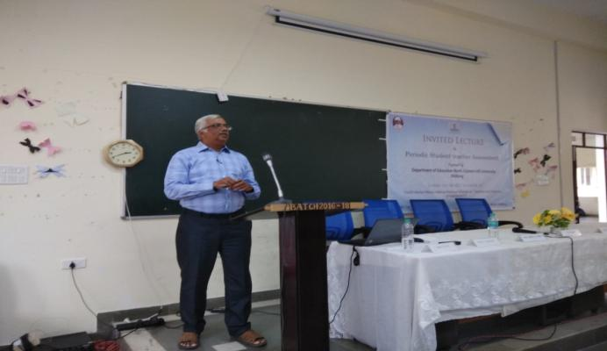

The speaker explained question setting patterns and more specifically cited parallel form of question papers ,peer evaluation systems. The linkage of students’ mental stress and prevailing periodic assessment system in higher education was highlighted by the speaker. A significant reference was made to predictive value or ability of a test.The second session ended with interactive dialogue with the participants.

Valedictory programme
Prof. S. M. Sungoh, Project co-ordinator, PMMMNMTT, summarised the deliberate attempts and discussed the assigned theme of the program in context to resource lectures. The project co ordinator highlighted the essence of the program and concluded by thanking the resource persons and all the participants for the success of the programme and urged students to understand the implication of the periodic assessment systems in higher education. Thereafter, resource persons were given certificates. Dr. Ashok Kumar, Organising secretary proposed the vote of thanks to distinguished dignitaries and all participants including research scholars.

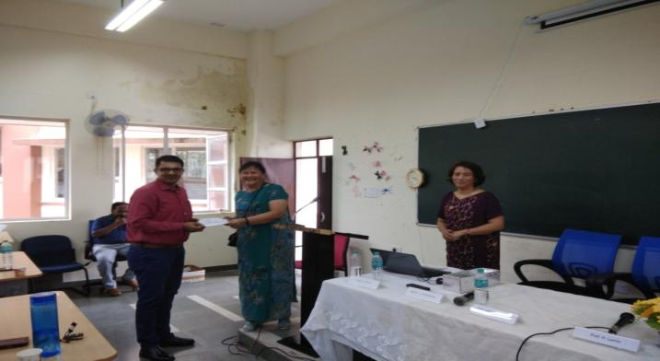

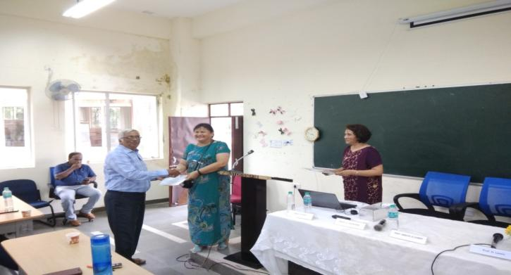
Prof. I. Syiem  Organising Secretary  Head, Dept of Education  NEHU, Shillong | Dr. Ashok Kumar  Organising Secretary  Dept of Education  NEHU, Shillong | Prof. S.M. Sungoh  Project Co-Ordinator (PMMMNMTT)  North-Eastern Hill University  Shillong, Meghalaya.

Report on MOOC Swayam and OER for Teacher Education
(Refer to sl no.11)
(Dr Amareshwaran)
September 16, 2019
A One-day National Workshop on MOOC, SWAYAM and OER for Teacher Education was organized at Don Bosco College of Teacher Education (DBCTE), Tura on the 16th September 2019. There were 172 (one hundred and seventy two only) participants; among them 150 student-teachers, 19 teacher educators and in-service teachers, and 3 subject experts from NEHU, Tura Campus and DIET, Tura have participated actively throughout the programme.

Duggirala Sesi, the senior Assistant Professor of DBCTE, Tura welcomed the dignitaries on to the Dias. The Workshop was inaugurated by Prof. Nikme S.C. Momin, Head, Dept of Education, North-Eastern Hill University, Tura CampusTura, Meghalaya. She delivered an excellent inaugural address. She has a vast knowledge on teaching-learning process. She focussed on the need of digital learning in teacher education programme. She provided a good number of academic and spiritual things for overall development of an individual with the help of technology. Dr. Zacharias George, Principal, DBCTE, Tura delivered his presidential remarks excellently and briefly. He stressed the need and importance of MOOC platforms with special attention to SWAYAM for active learning in the present digital world. Dr. N. Amareswaran, the workshop co-ordinator from School of Education (NEHU) delivered vote of thanks for providing for each and every one those who helped directly and indirectly to organize a nice workshop. Dr. Manoj Rana, Assistant Librarian cum National Resource Person was in the inaugural function. Dr. Challang R Marak, Assistant Professor, DIET, Tura and some more teacher educators were also present at the inaugural function.

The workshop was divided into three parts to cater to the three different topics. The resource person for the first session was Dr. Manoj Rana, Assistant Librarian at NEHU. He introduced the concepts of the OER – Open Educational Resources, such as electronic journals, scholarly databases and information gateways. Dr. Rana asked many questions to the participants to motivate them towards digital learning. He has given live examples to the participants to understand the given topic easily and quickly. Dr. Rana also discussed digital libraries and how we as student-teachers need to be constantly updated on the information of our times else we shall become obsolete. A brief video of how the Khan Academy teaches via audio-visual techniques was showed as well.

The second and third sessions were handled by Dr. N. Amareswaran, Assistant Professor cum Workshop Co-ordinator, Dept of Education, NEHU Shillong.. The resource person has completed 100 MOOC (Massive Open Online Courses) courses at various platforms. He introduced the FutureLearn MOOC platform (https://www.futurelearn.com) for better learning. He has also showed 43 MOOC providers through his blog (https://hamsareddy.blogspot.com). The resource person motivated the participants to enrol at futurelearn platform. Majority of the participants have created their account at FutureLearn platform. The resource person showed a video on ‘Education in 2050’. The participants benefited from the videos. He has also motivated the participants to use video by using a saying… ‘One gives single meaning, image gives thousand meanings and video gives million meanings’.

In the third and final session, the resource person concentrated on SWAYAM (Study Webs of Active Learning for Young Aspiring Minds) and Digital Initiatives of Govt of India. He has used the 7 Ss Model of Learning and Teaching through Online (Search, Select, Study, Skilful, Store, Share and Smart). He gave insight into his blog ‘Look Up Aim High’ (https://hamsareddy.blogspot.com) which gives access to various topics. He has provided a complete study material of B.Ed. and M.A. Education of seven educational institutions of India. He also shared his second personal blog purely for classroom teaching and learning (https://shillongeducation.blogspot.com). He provided many live examples through hands-on to understand the concepts nicely. He enlightened the students on certain ‘tricks’ to enhance Google searches and how to operate Google Drive more effectively. . The two resource persons have spent their valuable time (whole day) with the participants. Dr. Challang R Mark, Assistant Professor, DIET, Tura interacted with the participants towards joyful learning. Dr. Duggirala Sesi, Assistant Professor, Don Bosco CTE, Tura also attended along with her colleague to the participants during hands-on session.

Dr. Zakarias George, the Principal of DBCTE and the resource persons Dr. Manoj Rana; and Dr. N. Amareswaran distributed the certificates to all the student-teachers and teacher educators. Overall, the workshop motivated the participants to practice and use OER resources through MOOC and SWAYAM in their teaching-learning process to fulfil the learning desires of the students in day-to-day life.

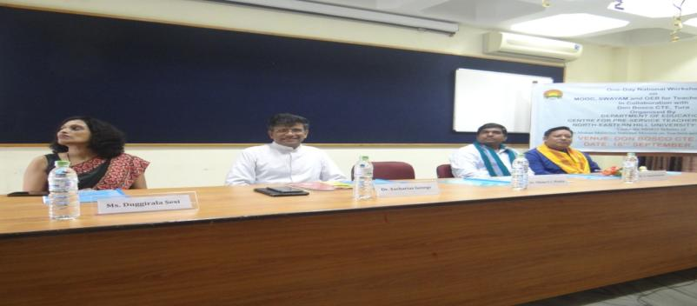

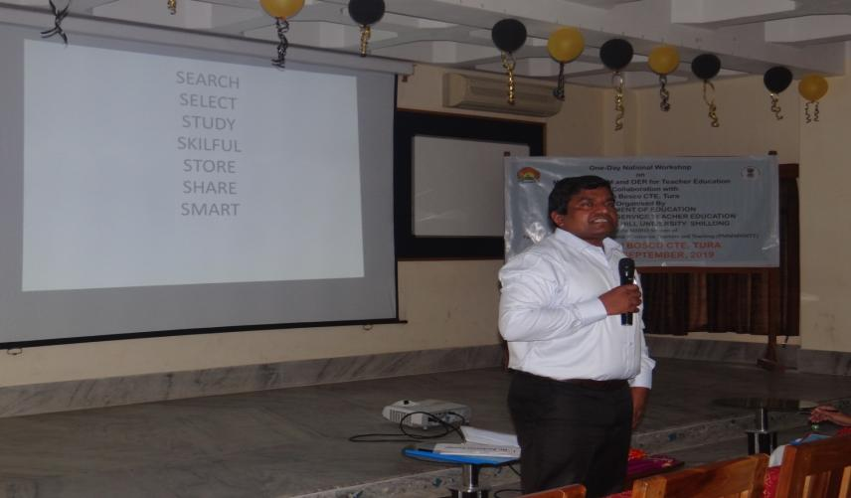

Dr. Amareswaran
Programme Coordinator
Centre for Pre-Service Teacher Education
School of Education, NEHU, Shillong
Report on Accountability System on Education for Pre-Service Teachers
(Refer to sl no.12)
(Prof B.B. Kharbirymbai)
September 20th & 23rd, 2019
A two day workshop on Accountability system in education for pre-service teachers Under the MHRD scheme, Pandit Madan Mohan Malviya Mission on Teachers &Training (PMMMNMTT) was organized by the Department of Education, North Eastern Hill University, Shillong. This workshop was participated by the pre-service student teachers at the elementary level coming from DIET-Nongpoh.

An accountability system is the set of policies and practices that the government measures and hold schools and districts responsible for raising student achievement and bringing out learning outcomes.

It is a process by which students, teachers, and administrators give an account of their progress, accountability is a means by which policy makers at the state and district levels monitor the performance of students and schools.
Teachers are at the heart of our education system. The success of any effort to improve the quality of education is centrally dependent upon the teacher. Quality issues in education are crucially linked to quality issues in teacher education.

Within this system, teacher educators are accountable for adherence to curriculum transaction, evaluation, standards to their peers. Teachers serve many roles in the classroom. Teachers set the tone of their classrooms, build a warm environment, mentor and nurture students, become role models, and listen and look for signs of trouble. The most common role a teacher plays in the classroom is to teach knowledge to children

Objectives of the workshop was-
To train the pre-service teachers in terms of-
- Accountability towards the learner, stakeholders/parents,profession etc.
- Structural and Systemic Reforms and accountability
- Academic accountability
- Generating a Knowledge Society
- Institutional &Accreditation accountability
- Quality pre-service teacher education programmes in terms of accountability.

In this context The Department of Education, North-Eastern Hill University under the MHRD Scheme of Pandit Madan Mohan Malviya National Mission on Teachers and Teaching (PMMMNMTT) organized the Two day workshop so as to train the pre-service elementary teachers in terms of accountability system so as to improve student learning outcomes.

North East Region is found to be lagging behind in quality education and lack of constructive professional higher educational institutions as compared to other regions of India. It is disheartening to notice that many of our youths are moving away from North East in search of quality education. Majority of the educated youths remain unemployed. Paucity of financial allocation, regional backwardness, political negligence and poor administration in higher educational institutes in North-Eastern Region drives the colleges and universities into disappointing condition

The following topics were discussed in the seminar-
- Introduction to Accountability system
- Resources & Accountability measures for teachers
- Need of Accountability for teachers
- Opportunities for improving Accountability system in teacher education
- Hands on workshop on accountability system

The Two day workshop on Accountability system in Education for pre-service teachers started with the inaugural function where the chief guest Prof. H. Lamin, Pro- Vice Chancellor of NEHU inaugurated the function.
The welcome address was given (Prof.B.B Kharbirymbai) where the accountability in the field of Education was discussed and the need for having the workshop.
Prof. S.M. Sungoh The Convener of PMMMNMTT highlighted some important points on the need of accountability for teachers and how it effects the teaching system in terms of in creasing the standard, quality,assessment practices etc.

Prof.H.Lamin,the Pro-vice chancellor of NEHU,Shillong was very delighted to be in the programme and to see the Pre-service student teachers from DIET,Nongpoh and stressed the need to train them on accountability so that they can take the experience to the rural pockets. He explained in a very simple way that how the success of education is centrally dependent upon the teacher.

Prof. C. Nongbri, The Dean School of Education, NEHU Shillong was the chairperson at the Inaugural Programme and gave her remarks on the Two day workshop on accountability system in education for pre-service teachers. She remarked that the teaching profession is a very difficult profession where various guidelines, principles, norms, accountability a teacher has to follow. Therefore a teacher has to be realistic, committed and accountable.
The vote of thanks was given by Prof.I.Syiem, The Head Department of Education, NEHU Shillong, where she thanked all the members at the inaugural function.

Two Day’s Workshop had Five Sessions
The first session was based on the sub theme Introduction to Accountability System in Teacher Education, the resource person for the session was Prof. Asheesh Srivastava ,Head Department of Education,Mahatma Gandhi Central University,Bihar who lectured on immense potential of the pre-service teachers in the North East in the education sector.He spoke on the NPE,RTE,NCTE,Challenges of education,42nd amendment of 1976 etc.

The second session was based on Resources and accountability measures for teachers
In this session Prof. Asheesh Srivastava highlighted on the various resources for measuring teachers accountability. Strategic planning on accountability in terms of financing and the role of HEFA,major progress,expectations,effectiveness etc.Emphasis was laid to improve the quality, equity and access in education.

The third session was based on Hands on workshop on Accountability system
Prof. Asheesh Srivastava the resource person in this session very systematically explored the possibilities of having hands on workshop on accountability system. The pre-service student teachers did worked wonderfully and were divided into 6 groups. Each group gave presentation and finally a conclusion was drawn. This session saw a lot of fruitful deliberation and discussion.

The fourth session was on the subtheme-Opportunities for improving accountability system in teacher education.
The resource person of this session was Prof.Rakesh Rai, Head Department of Education, Nagaland University. He highlighted on the various opportunities at the public and the private level in terms of accountability. Accountability,a very important characteristic of the education policy, is increasingly characterized by external monitoring and an emphasis on outcomes or results. This process involves enabling diverse education stakeholders to make use of organized opportunities to improve accountability system. Discussions of planning and evaluation is important. in particular, sustaining educational reforms over time and meeting ambitious collective goals in education.

The session-5 –Group work on Accountability
Prof. Rakesh Srivastava the resource person in this session divided the student teachers into groups and gave them topics on accountability system. The pre-service student teachers very enthusiastically presented their work and came up with very good ideas on accountability for teachers. This session saw a lot of fruitful deliberation and discussion.
The discussion pointed out the various purposes and potentials of using Accountability in Education. Integrating accountability in teaching and how it can make learning individualized and interactive and prepare pupil for the rapidly changing world.
Therefore, this 2 day workshop on Accountability system in Education for pre-service teachers focussed on the changing dynamics for the pre-service teachers requirement with regards to various aspects such as accountability of the external monitoring of schools and teachers and greater emphasis on outcomes or results. Hopefully this workshop will equip the pre-service teachers at elementary level in Meghalaya with knowledge so as to teach the elementary students with necessary skills and commitment.
In the valedictory session the welcome address was given by Prof.I.Syiem,Head Department of Education,NEHU Shillong. Prof.BB Kharbirymbai presented the report of the two day workshop on Accountability system in Education for pre-service teachers. Prof.C.Nongbri ,The Dean School of Education,NEHU Shillong presented the valedictory address.Prof.S.M.Sungoh, The Convener of PMMMNMTT distributed the certificates to the participants and the vote of thanks was given by Prof.B.B.Kharbirymbai the programme coordinator.
Prof. S.M. Sungoh Prof.B.B.Kharbirymbai
Convener-(PMMMNMTT) Programme coordinator
NEHU, Shillong Dept of Education, NEHU.

Report on First national Workshop on Applications of SPSS in ICT integrated Educational Research, NEHU, Shillong
(Refer to sl no.14)
(Dr N. Amareswaran)
October 29-30, 2019
The Statistical Package for the Social Sciences is playing a major role in data analysis process of the social sciences disciplines in general and educational research in particular. The majority of teachers and researchers are using the SPSS in their daily life. The Centre for Pre-Service Teacher Education has successfully organized the First National Workshop on “Applications of SPPS in ICT Integrated Educational Research” during 29th -30th October 2019. The Centre has decided to organize the Second National Workshop on the same topic by covering few more new applications of SPSS which are really helpful for all the research scholars of education discipline and also Pre-service Teachers of Meghalaya in General.

Objectives of the Workshop
- To Sensitise the Research Scholars/Pre-service Teachers to use SPSS in Educational Research.
- To provide the detailed information about how to use SPSS in Educational Research.
- To provide OER content with special reference to applications of SPSS in ICT integrated Educational Research.
- To provide hands-on experience to research scholars on the applications of SPSS in Educational Research.

Programme

The first National Workshop on Applications of SPSS in ICT Integrated Educational Research was inaugurated by Prof. J. Mawthoh, Dept of Adult and Continuing Education, NEHU, Shillong, on 29th October at NEHU Computer Centre. He stressed the need of quality research with special reference to North-East. The Professor motivated the scholars/Pre-service Teachers through his speech to do the best research for bright future. Dr. P.P. Dey from NEHU Computer Centre has joined in the auspicious occasion. Dr. N. Amareswaran, Workshop Coordinator, Dept of Education, NEHU, Shillong; Dr. Manoj Rana, Assistant Librarian, NEHU, Shillong; and Prof. J.C. Kalita, Director of International Relations, Gauhati University, Guwahati have delivered lectures on various Applications of SPSS in Educational Research. The participants have been well trained through hand-on activities. All the participants have completed two MOOC courses on Educational Research from World Class Universities of UK. At the end Prof. J. C. Kalita delivered his valedictory address. Prof. Kalita provided the information regarding the scope of research abroad for Indian scholars. Finally, Prof. J.C. Kalita distributed the certificates to all the participants. The workshop went on Blended Way of learning. The participants felt happy and benefited a lot. The programme was sponsored by MHRD, Govt of India under Pandit Madan Mohan Malaviya National Mission on Teachers and Teaching (PMMMNMTT). The Participants from Meghalaya, Tamil Nadu, West Bengal, Manipur, and Nagaland attended the programme. Prof. Sungoh, the Project Co-ordinator (PMMMNMTT) provided the logistics for the success of the programme.
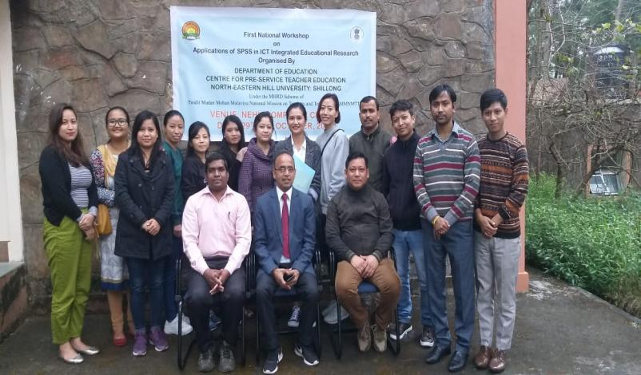
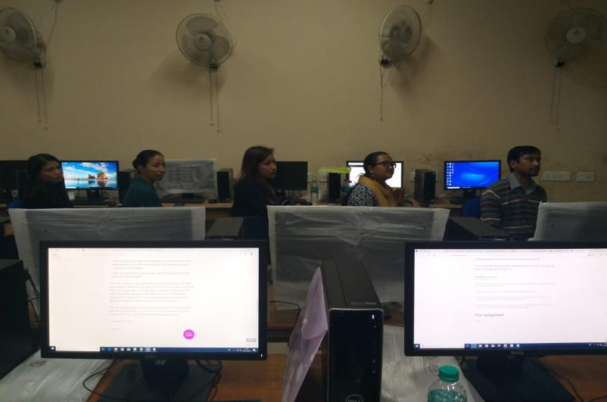
Dr. Amareswaran
Programme Coordinator
Centre for Pre-Service Teacher Education
School of Education, NEHU, Shillong

Report on Workshop on Innovative Methods of Teaching
(Refer to sl no.15)
(Prof B.B. Kharbirymbai)
October 31to November 1st , 2019
A two day workshop on Innovative Methods of Teaching for Pre-Service Teachers, Under the MHRD scheme, Pandit Madan Mohan Malviya Mission on Teachers &Training (PMMMNMTT) was organized by the Department of Education, North Eastern Hill University, Shillong in St.Mary’s CTE,Shillong. This workshop was participated by the pre-service student teachers at the Secondary level from the same College.

An innovative environment is one that is capable of evolving and adapting as educational practices evolve and change. A learning environment includes the physical, social, and pedagogical context in which learning occurs. The practice of effective and meaningful teaching can benefit immensely when educators thoughtfully experiment and apply new or different pedagogical approaches, technologies, curricular enhancement, course design and organization, and assessments.
Technological Innovations in Education are having an impact on educational systems at all levels. Online courses, teaching aids, educational software, social networking tools, and other emerging technologies have taken over traditional classroom environment.

Accordingly in teaching as a profession there are various guidelines, principles, norms of morality. Innovation in education encourages teachers and students to explore, research and use all the tools to uncover something new. It involves a different way of looking at problems and solving them. Innovation improves education because it compels students to use a higher level of thinking to solve problems.

But as the great poet William Butler Yeats once said: Education should not be the filling of a pail, but the lighting of a fire. It ignites a passion for learning and provides students with the tools they need to succeed in the innovation economy.
Therefore a teacher has to be realistic, committed and well equipped with different methods and techniques in teaching profession so as to have a multidimensional approach.

Objectives of the workshop was-
- To engage the pre-service teachers in various modes of learning.
- Structural and Systemic Reforms in teaching learning
- Academic Innovation
- Generating a Knowledge Society
- Innovative teaching strategies
- Quality pre-service teacher education programmes in terms of Innovative methods of teaching.

In this context The Department of Education, North-Eastern Hill University under the MHRD Scheme of Pandit Madan Mohan Malviya National Mission on Teachers and Teaching (PMMMNMTT) will be organizing Two day workshop in St.Mary’ s College of Teacher Education, Shillong so as to train the pre-service elementary teachers in terms of Innovative methods and improve student learning outcomes.

For the educational development the teachers need to be professionally equipped with various skills, competencies, commitment, determination and accountability to give their best.
The following topics were discussed in the seminar-
- Introduction to Innovative Methods of Teaching
- Innovative Teaching Strategies for Teachers
- Need for Innovative Methods for Teaching Today
- Different Innovative Methods for improving Teaching -Learning
- Digital Skills in Teaching-Learning
- Hands on workshop on Innovative Methods

The Two day workshop on Innovative Methods of Teaching for Pre-Service Teachers started with the inaugural function where the chief guest was Prof. C. Nongbri,The Dean School of Education, NEHU inaugurated the function.

The welcome address was given (Prof.B.B Kharbirymbai) where the need of having the workshop on Innovative Methods of Teaching for Pre-Service Teachers in the field of Education was discussed.

Prof. S.M. Sungoh The Convener of PMMMNMTT highlighted some important points on The project with regards to Pre-Service Teachers and how it effects the teaching system in terms of increasing the standard, quality,assessment practices etc.

Prof.C.Nongbri, the Dean, School Of Education, NEHU, Shillong was very delighted to be in the programme and to see the Pre-service student teachers from St.Mary’s College,Shillong and stressed the need to train them on Innovative Methods of Teaching so that they can take the experience to the secondary school students especially in the rural areas. She emphasized at length the need for success in education through innovation and how it is centrally dependent upon the teacher.
Prof. I. Syiem, The Head, Department of Education, NEHU Shillong was the chairperson at the Inaugural Programme and gave her remarks on the Two day workshop on Innovative Methods of Teaching in education for pre-service teachers. She remarked that the teaching profession is a very difficult profession where various guidelines, principles, norms, accountability a teacher has to follow. Therefore a teacher has to be realistic, committed and innovative.

The vote of thanks was given by Dr.R.Rymbai, from the Department of Education, NEHU Shillong, where she thanked all the members at the inaugural function.

Two Day’s Workshop had Five Sessions
The session-1 was based on the sub theme Innovative Teaching Strategies for Teachers, the resource person for the session was Prof. S.C.Roy,Department of Education,NERIE-NCERT,Umiam,Shillong who lectured on immense potential of Innovation for the pre-service teachers in the North East in the education sector. He also spoke on the various innovative teaching strategies needed at the present day and how we can incorporate them.
The session-2 was based on two topics:-
- Introduction to Innovative Methods of Teaching
In this session Prof. B.B.Kharbirymbai from the Department of Education,NEHU Shillong highlighted on the various ICT resources for Pre-Service Teachers.Major emphasis by ICT can be given by teachers to students so as to check the progress,expectations,effectiveness etc in teaching learning. Importance was given to improve the quality, equity and access in education .
- Need of Innovative Methods of Teaching today (Team Teaching)
In this Session Dr.Vandada and Dr. Ashok Kumar from the Department of Education,NEHU,Shillong made a very good presentation on Team Teaching as an innovative strategy of teaching.Various types of team teaching were discussed.

The Session-3 was based on Hands on workshop on Innovative Methods of Teaching
Dr.Vandana and Dr.Ashok Kumar the resource persons in this session very systematically explored the possibilities of having hands on workshop on Innovative Methods through Team Teaching. The pre-service student teachers were divided into 6 groups. Each group gave presentation on team teaching and also demonstrated hands on. The participants were very enthusiastic and enjoyed learning and demonstrating. This session saw a lot of fruitful deliberation and discussion.
The session-4 was on the subtheme- Different innovative methods for improving Teaching learning. The resource person of this session was Dr.Sudeshna Lahiri, Calcutta university
She highlighted on the various opportunities at the public and the private level in terms of implementing innovating teaching learning. Innovation a very important characteristic of the education policy, is increasingly characterized by external monitoring and an emphasis on outcomes or results.
Group work was given to the pre-service student teachers and the process involved diverse methods which may enable education stakeholders to make use of organized opportunities to improve the teaching–learning system. Discussions on innovation, planning and evaluation is important. In particular, sustaining educational reforms over time and meeting ambitious collective goals in education.

The session-5 – Digital Skills in Teaching Learning and Group work
Dr.Upasna Ray,RIE-Bhubaneshwar the resource person in this session first of all highlighted some important points on digital learning especially google classroom and gave the student teachers group work on ICT. The pre-service student teachers very enthusiastically presented their work and came up with very good ideas on digital skills for teachers. This session saw a lot of fruitful deliberation and discussion.

The discussion pointed out the various purposes and potentials of using Innovation in Education. Integrating Innovation in teaching and how it can make learning individualized and interactive and prepare pupil for the rapidly changing world.

The discussion and suggestion received from the two day workshop focussed on the changing dynamics of the pre-service teachers requirement with regards to innovation and accountability aiming to make the pre-service teachers at the secondary level in Meghalaya well equipped with knowledge so as to teach the secondary students with the necessary Innovative skills and commitment.

In the valedictory session the welcome address was given by Prof.B.B.Kharbirymbai,Department of Education,NEHU Shillong. The Principal of St.Mary’s CTE,Shillong distributed the certificates to the participants and the vote of thanks was given by Prof.B.B.Kharbirymbai the programme coordinator and also Dr.Alfa .M.Kurbah from the college.
Prof. S.M. Sungoh Prof.B.B.Kharbirymbai
Convener-(PMMMNMTT) Programme coordinator
NEHU, Shillong Dept.of Education,
NEHU,Shillong.
Report on Invited lecture on Constructivist Approach to Teaching
(Refer to sl no.17)
(Prof I. Syiem, & Dr Ashok Kumar, Prof. S.M. Sungoh)
November 6, 2019
Quality education is possible when meaningful learning experiences are created by teachers. The teacher education programs hold the responsibility of preparing teachers, hence it becomes the accountability of teacher education programs to inculcate a variety of skills in our teachers through pre-service and in-service education. Consequently, a constructivist approach to teacher education is needed so that students can develop problem-solving and critical-thinking skills and construct the knowledge in the context. The focus of the teacher education programmes should be to make teachers ready to rethink , modify the present practices of the teaching profession and realign it with new paradigms than mere giving of instructions. The 21st century education requires dynamic interaction between task, teacher and learner which can be addressed effectively with constructivist pedagogy. Recognising the importance, New Education Policy draft, 2019 and the NCF, 2005, NCFTE, 2009 emphasised the constructivist and learner-centred approach in education. In this context The Dept of Education, North-Eastern Hill University under the MHRD Scheme of Pandit Madan Mohan Malviya National Mission on Teachers and Teaching has planned and organised an invited lecture on Constructivist Pedagogy for Pre-service Student Teachers.

Objectives
- To promote constructivist pedagogy in pre-service teacher education institutes
- To sensitise student-teachers and teacher educators to use constructivist pedagogy.
- To promote democratic, interactive and student centred learning
- To create an active-learning environment in the in pre-service teacher education institutes with the constructivist pedagogy.

Date & Venue
The One –Day Invited lecture took place on 19th November, 2019 at the Department of Education NEHU , Shillong.

Total number of Participants: 50
Resource Persons:
Prof.S. M. Sungoh, Dept. of Education, NEHU, Shillong
Prof. I . Syiem, Dept. of Education, NEHU, Shillong
Dr. Anand Valmiki, NERIE, Shillong.
Dr. Ashok Kumr, Dept. of Education, NEHU, Shillong

Inaugural Session

The invited lecture on Constructivist Pedagogy for Pre-service Student Teachers commenced with the registration of pre service teachers who were the participants of the programme at 9.30 am . This was followed by the formal Inaugural function at 10.00am.

The opening Session began with a warm welcome by the Head Department of Education Prof. I. Syiem who graciously acknowledged and welcomed the all the participants, resource persons and invited guests.

Prof. S.M. Sungoh (Co-ordinator PMMMNMTT), elaborated on the project, its Mission & significance to achieving quality in teacher education in her keynote address .

The Inaugural function was then followed with a refreshments which was followed by technical sessions of the program.
Technical Session 1: commenced at 11.00 am wherein Resource persons gave their presentations.
The First speaker of Technical Session – I was Prof.S. M. Sungoh, Dept. of Education, NEHU, Shillong who gave an Introduction of the concept of Constructivism with its need and importance in the present context.

The second presentation was given by Dr. Anand Valmiki , Assistant Professor NERIE Shillong who introduced the Conceptual background & theoretical aspects of Constructivism with countless examples. The session end at 11.20am
Technical Session – II : commenced at 12.30 pm
The 2nd sessions started with lecture of Prof. I. Syiem on 5E model of Constructivism and followed by Dr. Anand Valmiki’s Lecture on How to make Lesson Plan using this 5E model. Supporting materials were provided. This was followed with Hands on Experience, where participants were divided into groups and given tasks to prepare Lesson Plan using 5E model. The session ended at 1 pm.
Lunch break 1.00pm-2.00pm
Technical Session – III commenced at 2.00pm
Students worked in groups to prepare Lesson Plans using 5E model. They have chosen a topic of their own interest and prepare the lesson plan. Resource persons Dr.Anand Vamiki and Dr.Ashok Kumar supervised, guided and clarified their doubts.
Technical Session – IV commenced at 3.00pm
In the session Each Group presented their lesson plans as mentioned below. Dr.Anand Vamiki and Dr.Ashok Kumar acted as moderators and gave their inputs.
Group- I : Micro-organisms: Friend and Foe
Group – II : Diffusion
Group –III : The Noun
Group –IV : Adjectives of Quality and quantity
Group –V : Saving energy
Group – VI : Advantages and Disadvantages of Democratic Government
Group –VII : Natural resources
Group –VIII : Natural Vegetation and wild life
Group – IX : Photosynthesis

It may be reported that Student teachers had participated very actively & worked out effectively in groups and presented the prepared Lesson Plans using 5E model wonderfully with lot of confidence.
Resource Persons then gave given their reflection on Lesson Plans after every presentation of student teachers. .
The Workshop concluded with a Certificate distribution and Vote of thanks.

1. | Prof. I. Syiem  Organising Secretary  Head, Dept of Education  NEHU, Shillong | 2. | Dr. Ashok Kumar  Organising Secretary  Dept of Education  NEHU, Shillong
Prof. S.M. Sungoh
Project Co-Ordinator (PMMMNMTT)
North-Eastern Hill University
Shillong, Meghalaya.

Report on Research Methodology in Education through FLIP Learning Approach
(Refer to sl no.18)
(Dr N. Amareshwaran)
11th November 2019
Introduction
Research is a continuous process. Research creates a new platform to solve the unsolved problems and to show right paths for better life. Research and development are two faces of the same coin. Research is an integral part of Higher Education. Research always encourages an individual to do tasks in innovative ways. Knowledge management is playing a pivotal role in the field of education in general and educational research in particular. Information and Communication Technologies are playing major roles in the field of educational research. Research Scholars are using many ICT tools to store data, to process data, to analyse data, and to share data and findings with others. The Government of India has initiated many ICT programmes for the benefits of Students, Research Scholars and Teachers in Higher Education to do high quality research for the sake of national development. There are many important digital initiatives of Government of India in Higher Education. They are: 1) SWAYAM; 2) SWAYAM PRABHA; 3) National Academic Depository (NAD); 4) National Digital Library of India (NDL India); 5) e-Shodh Sindhu (eSS); 6) Virtual Labs; 7) e-Yantra; 8) Talk to a Teacher Programme; 9) E-acharya; 10) E-Kalpa; 11) FOSSEE (Free/Libre and Open Source Software in Education); 12) Vidwan; 13) Spoken Tutorial; 14) BAADAL; 15) Global Initiative of Academic Networks (GIAN); 16) National Institutional Ranking Framework (NIRF); 17) IMPRINT – (IMPacting Research INnovation and Technology); 18) SAKSHAT: A One Stop Education Portal; 19) Atal Ranking of Institutions on Innovation Achievements (ARIIA); 20) Know Your College; 21) DigiLocker; 22) The National Programme on Technology Enhanced Learning (NPTEL); 23) OSCAR (Open Source Courseware Animations Repository); 24) ShodhGangotri; 25) Virtual Learning Environment; 26) Text Transcription of Video Content; 27) SOS Tools; 28) e-PG Pathshala; 29) Shodhganga; 30) Shodhshuddhi; 31) NASSDOC; 32) INDCAT; 33) SOUL 2.0; 34) Vidya-Mitra; 35) UGC-MOOCs; 36) INFISTATS; 37) INFED; 38) IRINS; 39) E-NBA; 40) National Testing Agency; and so on. These ICT initiatives could be reached through Flipped Learning Approach for the betterment of a learner. Flipped Learning is a pedagogical approach in which direct instruction moves from the group learning space to the individual learning space, and the resulting group space is transformed into a dynamic, interactive learning environment where the educator guides students/scholars as they apply concepts and engage creatively in the subject matter. A good number of MOOC courses are available with special reference to research methodology (qualitative & quantitative methods) at SWAYAM and FutureLearn platforms. The proposed workshop will focus on how to integrate these ICT initiatives through Flipped Learning Approach for quality research in Higher Education in general and education in particular. The Workshop will also focus on the applications of SPSS in Educational Research.
Objectives of the Workshop
- To Sensitise the Research Scholars to use Flipped Learning Approach in Research Methodology in Education.
- To provide the detailed information about Flipped Learning Approach in Research Methodology in Education.
- To provide OER content with special reference Research Methodology in Education through Flipped Learning Approach.
- To motivate Research Scholars to do MOOC Courses with special reference to Research Methodology in Education through Flipped Learning Approach.
- To provide hands-on experience through Flipped Learning Approach to research scholars on the applications of ICT in Research Methodology in Education.
Broad Themes of the Workshop
- Research Methodology in Education (Qualitative, Quantitative, and Mixed Methods)
- Research Methodology in Education through Flipped Learning Approach.
- Massive Open Online Courses (SWAYAM & FutureLearn): Research Methodology in Education through Flipped Learning Approach
- Applications of SPSS in Educational Research

Programme
The programme started at 10:00 am with formal inaugural function. Dr. Vaibhav G. Jadav, the Workshop Co-ordinator welcomed all the delegates and the participants. Prof. S.A. Sonawane and other teachers in the Dept of Education & Extension, Pune University and teachers from other departments attended the function along with 51 participants. The workshop Convenor Prof. Sonawane stressed the need of ICT in today’s learning environment for the professional development of teachers. Dr. N. Amareswaran, the workshop co-ordinator from NEHU side delivered vote of thanks.
The programme was divided into four sessions for the duration of 90 minutes per session. Dr. N. Amareswaran, Assistant Professor, Dept of Education, NEHU, Shillong acted as a resource person for the entire programme. The teacher educators, teachers and research scholars participated actively. 51 participants (total) showed their interest and interacted with the resource person nicely and completed 4 MOOC courses during the workshop period. The resource person shared his blog (https://hamsareddy.blogspot.com) for effective learning. The resource person provided A-Z information (Text, Images, Videos, Books, Online Courses, Journals, and so on) about Research Methodology in Education to all the participants. All the participants were happy and actively participated to learn Research Methodology in Education through Flipped Learning Approach.
Prof. Sonawane distributed certificates to all the participants. The participants requested the organizer to organize some more programmes in the same manner for the professional development of teacher education and to enhance the research skills of the research scholars. The programme was closed by delivering vote of thanks to each and every one those who helped for the grand success of the programme.
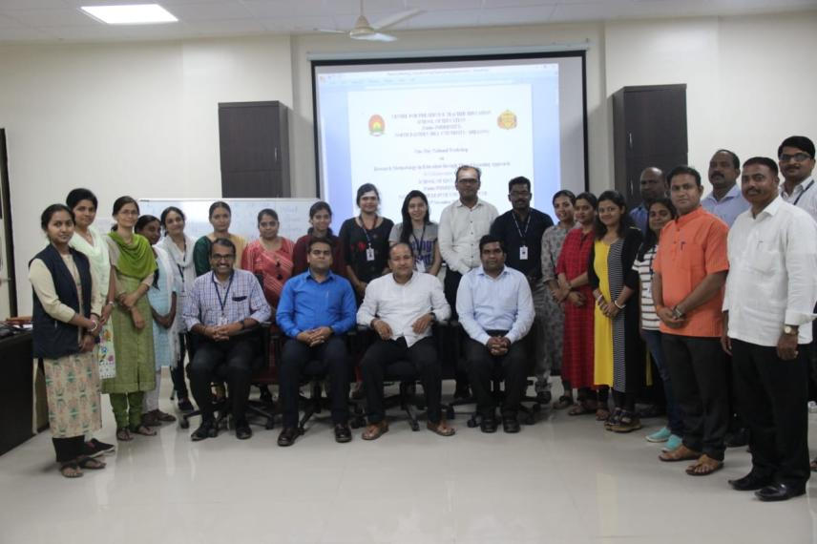
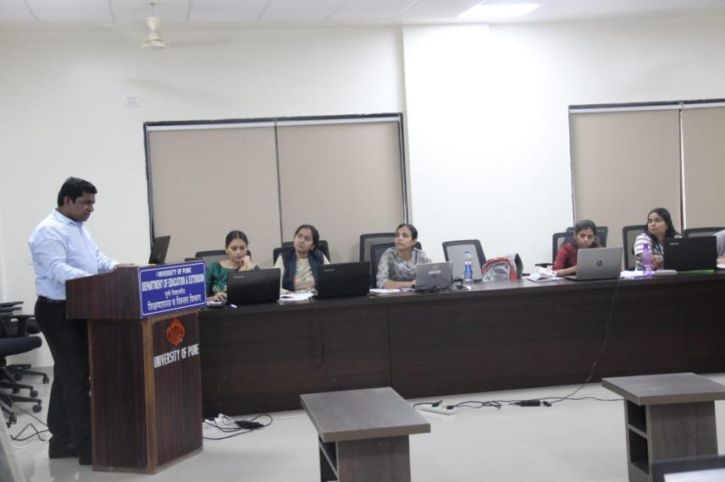

Dr. Amareshwaran
Programme Coordinator
Centre for Pre-Service Teacher Education
School of Education, NEHU, Shillong

Report on Orientation Programme on Research Methodology
(Refer to sl no.19)
(Dr Vandana)
November 13-14, 2019
Introduction:
The discourse of teacher training is incomplete without research. Research enables teachers to develop innovative practices in teaching and modify the existing practices. Research is an important instrument for knowledge generation and verification. In-depth understanding of methodological aspects of research is crucial for teachers and researchers. The present workshop was organized to equip the participants with knowledge of research designs, tool construction, sampling techniques, and publication ethics.
Objectives of the workshop
- To acquaint students about mixed method research design.
- To develop in-depth understanding among scholars about sampling design and instrumentation in social science research.
- To give the participants hands-on experience on various aspects of research methodology.
- To sensitize scholars about ethical issues and considerations involved in social science research.
Target population: Pre-service teachers, M.Phil. and Ph.D. scholars (across India) from social science and education background.
Number of Participants- 25
Duration of the workshop- 2 days (13-14 November, 2019)
Venue- UTirot Sing Syiem Guest House, NEHU Campus, Shillong, Meghalaya.
Registration- No registration fee was collected.
TA/DA and accommodation to the participants: TA was provided to all the outstation participants. Accommodation was provided to the participants who sought for the same. Lunch and refreshment were provided to all the participants.
Conduction of the Workshop: The workshop was conducted in two days; the detailed report of the two-day workshop is as follows;

Day-1 (13th November, 2019)
The workshop started with a formal inaugural speech by Prof C. Nongbri, Dean School of Education, NEHU, Shillong, followed by a speech by Dr. Ibadani Syiem. Whereby, the project co-ordinator and convener of the PMMMNMTT, Prof. S.M Sungoh introduced the project and the programme of the participants. In the pre-lunch session of the workshop, resource person was Prof. Meenakshi Singh from Faculty of Education, BHU, Varanasi) who gave a comprehensive and interactive lecture on Sampling Design. She discussed about population and its major types, sample frame, types of sampling etc. among other things falling under the above mentioned topic. This was followed by a practical session, where participants were divided into groups (six in each) and distributed with worksheets. This was aimed at providing hands on experiences to the participants.
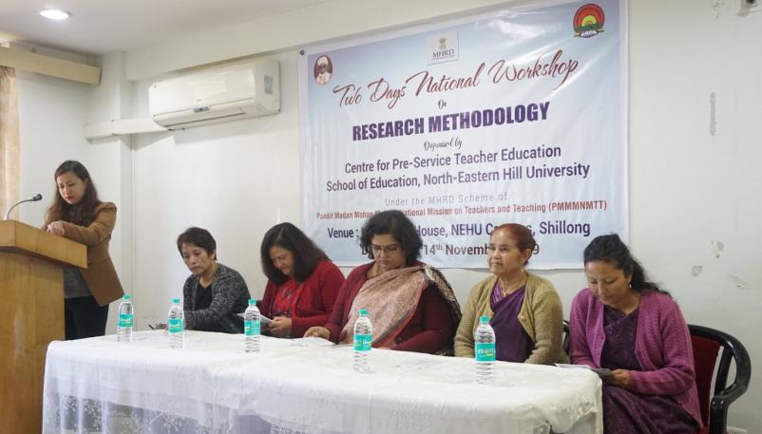
In the post-lunch session there was again Prof. Meenakshi Singh, who delivered an interactive lecture on the broad topic Instrumentation in social science research. Wherein she discussed questionnaire development and validation, essentials of validation, types of validity, pilot testing etc. Again this was followed by hands-on practical session. Dr Vandana and Prof Meenakshi were moderators for the workshop session.
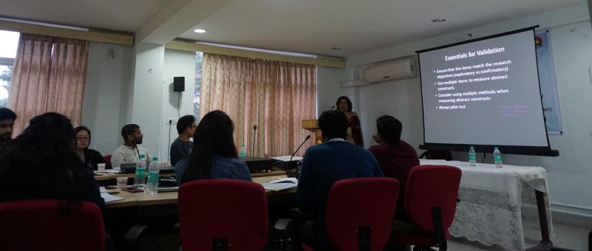
Outcome: The participants learned about the basics of research. They developed in-depth understanding about sampling design and instrumentation in social science research. And the practical sessions in both the pre-lunch and post-lunch optimized their learning outcome.
Day-2
The pre-lunch session of the second day of the workshop was conducted by Prof. S. M. Sungoh from Dept of Education, NEHU, Shillong. She was dealing with the topic review of related literature, under which she discussed about the general format of a research proposal, literature priority, where to start and how to start reviewing, types and structure of literature review. Prof Sungoh have elaborated the different aspects of literature review and had an interactive session with students.
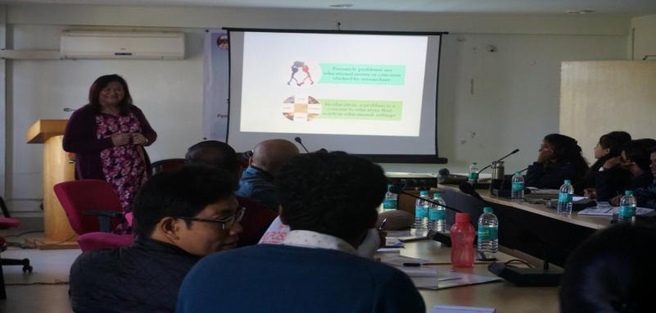
The next pre lunch session was conducted by Dr.Vandana from Dept of Education, NEHU, Shillong, who had stressed on mixed method research design. She gave an in-depth lecture on the basics of mixed method research design, its types, saturation point, sampling and validation in mixed method research. At the end of the lecture an interaction session was kept wherein participants’ doubts and concerns were addressed by the resource person.
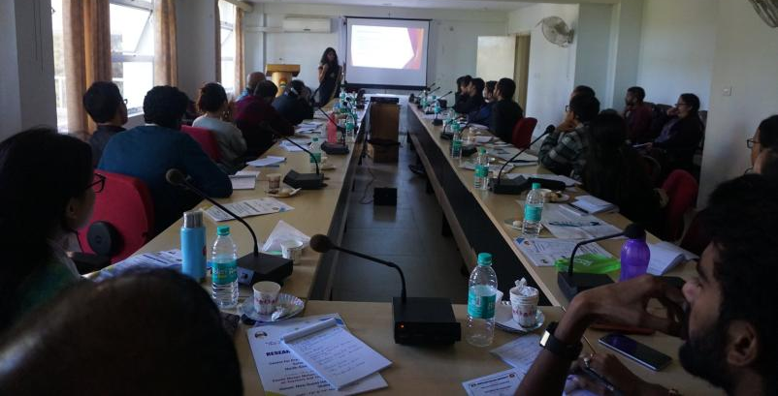
In the post-lunch session Mr. F. R. Sumer (Deputy librarian, NEHU, Shillong) led the workshop and he dealt with the topic writing research paper; Referencing styles (in-text, footnotes, reference, research ethics & plagiarism (Theory and hands-on experience). Under his topic, he stressed on academic integrity, academic ethics, Mendeley software, scopus and science direct, plagiarism, anti-plagiarism softwares etc.
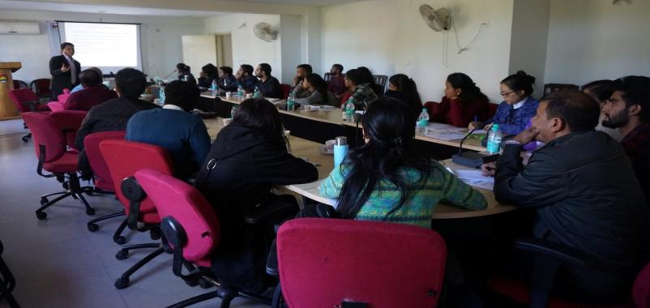

Second day program came to an end with valedictory session and certificate distribution. Valedictory session was conducted by Dr Vandana, the program coordinator. Valedictory speech was given by Prof. C Nongbri, Dean School of Education, followed by participants’ feedback. Afterwards, certificate distribution was done by Prof S M Sungoh, Co-ordinator PMMMNMTT. The workshop came to an end with the vote of thanks from Dr Vandana
.
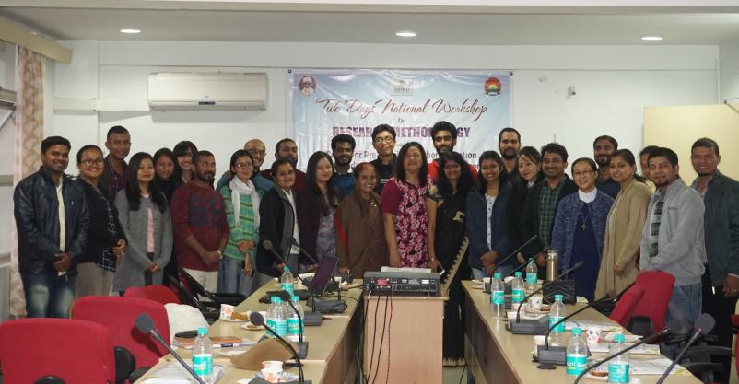
Outcome: Participants were acquainted with mixed method research design. They got a clear idea about dos and don’ts of literature review. They also got to know about the referencing styles, how to use anti-plagiarism software. Participants got practical knowledge of using the Mendeley software.
Organizing Secretary:
Dr.Vandana,
Assistant Professor, Department of Education
NEHU, Shillong.

Convener:
Prof. S.M. Sungoh
Co-ordinator (PMMMNMTT)

Report on National Workshop on Integration Of Theory and Practice of Education through ICT
(Refer to sl no. 20)
(Dr Amareshwaran)
November 19, 2019
The main aim of education is all-round development of an individual i.e. Physical Development, Mental Development, Social Development, Spiritual Development, Political Development, Economic Development, Technological Development and so on. The home and school are playing a pivotal role in the process of all-round development of a student. A school/an educational institution is a miniature of society. A student can learn at any time and place from/through any person or thing. A systematic learning process helps a student to learn more easily and quickly within a given time. There are various types of learning theories (Behaviourism, Cognitivism, and Constructivism) which really help the individual for systematic learning. Learning is a lifelong process. There is no unique definition for learning. Behaviourism says that learning and behaviour changes are acquired by linking stimuli and response; according to cognitivism learning is internal and is a result of an individual processing and organizing new information; and according to Constructivism, knowledge is constructed by adapting new information based on previous knowledge and experience of an individual. Social constructivism is playing a major role in learning process of an individual in the present digital world. Social constructivism reflects the work of Russian Psychologist Lev Vygotsky, who researched the role of social interaction in learning. Vygotsky believed that learning is driven by external forces including culture, language, and social interaction, and that every mental function has a social component. He is best known for his theory of the Zone of Proximal Development (ZPD). The main aim of the workshop is to show right paths to student-teachers and teacher educators to integrate theory and practice of learning.
Objectives of the Workshop
- To Sensitise Student-Teachers and Teacher Educators to use social learning theory in teaching-learning process.
- To provide the detailed information about the various types of learning theories under behaviourism, cognitivism, and constructivism.
- To use OER content with special reference to learning theories rightly in teaching-learning process.
- To create an active-learning environment through 7 Ss Model of Learning and Teaching through Online.
Broad Themes of the Workshop
- Social Constructivism
- Open Educational Resources (OER) of Theory and Practice of Learning
- 7 Ss Model of Learning and Teaching through Online
Programme
The programme started with inaugural function. Ms. Yesikhani R. Marak, the Principal, DIET, Rongkhon, Tura chaired the session. Dr. Chellang R. Marak welcomed all the delegates, teacher educators and student teachers. There 120 participants attended the programme. Ms. Y.R. Marak stressed the need and importance of ICT in teaching and learning. She also informed that Integration of theory and practice of education through ICT is need of an hour. Dr. Manoj Rana, Assistant Librarian, NEHU, Shillong Campus, Shillong delivered vote of thanks.
The programme was sub-divided by three broad themes viz., Social Constructivism, OER of Theory and Practice of Learning and 7 S’s Model of Learning and Teaching through Online. Dr. Chellang R. Marak handled the first session by covering the first theme i.e. Social Constructivism. He stressed the role of constructivism in teaching and learning for overall development of an individual. The Second session was taken by Dr. Manoj Rana, Assistant Librarian, NEHU, Shillong. The resource person covered OER of theory and practice of learning in the present session. Dr. Rana showed Open Educational Resources through hand-on activities.
The last and final session was handled by Dr. N. Amareswaran, Assistant Professor, Dept of Education, NEHU, Shillong. The resource person introduced his own model i.e. 7 S’s Model of Learning and Teaching through Online. The seven S’s are Search, Select, Study, Skilful, Store, Share and Smart. The resource person delivered his lecture through hand-on activities. He delivered his lecture by giving appropriate live examples to integrate theory and practice of education by using various ICT tools. The resource person shared 15 theories of education through his blog https://hamsareddy.blogspot.com.
The programme ended by distributing certificates to all the participants. The participants really felt that the programmed was very helpful and showed their interest in the programme. The student teachers and teacher educators of DIET, Tura requested to organize some more programmes for the benefits of student teachers and teacher educators.
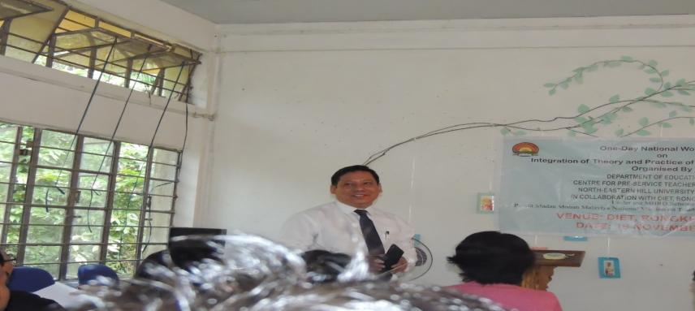
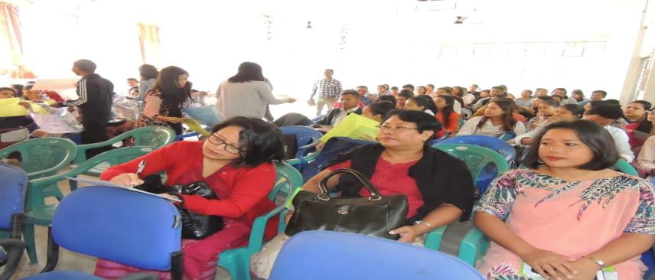

Dr. Amareswaran
Programme Coordinator
Centre for Pre-Service Teacher Education
School of Education, NEHU, Shillong

A Report on National Workshop on Integration Of Theory and Practice of Education through ICT in collaboration with Dept of Education, NEHU, Tura
(Refer to sl no. 21)
(Dr Amareshwaran)
November 19, 2019
The main aim of education is all-round development of an individual i.e. Physical Development, Mental Development, Social Development, Spiritual Development, Political Development, Economic Development, Technological Development and so on. The home and school are playing a pivotal role in the process of all-round development of a student. A school/an educational institution is a miniature of society. A student can learn at any time and place from/through any person or thing. A systematic learning process helps a student to learn more easily and quickly within a given time. There are various types of learning theories (Behaviourism, Cognitivism, and Constructivism) which really help the individual for systematic learning. Learning is a lifelong process. There is no unique definition for learning. Behaviourism says that learning and behaviour changes are acquired by linking stimuli and response; according to cognitivism learning is internal and is a result of an individual processing and organizing new information; and according to Constructivism, knowledge is constructed by adapting new information based on previous knowledge and experience of an individual. Social constructivism is playing a major role in learning process of an individual in the present digital world. Social constructivism reflects the work of Russian Psychologist Lev Vygotsky, who researched the role of social interaction in learning. Vygotsky believed that learning is driven by external forces including culture, language, and social interaction, and that every mental function has a social component. He is best known for his theory of the Zone of Proximal Development (ZPD). The main aim of the workshop is to show right paths to students and scholars to integrate theory and practice of learning.
Objectives of the Workshop
- To Sensitise Students and Scholars to use social learning theory in teaching-learning process.
- To provide the detailed information about the various types of learning theories under behaviourism, cognitivism, and constructivism.
- To use OER content with special reference to learning theories rightly in teaching-learning process.
- To create an active-learning environment through 7 Ss Model of Learning and Teaching through Online.
Broad Themes of the Workshop
- Social Constructivism
- Open Educational Resources (OER) of Theory and Practice of Learning
- 7 Ss Model of Learning and Teaching through Online
Programme
The programme started with inaugural function chaired by Prof. Nikme S.C.Momin, Head, Dept of Education, NEHU, Tura Campus. Mrs. Geetam Chetry welcomed all the delegates, teachers of education and other departments, students, and scholars. There 149 participants attended the programme. Prof. Nikme S.C. Momin stressed the need and importance of ICT in teaching and learning. She also informed that Integration of theory and practice of education through ICT is need of an hour. Prof. B.C. Das, Dept of Education and Dr. A.J. Sing, Assistant Librarian, NEHU, Tura Campus acted as guests of honour at inaugural function. Dr. N. Amarewaran, Workshop Co-ordinator delivered vote of thanks.

The programme was subdivided into three broad themes viz., Social Constructivism, OER of Theory and Practice of Learning and 7 S’s Model of Learning and Teaching through Online. Prof. Nikme S.C. Momin handled the first session by covering the first theme i.e. Social Constructivism. She stressed the role of constructivism in teaching and learning for overall development of an individual. The Second session was taken by Dr. N. Amareswaran. The resource person introduced his own model i.e. 7 S’s Model of Learning and Teaching through Online. The seven S’s are Search, Select, Study, Skilful, Store, Share and Smart. The resource person delivered his lecture through hand-on activities. He delivered his lecture by giving appropriate live examples to integrate theory and practice of education by using various ICT tools. The resource person shared 15 theories of education through his blog https://hamsareddy.blogspot.com.

The last and final session was handled by Dr. Manoj Rana, Assistant Librarian and Prof. Nikme S.C.Momin. The resource persons covered OER of theory and practice of learning in the present session. Dr. Rana showed Open Educational Resources through hand-on activities. Prof. Nikme S.C. Momin used the theory part of learning and Dr. Rana showed the same information through online resources.

The programme ended by distributing certificates to all the participants. The participants benefited from the programmed and showed keen interest. The participants and teachers of the department requested to organize some more programmes for the benefits of students and scholars.
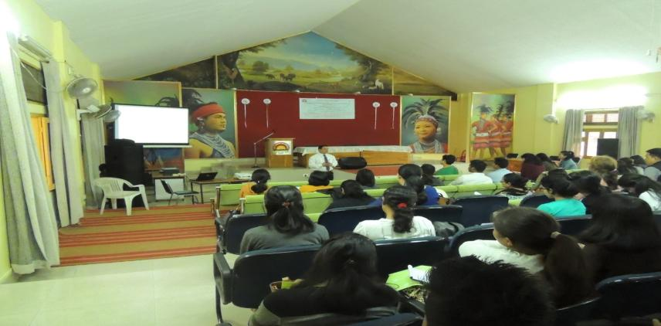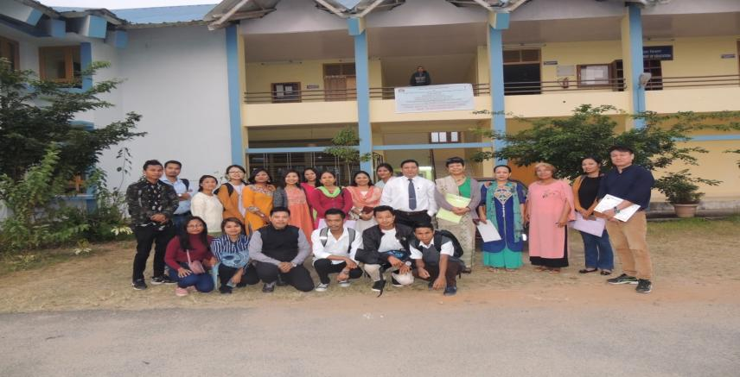
Dr. Amareshwaran
Programme Coordinator
Centre for Pre-Service Teacher Education
School of Education, NEHU, Shillong

Report on Second National Workshop on Application of SPSS in ICT Integrated Educational Research
(Refer to sl no. 22)
(Dr Amareshwaran)
November 21-22 , 2019
Introduction
The Statistical Package for the Social Sciences is playing a major role in data analysis process of the social sciences disciplines in general and educational research in particular. The majority of teachers and researchers are using the SPSS in their daily life. The Centre for Pre-Service Teacher Education has successfully organized the First National Workshop on “Applications of SPPS in ICT Integrated Educational Research” during 29th -30th October 2019. The Centre decided to organize the Second National Workshop on the same topic by covering few more new applications of SPSS which are really helpful for all the research scholars of education discipline.
Objectives of the Workshop
- To Sensitise the Research Scholars to use SPSS in Educational Research.
- To provide the detailed information about how to use SPSS in Educational Research.
- To provide OER content with special reference to applications of SPSS in ICT integrated Educational Research.
- To provide hands-on experience to research scholars on the applications of SPSS in Educational Research.
Broad Themes of the Workshop
- SPSS – Factor Analysis
- SPSS - Reliability of a test (Types)
- SPSS – Correlation (Types)
- SPSS – Regression (Types)
- SPSS – Kruskal – Wallis test
- SPSS – Friedman test
- SPSS – Chi-square test
Programme
The Two-Day National Workshop on Applications of SPSS in ICT Integrated Educational Research in collaboration with Computer Centre, NEHU, Shillong started with Inaugural Function. Mrs. Shalini welcomed all the delegates and participants (Scholars and Teachers). Prof. P.K. Gupta, the former Dean, School of Education, NEHU, Shillong delivered the inaugural address. Prof. Gupta stressed the need of research for happy and healthy life. He mentioned that, the identification of a research problem is a problem for research scholar. He advised to all the participants to select the right and appropriate problem for a research study. The Special Invitee, P.P. Dey, informed about the development of computers (software and hardware) with firsthand experience. Prof. S.M. Sungh, the Convenor PMMMNMTT, Prof. I. Syiem, the Head, Dept of Education, Pro. Goel, Dr. Panneer Selvam, Dr. Manoj Rana, and other teachers of the various departments attended the inaugural function. Dr. N. Amareswaran, the workshop coordinator delivered vote of thanks.
The programme covered major topics through eight sessions. In the first day, the first session was handled by Prof. P.K. Gupta. The resource person delivered an excellent and wonderful lecture on the topic ‘Philosophical Basis of Educational Research’. The resource person influenced all the participants through his lecture. The second and fourth sessions were handled by Prof. Goel and Dr. N. Amareswaran. The resource persons took more care of all the participants regarding hands-on activities for Chi-square Test and Friedman Test. The third session was delivered by Dr. Manoj Rana & Dr. Panneer Selvam. The resource persons delivered a lecture cum hands-on activities on the topic Correlation (types). The participants were involved with hands-on activities. The participants used internet to refer online manuals regarding SPSS.
The first session of second day was handled by Prof. P.K. Gupta. The resource person delivered a wonderful lecture on the topic ‘Qualitative and Quantitative Approaches to Educational Test’. Prof. Gupta, the resource person mentioned many live examples to understand the concept easily. The second session was handled by Prof. Goel & Dr. N. Amareswaran. The resource persons taught all the participants to work on the Kruskal-Wallis Test through SPSS by giving own problem. The third session was handled by Dr. Manoj Rana & Dr. N. Amareswaran. The resource persons explain the need and importance of Regression Analysis (types) to the participants and motivated them to do by themselves. The fourth and the last session of the workshop was handled by Dr. Panneer Selvam & Dr. N. Amareswaran. The resource persons provided data to all the participants. Dr. N. Amareswaran provided valuable information and data through his blog https://hamsareddy.blogspot.com. All the participants benefitted through this workshop.
The programme was ended by taking the group photo and by distributing the certificates to all the participants and resource persons. The participants requested the organizer to conduct one week National Workshop on SPSS to be acquainted and to learn more concepts on SPSS.
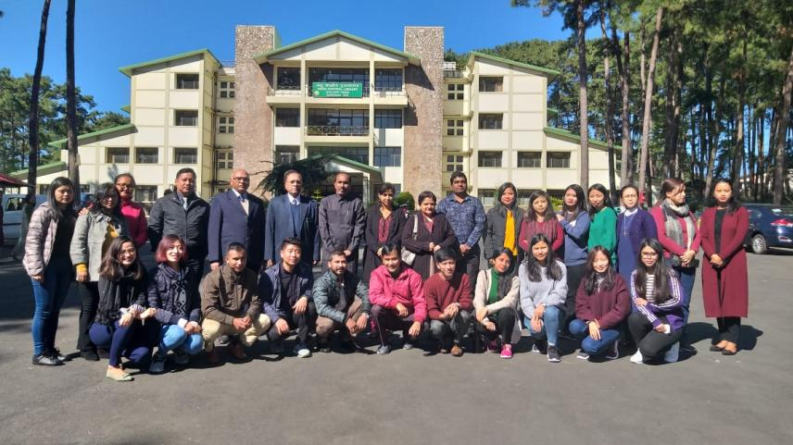
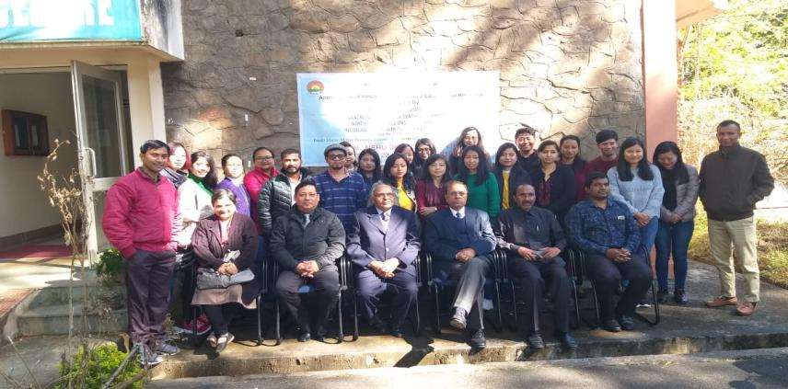
Dr. Amareshwaran
Programme Coordinator
Centre for Pre-Service Teacher Education
School of Education, NEHU, Shillong

Invited Lecture on Knowledge Level, Understanding Level and Reflective Level of Teaching
(Refer to sl no. 23)
(Prof I. Syiem, Dr Ashok Kumar, Prof S.M. Sungoh)
December 4, 2019
Teaching is a purposeful activity and through teaching the teacher brings a desirable change in the learner. Both the concepts teaching and learning are interrelated to each other. Development of all-round personality of the learner is the final goal of teaching and learning. During teaching an interaction takes place between an experienced person (teacher) and an inexperienced person (student). Here, the main aim is to bring change in the behavior of the student. Teachers teach students at three levels. They have to keep in mind about the developmental stage of the learners so that desired educational objectives can be achieved. These three levels are 1. Memory level: least Thoughtful teaching, 2. Understanding level: moderate Thoughtful teaching and 3. Reflective level: Upper/most thoughtful level.

The existing education system focuses on first two levels of teaching i.e. memory and understanding. However the reflective level is very important and provides scope for introspection. Moreover it is Student centred rather than teacher centred. Prospective teachers must have the knowledge of all three levels of teaching and apply the same in the classrooms.
In this context, recognising the importance of the different levels of teaching, the Department of Education, North-Eastern Hill University in collaboration with DIET, Nongpoh under the MHRD Scheme of Pandit Madan Mohan Malviya National Mission on Teachers and Teaching have planned to organize an Invited Lecture on ‘Knowledge, Understanding and Reflective Levels of Teaching’. The lecture aims to sensitize the student-teachers and teacher educators on different levels of teaching.

Objectives of the Workshop
- To sensitise student-teachers and teacher educators on different levels of teaching.
- To develop insights on various types of teaching among student-teachers and teacher educators with the help of hands on experiences
- To improve the quality in teaching –learning process with special reference to North-East

Date & Venue
The One –Day Invited lecture took place on 4th December, 2019 at the DIET, Shedin, Nongpoh.

Total number of Participants: 52
Resource Persons:
Dr. Anand Valmiki, NERIE, Shillong.
Dr. Ashok Kumr, Dept. of Education, NEHU, Shillong
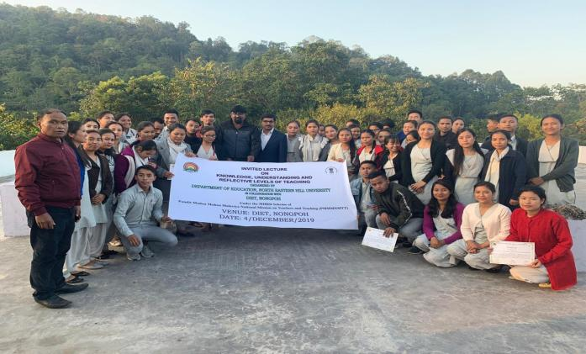

The invited lecture on Knowledge, Understanding and Reflective Levels of Teaching for Pre-service Student Teachers commenced with the registration of pre service teachers who were the participants of the programme at 9.30 am. This was followed by the formal Inaugural function at 10.00am.

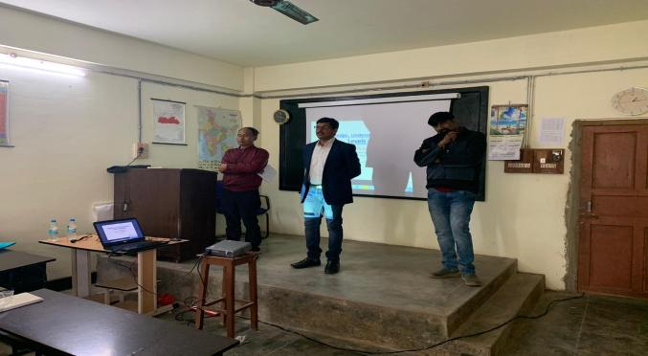

The opening Session began with a warm welcome by the in-charge principal of the DIET, Nongpoh, Dr. Elevenstone Synrem who graciously acknowledged and welcomed all the participants, resource persons and invited guests.

Dr.Ashok Kumar, organizing secretary briefly mentioned about the project, its mission & significance in achieving quality in teacher education and also importance of the theme of the invited lecture .
The Inaugural function was then followed with refreshments and there after the technical sessions of the program was carried out.
Technical Session 1: commenced at 10.30 am wherein Resource persons gave their presentations.
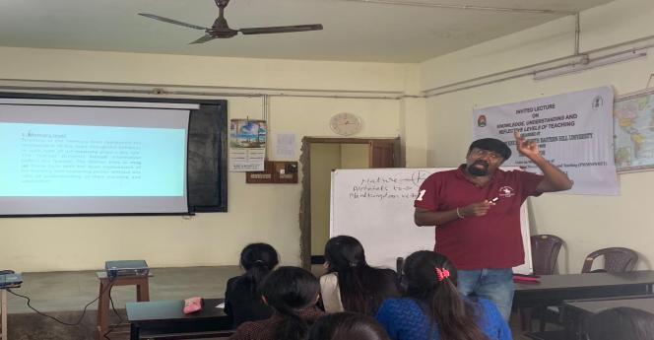
The First speaker of Technical Session – I was Dr. Anand Valmiki , Assistant Professor NERIE Shillong who presented Knowledge, Understanding and Reflective Levels of Teaching. His lecture covered the hierarchy of levels of teaching, psychological theories and ideas which influence these levels.

With regard to Memory level, he explained Herbert theory of appreciation, Thorndike’s connectionism and theory of conditioning. The lecture stressed upon Objectives of Memory-level teaching i. Acquisition of presented facts through “rote learning”, ii. Retention and reproduction through recall or recognition. While talking on Nature of the subject matter and its presentation he mentioned that Memory level teaching is predominantly subject centered. He elaborated on Classroom implications of teaching at memory level i.e. i. Subject matter as the Focus, ii. Learning is short-lived, iii. Great strain on the learner, iv. Motivation, v. Testing, vi. Interaction and vii. Superficial knowledge. He also dealt with role of teacher and learner, uses of knowledge level and also merits and demerits. The session ended at 11.30am.

Technical Session – II : commenced at 11.30 pm
The 2nd session continued with lecture of Dr. Anand Valmiki. He focused on Understanding and Reflective Levels of Teaching, The lecture stressed upon Objectives, Nature of the subject matter and its presentation, Classroom implications, role of teacher and learner, uses, merits and demerits of the both the levels of teaching. He mentioned reflective level is of higher order thinking level where teachers should act as facilitator and develop problem solving ability among learners. The session ended at 12.30am.
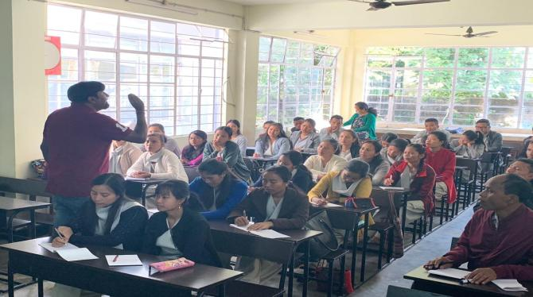
Technical Session – III commenced at 12.30 pm
The 2nd session started with lecture of Dr. Ashok Kumar, NEHU,Shillong. The lecture focused on Functions of teaching, Phases of teaching. He stressed upon Diagnostic, Prescriptive and Evaluation functions of teaching and switched over to different phases of teaching i.e., Pre-active or Preparation Phase, Intermediate or Presentation Phase and Post-active or evaluation Phase.
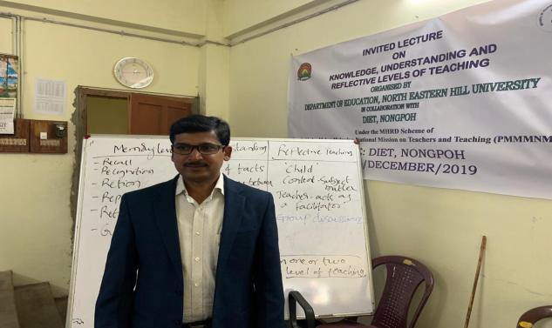
He also elaborated on different Levels of teaching with support of Models of teaching. For explaining knowledge level he used Herbert’s model. For explaining understanding level he used Morrison model and for Reflective level he used Hunt’s mode of teaching. Each model includes Focus, Syntax, Social system and Support system. The session ended at 1.30pm.
Lunch break 1.30pm-2.00pm
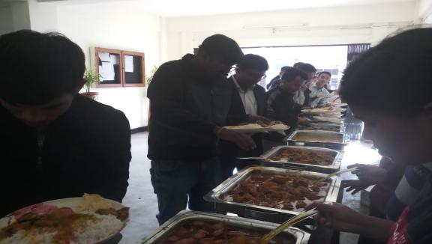
Technical Session – IV commenced at 2.00 pm
The post lunch session started with lecture of Dr. Anand Valmiki. He explained all the levels of teaching with the help of numerous examples. This was followed by group work by the students. Students worked in groups to identify different levels of teaching points from the MBOSE elementary class text books. Resource persons Dr.Anand Vamiki and Dr.Ashok Kumar supervised, guided and clarified their doubts. The session ended at 3.00pm.
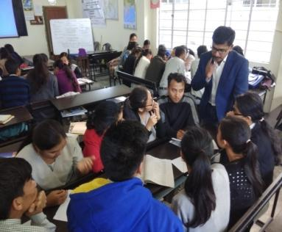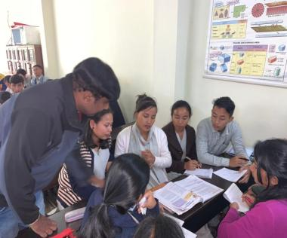
Technical Session – V commenced at 3.00 pm.
In the session, Each Group presented their work as mentioned below. Dr.Anand Vamiki and Dr.Ashok Kumar acted as moderators and gave their inputs.
Group- I : Fundamental Rights
Group – II : Pollution
Group –III : Interdependence in Nature
Group –IV : Components of Environment
It may be reported that Student teachers from DIET, Nongpoh have participated very actively & worked out effectively in groups and presented wonderfully with lot of confidence.
Resource Persons then gave given their reflection on Lesson Plans after every presentation of student teachers. .
The Workshop concluded with a Certificate distribution and Vote of thanks.
Dr. Ashok Kumar  Organising Secretary  Dept of Education  NEHU, Shillong | Prof. I. Syiem  Organising Secretary  Head, Dept of Education  NEHU, Shillong | Prof. S.M. Sungoh  Project Co-Ordinator (PMMMNMTT)  North-Eastern Hill University  Shillong, Meghalaya.

