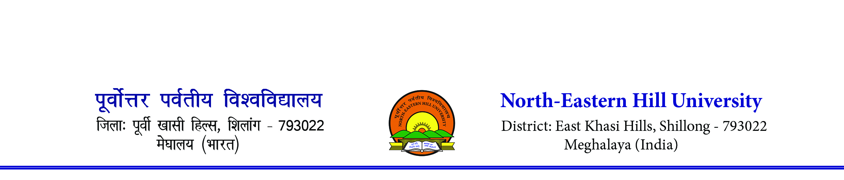Sports Department
NEHU Inter College Basketball (Men) Tournament 2023
Venue- Basketball Courts, NEHU Permanent Campus, Shillong
From 19th September to 23rd September 2023
Revised Fixture
- K. L. Bajoria College, Shillong (Bye)
19/09/2023 1.30 pm
- St. Edmund’s College (Bye)
21/09/2023 10.00 am
- Shillong Law College(Bye)
20/09/2023 9.30 am
- Nongstoin College(Bye)
22/09/2023 11.45 am
- Synod College
19/09/2023 9.30am
- NEIGRIHMS
20/09/2023 10.30 am
- Christ College (Bye)
21/09/2023 11.30 am
- Union Christian College (Bye)
20/09/2023 1.30 pm
- Shillong College(Bye)

23/09/2013 11.30 am
(FINAL)
- NEHU, Shillong
20/09/2023 2.45 pm
- Shillong Commerce College
21/09/2023 1.30 pm
- Sankardev College
20/09/2023 11.30 am
- Don Bosco College, Tura
22/09/2023 2.45 pm
- Kiang Nangbah Govt. College
19/09/2017 2.45 pm
- St. Dominic’s College
21/09/2023 2.45 pm
- Seng Khasi College
19/09/2023 11.30 am
- St. Anthony’s College

Note-
- Fixture is subject to alteration due to any unavoidable circumstances
- For any further clarification please contact Mrs. A. R. Synnah, Basketball Coach cum Convener -9436311302

Sports Department
NEHU Inter College Basketball (Women) Tournament 2023-24
Venue- Basketball Courts, NEHU Permanent Campus, Shillong
From 19th September to 23rd September 2023
Revised Fixture
- St. Anthony’s College, Shillong
20/09/2023 1.30 pm
- St. Edmund’s College
21/09/2023 1.45 pm
- Kiang Nangbah Govt. College
19/09/2023 9.30 am
- Shillong Commerce College
22/09/2023 10 am
- NEIGRIHMS
19/09/2023 11.00 am
- Seng Khasi College
21/09/2023 10 am
- Sankardev College
20/09/2023 10.00 am
- St. Mary’s College
23/09/2023 10 am
(FINAL)
- Shillong College
19/09/2023 1.30 pm
- Christ College
21/09/2023 2.45 pm
- NEHU, Shillong
20/09/2023 11.30 am
- Shillong Law College
22/09/2023 1.30 pm
- Union Christian College
20/09/2023 2.45 pm
- Balawan College
21/09/2023 11.30 am
- Nongstoin College
19/09/2023 2.45 pm
- Lady Keane College

Note-
- Fixture is subject to alteration due to any unavoidable circumstances
- For any further clarification please contact Mrs. A. R. Synnah, Basketball Coach cum Convener -9436311302

