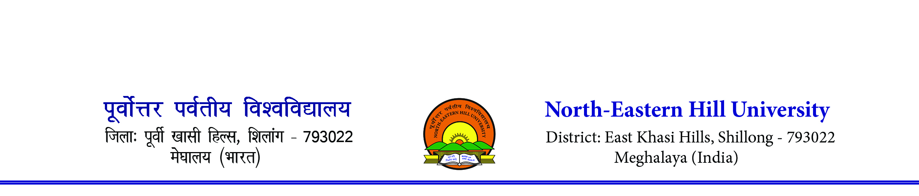
Sports Department
NEHU Inter College Football (Men) Tournament 2023
Venue- SAI, Football Ground, NEHU Campus, Shillong
From 21st August to 31st August 2023
Revised Fixture
Group-A
- St. Anthony’s College

- Bye
25/08/2023 8.30 am
- St. Dominic College, Shillong
21/08/2023 8.30 am
- Ri-Bhoi College, Nongpoh
28/08/2023 1.30 pm
- NEHU Tura Campus
21/08/2023 10.15 am
- Sohra Govt. College
25/08/2023 10.15 am
- K. L. Bajoria College
21/08/2023 1.00 pm
- Morningstar College
30/08/2023 9.30 am
Group-B
- Seng Khasi College
22/08/2023 8.00 am
- Mawlai Presbyterian College
25/08/2023 1.30 pm
- Union Christian College, Umiam
22/08/2023 9.30 am
- Donbosco College College, Byndihati
29/08/2023 8.30 am
- NEIAH
22/08/2023 11.00 am
- Smit College
26/08/2023 8.30 am
- Balawan College, Umsning
22/08/2023 1.30 pm
- Kiang Nangbah Govt. College
Final: - Winner of A & B v/s Winner of C & D on 31/08/2023 at 9.30 am
Note-
- Accommodation will only be provided to those outstation colleges who are residing above 80 km of distance from the North-Eastern Hill University, Shillong prior to quarter final match. Any outstation colleges qualified for the quarter final matches will be provided accommodation irrespective of distance. Outstation team has to vacate the accommodation place on the day of their last match.
- If any team does not turn up as per scheduled time, the organizers will wait a maximum of 5 minutes to start the match otherwise walk over will be given to the opponent team. Any excuses especially traffic jam will not be entertained. Please plan accordingly.

(N. Das)
Asst. Director (PE & Sports)
Sports Department
NEHU Inter College Football (Men) Tournament 2023
Venue- SAI, Football Ground, NEHU Campus, Shillong
From 21st August to 31st August 2023
Revised Fixture
Group- C
- BBS College
24/08/2023 1.30 pm
- Shillong Commerce College
26/08/2023 10.15 am
- NEIGRIHMS
23/08/2019 8.00 am
- JJM Nicholas Roy College
29/08/2023 10.15 am
- Riwar College, Pynursla
23/08/2023 9.30 am
- Shillong Law College
26/08/2023 1.30 pm
- Nongtalang College
23/08/2023 11.00 am
- St. Edmund’s College
30/08/2023 1.00 pm
Group-D
- NEHU, Shillong
23/08/2023 1.30 pm
- Phukan Memorial College, Dalu
28/08/2023 8.30 am
- Shangpung College, Shangpung
24/08/2023 8.00 am
- Khadsawphra College, Mairang
29/08/2023 1.30 pm
- Khrawsing Christian College
24/08/2023 9.30 am
- Ri-Bhoi Synod College, Umsning
28/08/2023 10.15 am
- Jaintia Eastern College
24/08/2023 11.00 am
- Shillong College
Final: - Winner of A & B v/s Winner of C & D on 31/08/2023 at 9.30 am
Note-
- Accommodation will only be provided to those outstation colleges who are residing above 80 km of distance from the North-Eastern Hill University, Shillong prior to quarter final match. Those outstation colleges qualified for the quarter final matches will be provided accommodation irrespective of distance.
- If any team does not turn up as per scheduled time, the organizers will wait a maximum of 5 minutes to start the match otherwise walk over will be given to the opponent team. Any excuses especially traffic jam will not be entertained. Please plan accordingly.

(N. Das)
Asst. Director (PE & Sports)

