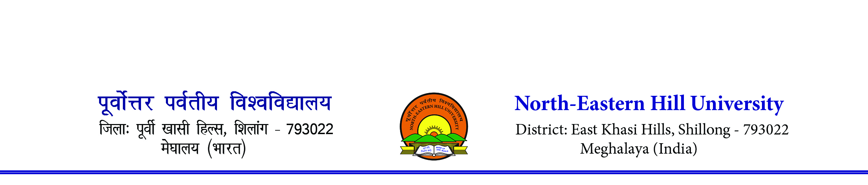
Sports Department
Contact number- 0364-2721381/1383. Email -nehusports@nehu.ac.in

NEHU INTER COLLEGE BASKETBALL MEN & WOMEN TOURNAMENT 2023

TOURNAMENT REGULATIONS

The tournament will be conducted as per the FIBA Official Basketball Rules and Interpretation, 2023.
- Tournament Format: The tournament will be conduct on a single round elimination format (Knock – Out).

- Team Bench Area: The first team named in the fixtures shall occupy the team bench area on the left side of the official’s table.

- Uniform: The uniform of all team members shall consist of:
  - Shirts of the same dominant colour front and back as the shorts. If shirts have sleeves, they must end above the elbow. Long sleeves shirts are not permitted.
  - All players must tuck their shirts into their playing shorts. ‘All in one’ are permitted.
  - Shorts should be of the same dominant colour as that of the shorts. The shorts must end above the knee.
  - Socks must be of the same dominant colour for all team members. Socks need to be visible. (Ankle length socks are not permitted)
  - All teams should have 2 (Two) sets of uniforms. A light colour (preferably white) and a dark colour uniform.
  - Permissible numbers are 00,0,1,2,3,4,5,6,7,8,9,10 to 99.
  - 01, 02 09 are not valid numbers as per FIBA OBR 2023.

- Game time:

  - Teams must report at least 20 minutes before the schedule time. Failing to report will lead to that team losing the match by forfeit as per Article 20 of the FIBA OBR 2023.
  - The games shall consist of 4 (four) quarters of 10 minutes duration each. There will be 2 minutes interval of play between the 1st and the 2nd quarter and also between the 3rd and 4th quarter. There will be 10 minutes interval of play between the 2nd and 3rd quarter.

  - In case there is a tie at the end of the fourth quarter, the game shall continue with as many overtimes of 5 minutes duration each as necessary to break the tie.

- No PROTEST will be entertained.
- Teacher-in-Charge of each college is to ensure that the team maintains discipline during the tournament and team report for play at the venue, time and date as per fixture.

- Under no circumstances protest against officials/referees/judges will be entertained.
- No postponement shall be entertained.
- Referee’s decision during the match is final.

- Colleges will be fully responsible for any indiscipline that may occur before, during and after the match. Tournament Committee reserves the right to suspend colleges for up to 1 to 3 years depending on the seriousness of the incident that may have occurred.
- Every College needs to pay a sum of Rs. 1,000/- as Entry Fee before their first match at the venue along with Annual Sports Affiliation Fee if any.
- Accommodation will only be provided to those outstation colleges who are residing above 80 km of distance from the North-Eastern Hill University, Shillong prior to quarter final match. Any outstation colleges qualified for the quarter final matches will be provided accommodation irrespective of distance. Outstation team has to vacate the accommodation place on the day of their last match.
- If any team does not turn up as per scheduled time, the organizers will wait a maximum of 5 minutes to start the match otherwise walk over will be given to the opponent team. Any excuses especially traffic jam will not be entertained. Please plan accordingly.
- Participating Colleges need to depute 02 escorts officially either coach/manager/ Teacher In-charge along with the team. Only officially deputed escorts will be allowed to enter the ground. Kindly depute escorts and intimate the Sports Department, NEHU with their contact details on or before 16th September 2023 through email nehusports@nehu.ac.in.

Mrs. A. R. Synnah
Basketball Coach Cum
Convener
9436311302

