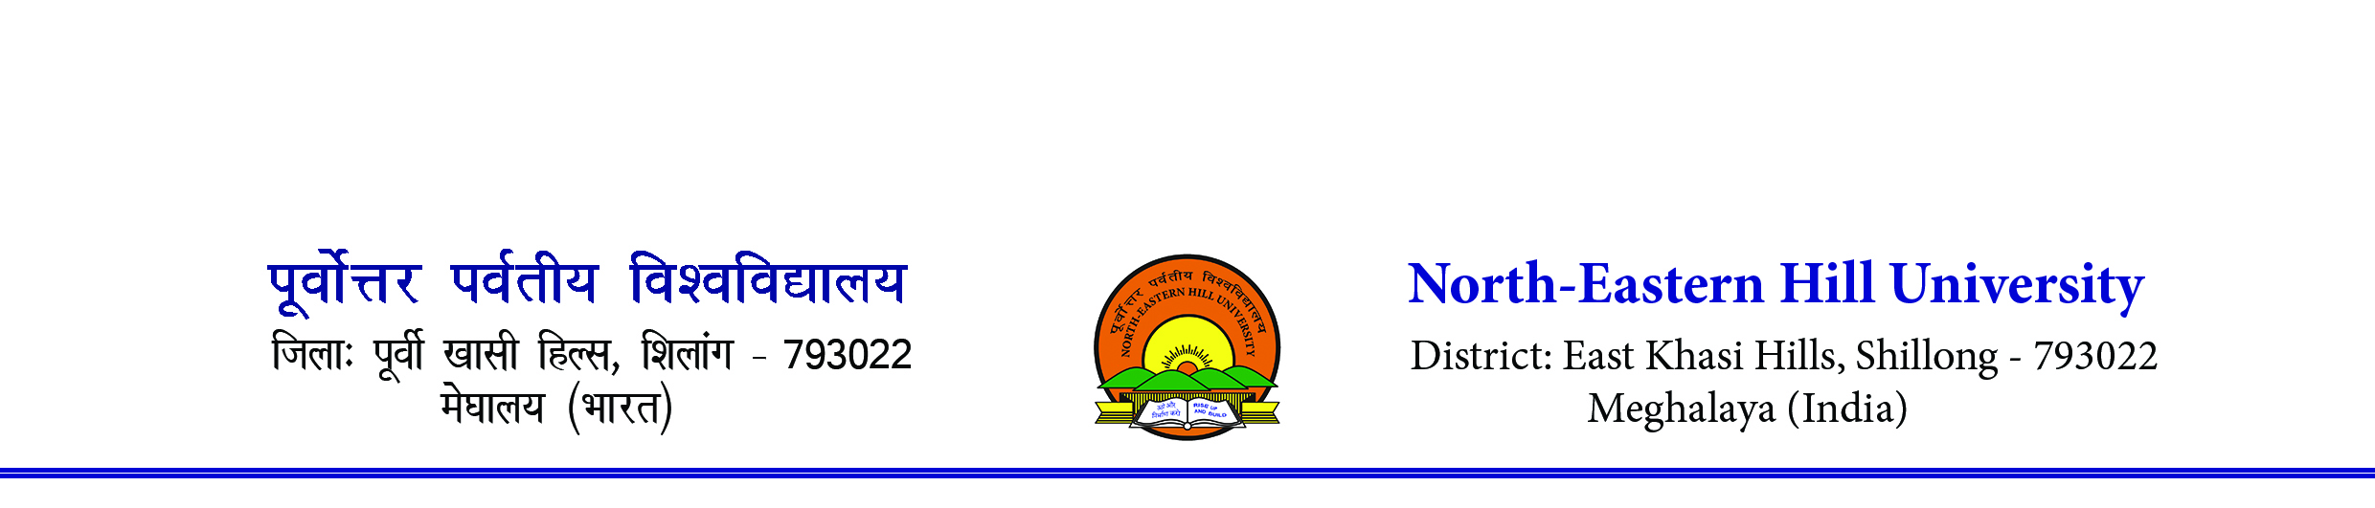 Sports Department
Contact number- 0364-2721381/1383. Email- nehusports@nehu.ac.in
-------------------------------------------------------------------------------------------------------------
RULES AND REGULATIONS FOR NEHU INTER COLLEGE FOOTBALL (MEN) TOURNAMENT, 2023.
1. The tournament shall be conducted on knock-out basis as per A.I.F.F rules.
2. Duration of a match will be 35+5+35 minutes, Semi Final & final matches will be of 45+10+45 minutes.
3. 3(three) substitution shall be allowed in a match.
4. List of players to be submitted 30 minutes before the kick off.
5. Date and timing of the game are subject to alternation according to the decision of the Tournament Committee.
6. In case of draw in the normal time, no extra time shall be given tie-breaker rule will be applied directly.
7. No PROTEST will be entertained.
8. Teacher-in-Charge of each college is to ensure that the team maintains discipline during the tournament and team report for play at the venue, time and date as per fixture.
9. Under no circumstances protest against officials/referees/judges will be entertained.
10. No postponement shall be entertained.
11. Referee’s decision during the match is final.
12. Colleges will be fully responsible for any indiscipline that may occur before, during and after the match. Tournament Committee reserves the right to suspend erring colleges for up to 1 to 3 years depending on the seriousness of the incident that may have occurred.
13. FIXTURE IS SUBJECT TO ALTERATION.
14. Every College needs to pay a sum of Rs. 1,000/- as Entry Fee before their first match at the venue along with Annual Sports Affiliation Fee if any.
15. Accommodation will only be provided to those outstation colleges who are residing above 80 km of distance from the North-Eastern Hill University, Shillong prior to quarter final match. Any outstation colleges qualified for the quarter final matches will be provided accommodation irrespective of distance. Outstation team has to vacate the accommodation place on the day of their last match.
16. If any team does not turn up as per scheduled time, the organizers will wait a maximum of 5 minutes to start the match otherwise walk over will be given to the opponent team. Any excuses especially traffic jam will not be entertained. Please plan accordingly.
17. Participating Colleges need to depute 02 escorts officially either coach/manager/ Teacher In-charge along with the team. Only officially deputed escorts will be allowed to enter the ground. Kindly depute escorts and intimate the Sports Department, NEHU on or before 19th August 2023 through email nehusports@nehu.ac.in.

Sd/-
(N. Das)
Asst. Director (PE & Sports)
Sports Dept. ,NEHU, Shillong.

