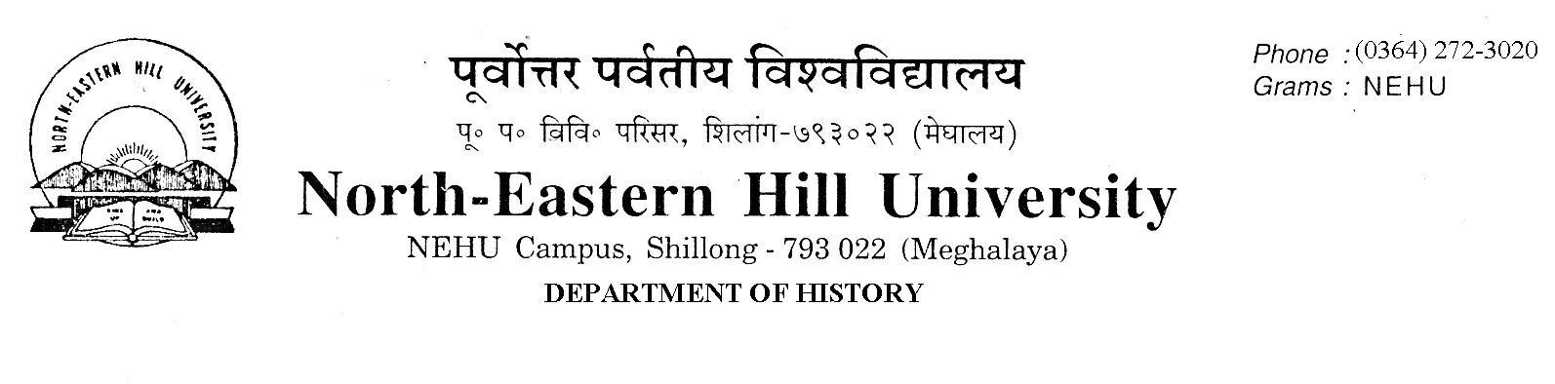
Prof. V. Rengsi
Head

No. DH/63/Ph.D./2019/558 Date: 03-12-2019

Admission Notice

The following candidates have been selected for admission to the Ph.D. and M. Phil. Programmes of study 2019 in the Department of History. For admission candidates are to pay the requisite fees and deposit the receipt of fees paid to the Department of History office latest by 11th December 2019 up to 4 PM failing which they will forfeit their seats.

NO FURTHER CLAIMS WILL BE ENTERTAINED THEREAFTER.
Employed candidates must produce ‘No Objection Certificate’ from their employers.

Sd/-

V. Rengsi

Selected Candidates M. Phil. / Ph. D Admission
Ph.D

Sl. No. |  | Name | Marks in Written Test 70% | Marks in Interview 30% | Weightage  NET/SLET  10%  Over and above | Total
 | 19142726 | ROJA AHMED | 52 | 24.4 | 10 | 86.4
 | 19142598 | AMEBARI KHARKONGOR | 50 | 26.3 | 10 | 86.3
 | 19141708 | CHRISTINE Z.MYLLIEMNGAP | 52 | 23.6 | 10 | 85.6
 | 19142372 | RIMA SARKAR | 52 | 23.6 | 10 | 85.6
 | 19142473 | SWEETTY QUEEN LYNGDOH MAWLONG | 52 | 21.2 |  | 73.2
 | 19140206 | RIPUNJAY NATH | 48 | 23.6 |  | 71.6
 | 19143044 | MEDOSANO MARY | 48 | 23.6 |  | 71.6
 | 19142912 | SUNAINA GOGOI | 35 | 26.4 | 10 | 71.4
 | 19140562 | VUNG LUN MAWI | 50 | 20.9 |  | 70.9
 | 19140573 | SAURABH KUMAR SHANU | 39 | 20.9 | 10 | 69.8
 | 19140530 | DEEPAK KUMAR SHAHI | 40 | 19.6 | 10 | 69.6
 | 19140110 | PANGKIME CH MOMIN | 50 | 19.5 |  | 69.5
 | 19140960 | JASMINE KHARBTENG | 48 | 19.2 |  | 67.2
 | 19142860 | SANSHI UPADHYA (EWS) | 43 | 23.4 |  | 66.4
 | 19141942 | THANGLENMANG CHONGLOI | 49 | 17.3 |  | 66.3
 | 19140014 | LUNMINTHANG LHOUVUM | 52 | 13.8 |  | 65.8
 | 19142033 | KHACHULO KEVEKHA ZEHOL | 46 | 19.6 |  | 65.6
 | 19142009 | KIRTANA BARDALAI | 39 | 23.2 |  | 62.2

M.Phil
Sl. No. |  | Name | Marks in Written Test 70% | Marks in Interview 30% | Weightage  NET/SLET  10%  Over and above | Total
1. | 19130117 | ANGHSUMALEE DUTTA | 48 | 23.5 |  | 71.5
3. | 19130078 | JOYASHREE BORAH | 47 | 16.2 |  | 63.2

Sd/
V. Rengsi

Copy to:
1. The Registrar, NEHU, Shillong.
2. The Finance Officer, NEHU, Shillong.
3. The Librarian, NEHU, Shillong.
4. The Dean Students’ Welfare, NEHU, Shillong.
5. Notice Board.

