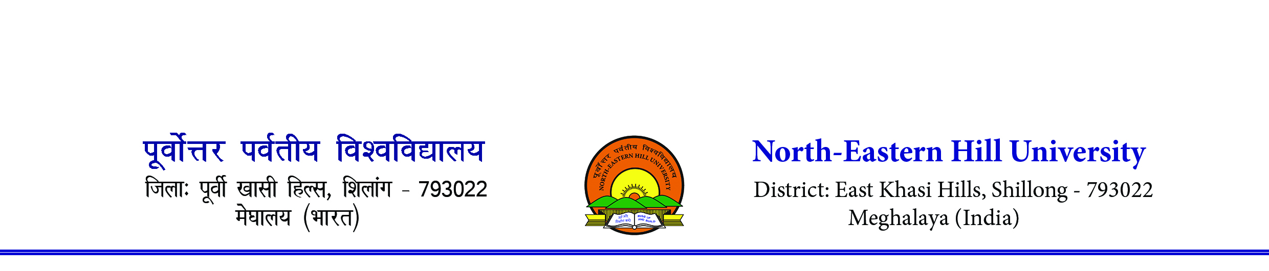
Contact-0364-2721383/1382 Email- nehusports@nehu.ac.in------------------------------------------------------------------------------------------------------------F. No. 1-81/SP/IU/2022- 251 Dated: 28th October 2022
To,
The Director/ Principal
Affiliated Colleges of the
North-Eastern Hill University, Shillong

Subject: Selection Trial for Athletics (Men & Women) for participation in the North-East Zone Inter University Athletics (Men & Women) Championship 2022-23 reg.

Sir/Madam,

Sir,
With reference to the subject cited above, this is to inform you that the Association of India Universities (AIU), New Delhi has entrusted the KIIT University, Bhubaneswar, Odisha to organise the North-East Zone Inter University Athletics (Men & Women) Championship 2022-23 from 20th to 23rd December 2022.
In this regard, may I request you kindly nominate one athlete for each event from your esteemed college/institute to take part in the said selection trial on the 7th November 2022 at the SAI Athletic Track, NEHU Permanent Campus, Shillong at 8.00 am. All participants are requested to report at the venue for the same on the 7th November 2022 at 7.30 am.
*Selection Trails will be held strictly for the events of 1500 M, 5000 M, 10000 M and Half Marathon for both Men & Women.
This is for your kind information and necessary action.
Thanking you.
Yours faithfully,
Sd/-
(Shri N. Das)
Asst. Director (PE & Sports)

Note:-
- Participation in the said championship will be depends upon on the performance of athlete during the selection trails. Mere obtaining 1st position in any event does not mean for qualifying for participation in the championship. The University authority has every right to cancel the participation without assigning any reason.
- No TA/DA will be provided by the University to take part in the selection trials
- Participants needs to arrange their own boarding & lodging
- Xerox Copy of College Identity Card, Class XII pass certificate, birth certificate, Adhaar card, final covid19 vaccination certificate duly attested by the Principal of the concerned college is mandatory to submit along with the Eligibility Proforma.
- Only students who are less than 27 years of age as on 1st July of the academic year in which the tournament is held, can participate as per AIU rules.
- No separate calling entry letter will be issued. Colleges may download the eligibility proforma from the NEHU web site. www.nehu.ac.in

Copy to,
- The Sports Secretary, NEHUSU for information and necessary action

REVISED ELIGIBILITY RULES FOR PARTICIPATION IN THE INTER UNIVERSITY TOURNAMENTS

A) Eligibility Rules
1. Only bonafide, full time student, who is enrolled for a degree or post-degree or diploma course which is of a minimum duration of one academic year and whose examination is conducted by the university subsequent to passing the 12th class examination under the 10+2 pattern of education by a recognized Board of Higher Secondary/Senior Secondary conducted in the country or an equivalent examination shall be eligible to participate in the Inter University Tournaments approved by the Inter-University Sports Board of India.

1.1 Students of Open Universities shall be considered to be bonafide students and shall be eligible to participate provided they fulfil other conditions. However, students enrolled in Correspondence Course, Institutes or Universities, casual students, external students and students pursuing Bridge courses shall not be eligible to participate in Inter University Tournaments

- All students for participating in the Inter University Tournaments shall fulfil the following compulsory conditions:

a) Not more than 7 years have elapsed since a student passed the exanimation qualifying his/her for first admission to a degree or diploma course of a university or college affiliated to a university.
b) Only students who are less than 27 years of age as on 1st July of the academic year in which the tournament is held, can participate as per AIU Rules.

c) Students can participate for one year more than the normal length of the academic programme which he/she is following/ pursuing.

3. A student employed on full time and part time basis shall not be eligible to participate.

4. A student shall not be allowed to represent more than one university during a single academic year.

5 Provisional admission to a course of a University’ or college shall not make the student eligible to represent in the Inter University Tournaments

6. In the case of a student migrating from one College to another, his/her migration case will be considered eligible only after his/her admission in the new college is regularized and he/she is admitted as a bonafied student by the new University

7. A bonafide and eligible University/college student shall be allowed to participate in Inter University Tournaments not more than two years in a particular class maintaining the same restriction of participation to a period of one year more than the normal length/duration of a degree/course. For example, not more than four years while pursuing Graduate degree course and not more than three years while pursuing Post graduate Course/Degree, as the case may be.

8. Interchange of faculty is allowed, provided the student passes the first year of the class/course.
If the candidate plays for two years from one class and if he/she changes course for the identical year, he/she shall not be eligible to participate in Inter University Tournaments unless he/she clears/passes 1st year of his/her new course.

B) Explanation
1. One year means the academic year in which the tournament is held irrespective of whether the student's result is declared or not. It will normally extend from June/July of one year to 12 calendar months to the next Year.
2. The restriction of participation in Inter University Tournaments to a period of one year more than the length/duration of academic course means that the students pursuing a three-year degree programme (i.e. BA, B. Com, B. Sc etc.) can participate for four years, while a student .pursuing four year programme (i.e. BE, B.Tech etc.) can participate for five years.

C. Disqualifications for violation of Eligibility Rules
1. Any disqualification of a player on grounds of ineligibility will result in the automatic scratching of the student for that academic year. The student shall also be debarred from participating in the tournament (in that game) to be held in the following year.
2. A player disqualified on the grounds of ineligibility shall not be permitted to participate in Inter University Tournaments in the next year also.

Sd/
(N. Das)
Asst. Director (PE & Sports)

